Alanna N. Black, Jayson P. Dickinson, Christina J. Morrow, Ryker W. Mullinix
FAMU-FSU College of Engineering 2525 Pottsdamer St. Tallahassee, FL. 32310

Team 517: Lunar Landing Payload Crane
4/13/2021

Abstract
In 2017, NASA introduced the Artemis missions with a goal of building a base on the moon. The team at Langley Research Center created a crane that will land on the moon attached to their Peregrine lander and unload the cargo. After unloading, the crane lowers onto a rover. The rover and crane combination will set up the lunar base before astronauts arrive.
Team 517 designed a machine that lowers this crane from the moon lander to the rover. NASA uses popular acronyms when naming projects, so our design is called the ARROW (Automated and Ranged Relocation Of the crane for Wider application). The idea comes from Artemis’ role in Greek mythology as the goddess of the hunt. Her symbols are the bow and arrow.
The design considers several constraints given to our team. This includes a weight limit, doing tasks free from outside control, and scaling for different crane sizes. The constraints allow the team to create a working design in the time given. Our team was successful in meeting these goals by keeping the weight below 20 pounds, making the ARROW scalable for any size, and enabling to the ARROW to work by itself. Our calculations were based on the mini crane.
Our ARROW supports the crane and rotates it off the Peregrine lander to position it onto the rover. The base of the ARROW uses a motor and gears to rotate the crane 90 degrees. The top half uses another motor pinned to a plate. The plate mates with the crane and angles it down towards the ground. The crane uses supplied power from the plate to lower itself to the rover. The ARROW can scale for different crane sizes, meaning our design’s use extends to multiple missions.

Acknowledgement
We would like to take a moment to recognize the sponsor for our project: Rachel McCauley and Justin Rowe of the NASA Marshall Space Flight Center.
- Rachel, thank you for this opportunity and for your encouragement during every design review.
- Justin, thank you for everything you have done for us throughout this project. Most of all, thank you for enthusiastically believing in us and allowing us to go for the "four chili pepper" option.
We would like to recognize our academic advisor, Dr. Eric Hellstrom. Thank you for lending your expertise.
Next, we would like to thank everyone at the FAMU-FSU College of Engineering Machine Shop. Special thanks to Justin and Tom for working with us to achieve the build for our project.
Lastly, the biggest thanks in the world to our senior design professor and coordinator, Dr. Shayne McConomy. Thank you so much for your presence and role in our college. We see your long nights of work, setting the stage for our learning and growth. Your genuine interest in us and our success means more than you know. We have made it this far because of you.

Nomenclature
ARROW = Automated and Ranged Relocation Of the LSMS for Wider application
CAD = Computer Aided Design
CLPS = Commercial Landing Payload Services
DC = Direct Current
EVA = Extra-Vehicular Activity
LSMS = Lightweight Surface Manipulation System
LED = Light Emitting Diode
NASA = National Aeronautics and Space Administration
RGB = Red Green Blue
DR6 = Design Review 6

Table of Contents
Abstract 2
Acknowledgement 3
Chapter One: EML 4551C 7
1.1 Project Scope 7
1.2 Customer Needs 9
1.3 Functional Decomposition 11
1.4 Target Summary 16
1.5 Concept Generation 21
1.6 Concept Selection 23
1.7 Spring Project Plan 34
Chapter Two: EML 4552C 35
2.1 Spring Plan 35
Project Plan 35
Build Plan. 35
2.2 Restated Project Charter 35
2.3 Results 38
Discussion 38
Conclusion 38
Future Work 38
Appendices 40
Appendix A: Code of Conduct 40
Appendix B: Functional Decomposition 44
Appendix C: Target Catalog 45
Appendix D: Concept Generation & Selection 46
Concept Generation List 46
Concept Generation Tables & Figures 55
Concept Selection Tables 58
Appendix E: Operations Manual 64
Overview 66
Acronyms 66
Project Description 67
Project Objective 67
Key Goals 67
Assumptions 68
Component/Module description 68
Cad Overview 68
Modules 73
Electrical Module 73
Vertical Rotation Module 74
Horizontal Rotation module 74
Demonstration Module 74
Payload Deck model 75
Cradle 76
Automation Code 76
State Diagram 76
Integration 78
Assembly 78
Operation 79
Troubleshooting 79
Appendix F: Engineering Drawings 81
Appendix G: Calculations 123
Appendix H: Risk Assessment 1
List emergency response contact information: 19
Safety review signatures 20
Appendix I: Automation Code 1

List of Tables
Table 1: Customer Responses and Interpreted Needs ……………………………….12
Table 2: Functional Decomposition Cross Reference Chart……………...………….18
Table 3: Targets and Metrics Breakdown ………...…………………………………23
Table 4: Medium Fidelity Concepts ………………………………………………….25
Table 5: High Fidelity Concepts ………...……….………….……………………….26
Table 6: Customer Requirements and Engineering Characteristics ……...………….26
Table 7: Binary Pairwise Comparison ……………………………………………….27
Table 8: House of Quality……………………….…………………………………….28
Table 9: Pugh Chart Iteration 1……………………………………………………….29
Table 10: Pugh Chart Iteration 2………………...…..……………………………….30
Table 11: Pugh Chart Iteration 3……………...………..…………………………….30
Table 12: Analytical Hierarchy Process……………..……………………………….31
Table 13: Normalized Comparison Matrix …………………….……………….…….32
Table 14: Consistency Check………………………………………………………….32
Table 15: Consistency Comparison…………………..……………………………….33
Table 16: Power to Torque Consistency Check……………………………………….33
Table 17: Criteria Consistency Ratio Tables………………………………………….34
Table 18: Final Rating Matrix………………...……………………………………….34
Table 19: Alternate Value Rating…………………...……………...………………….35

List of Figures
Figure 1: Functional Decomposition Hierarchy Chart ……………………………….16
Figure 2: Lazy SUSAN……………...………………………………………………….36
Figure 3: High Fidelity Concept # 42 Acrobat ……….…….…………………………59
Figure 4: High Fidelity Concept #81 FLEEs………………….……………………….59

Chapter One: EML 4551C

1.1 Project Scope
Project Description
NASA, partnered with Commercial Landing Payload Services (CLPS), intends to develop an autonomous means of payload transportation to operate on the lunar surface. This is necessary for establishing a lunar presence and building the foundation for future missions to Mars. NASA wants to create means of building a base at one of the poles on the Moon and develop a method of rapid assembly of the base. In order to do this, a payload movement device (PMD) will be used.
Project Objective
The objective of this project is to move a payload on the lunar surface by developing a PMD that will be designed, analyzed, prototyped, and tested.
Key Goals
A key goal is to create a PMD capable of unloading payloads and aiding in the construction of a lunar base. Making this a key goal is a direct result of the customer statement regarding the project requirements.
Another key goal of this project is to create a PMD that is scalable to any degree. The virtual simulation should be a 1:1 scale of the project but there will also be the ability to increase or decrease the scale as needed. There should be the ability to create a PMD of various models so that there can be money saved in the creation of smaller models and a prototype can be delivered to the customer that works exactly as the final product would work. This allows for potential issues to be addressed prior to finding out once then final product is assembled.
The final key goal is for the PMD to be operator-controlled by someone on or near the PMD. Some autonomous features will be utilized but overall control will be handled by an operator. The customer wants the overall control of the PMD to be handled by an operator to allow for any machine errors to be corrected by a human experiencing the environmental factors that cannot be accounted for in simulation or in models on Earth. Keeping the control in the hands of an operator also allows for more ease in the creation of the PMD as it will not have to be able to do the operations itself and will not need more advanced coding and assembly.
Primary Market
The primary market for this project is NASA at their Marshall Space Flight Center and the Commercial Landing Payload Services (CLPS). These are the organizations most involved in the establishing a lunar PMD to transport supplies.
Secondary Markets
One of the secondary markets for the project is the commercial construction, shipping, and manufacturing industries. This PMD would help enable them to perform their respective transporting functions as necessary. Another secondary market is the military, which can utilize the PMD in transporting equipment, machines, and other necessities. The research field is also a market for this project. For example, research being done in Antarctica’s McMurdo could utilize the payload PMD to transport food, supplies, and experimental machinery.
Assumptions
Some assumptions were made to narrow the scope of the teams’ efforts. It is assumed that the team is not responsible for transportation of the PMD to the lunar surface and operation of the PMD will take place on the moon. It is also assumed that the PMD will be stationary, with access to a power source. Additionally, it is assumed that some level of assembly will be required once it arrives at the destination. It is also assumed that an existing end effector will be utilized, to increase time spent on other design aspects.
Stakeholders
The stake holders of this project include: NASA, the FAMU-FSU College of Engineering, senior design coordinator Dr. Shayne McConomy, academic advisor Dr. Eric Hellstrom, and Commercial Landing Payload Services (CLPS) (and its providers: SpaceX, Lockheed Martin, Blue origin, and other space companies). NASA is the sponsor of the project was approached by CLPS who is interested in this project's possible applications. Dr. Shayne McConomy, FAMU-FSU College of Engineering, and Dr. Eric Hellstrom are being represented; therefore they are interested in the project.

1.2 Customer Needs
NASA has partnered with CLPS (Commercial Landing Payload Services) to develop an autonomous payload movement device (PMD) for future lunar missions. Dr. Shayne McConomy of the FAMU-FSU College of Engineering is acting as the stand-in sponsor and has provided the responses seen in Table 1 below.
Table 1: Customer Responses and Interpreted Needs
Questions | Response | Interpretation
- How heavy is the payload we will be lifting? | “300 kg in earth’s gravity” | The PMD lifts up to a mass of 300 kg.
- What are the size constraints of the system? | “4m x 4m” | The PMD fits in an area of 16 square meters, fully assembled.
- What scale of a model do you expect? | “There is no reason why it couldn’t be scaled to real life.” | The simulation is at a scale of 1:1
- How detailed of a simulation? | “I don’t want it to be extremely detailed, but I do want to see forces and moments and stuff like that.” | The simulation will use a physics model in lifting and transporting payloads.
- Do we need to worry about how to power the system? | “Research what NASA usually does.” | Powering the PMD will be the responsibility of the team.
- Do you want it to be fully assembled when we get there? | “Assume it is assembled on the moon.” | The PMD parts will fit in a vessel and be assembled on the moon using simple tools.
- Will the operator be on the moon or on Earth? | “The operator would be on the same ‘planet’ as the machine.” | The operator of the PMD will be relatively close to the system.
- Do we have mass constraints? | “Less than 805 kg.” | The PMD is less than 805 kg.
- What range do you desire? | “The crane would be on a seven-meter diameter platform.” | The PMD will move within the x, y, and z dimensions.
- Are you concerned about regolith? | “TBD, assume yes until clarified” | The design accounts for regolith.
- Is there a specific program or software package the simulation should be done in? | “One that is industry friendly and can be shared if necessary.” | Until further notice, the team will use the simulation tool recommended by our faculty advisor.
- Is there a preferred controller for the “driver” to use? | “No.” | The controller system to be used by the driver is at the discretion of the team.
- Is there a concern for the time needed to move a payload? | “Yes, but this will be determined later.” | This is not the current focus of the design.
- Is there a required material for the project? | “No but rubber is bad. And be careful with anything involving pressure.” | The material selected is suitable for use in space and can withstand environmental factors.
- Is an end effector required? | “We have a standard hook we use.” | The end effector will utilize the standard attachment used by NASA.
The team was provided with a brief project background and description of the project needs. After reviewing this document, the team brainstormed the questions found in Table 1 in an attempt to narrow down the project scope and determine the true needs of the project. These questions were posed to the stand-in sponsor via a zoom meeting and each response was evaluated and a need interpreted; these can also be found in Table 1 above. The primary interpreted needs of the project are to lift a 300 kg payload and transport the payload in the x, y, and z axis. The design will need to fit in an area of 16 square meters, fully assembled, and weighing less than 805 kg. A 1:1 scale simulation is required, including design physics in lifting and transporting the model. The design team will be responsible for powering the system and it is specified that the system operator will be on the same ‘planet’ as the PMD. The material for the PMD will be able to resist environmental impacts and the end effector will be a standardized attachment by NASA.
Based on these interpreted needs, the group will move forward in refining the scope of the project and begin to explore ways of addressing these needs.

1.3 Functional Decomposition
Introduction
The functional decomposition process was utilized to take broad project scope information and translate it into smaller, more specific necessities that the project will need to achieve. By establishing basic level functions for the payload movement device (PMD), the group will be able to better identify the targets and metrics of the system.
Data Generation
The functions developed in Figure 1 were concluded by asking, “What are the tasks this device needs to perform?” These questions were answered by analyzing the key goals, customer needs, assumptions, and project description. After that, the required major and minor functions were determined in order to achieve a scalable, semi-autonomous, PMD.
Flow Chart Reasoning
The functional decomposition hierarchy chart, seen in Figure 1, is broken down into four major systems: motion, support, power, and communication. The motion system encompasses all functions pertaining to the movement of the payload.
The support system covers the stability and positioning of the payload, and the scalability of the system. The power system covers the receiving of power. The communication system covers the signals sent and received by the user and the autonomous component of the device. The PMD was broken down into these four systems based on the primary goals and interpreted needs of the project: lift a 300 kg payload, transport the payload in the x, y, and z axis, develop an autonomous system and communication with the PMD operator, and power the PMD.
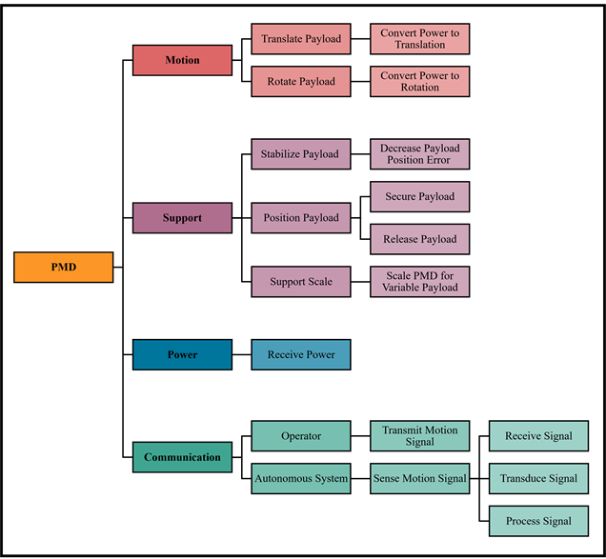
Figure 1: Functional Decomposition Hierarchy Chart
The motion of the device is divided into two subsystems: translational, and rotational movement. Under these motion types is a function for converting power to a specified motion type.
The support system is divided into three subsystems: stability, position, and scalability. Stability refers to the amount of undesired movement when relocating the payload. The goal would be to reduce the amount of undesired payload movement such as swinging or vibrating. The position subsystem includes functions for securing and releasing the payload. The scalability subsystem includes a function for the scalability as it relates to variable payloads.
Due to previous assumptions, the subsystem pertaining to power has only the one function of receive power. It will be assumed that an adequate amount of power will be provided.
The communication system has two major components, the operator, or user, and the autonomous system. The user will transmit motion signals that will then be sensed by the autonomous system. Once the signal is sensed by this system, the signal will then be received, transduced, and processed. In this case transduce refers to the translation of the signal into meaningful data, and processing the signal refers to the action taken from that meaningful data.
Connection to Systems
The functional decomposition cross reference chart, shown below in Table 2, is a visual comparison of functions as they relate to the systems; this tally is useful in determining which systems will take priority in the design process. The X indicates which of the systems the given function has a reaching effect on; as shown, the functions have the potential to physically relate to multiple systems. For example, Decrease Payload Position Error relates to both the motion of the payload and the support of the payload. From the cross-reference table, the systems containing the most functions can be identified as Support and Communication. Though these systems are tied in their number of physically pertinent functions, it was decided that Support will be the system to take priority. The physical outcome of this project is to move a payload on the lunar surface; while there are set goals to achieve motion of the payload, supporting the payload will be a main priority for the duration of the design process.
Table 2: Functional Decomposition Cross Reference Chart
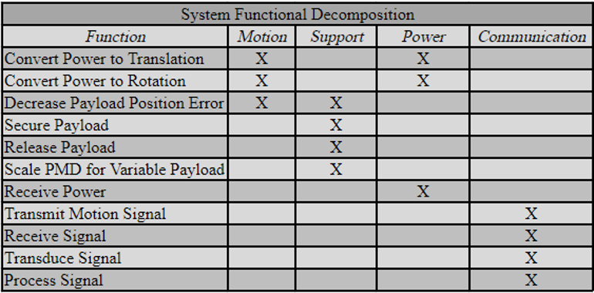
Integration
The first functions that are integrated into multiple sub-systems are conversion of power into translational and rotational motion, which are part of both the motion and power sub-systems. This is due to there being a direct correlation between energy from the power supply being converted into physical forces and torques. Decreasing the payload positioning error will require two sub-systems as well, one being motion and the other being support. This is because the payload will require support while the PMD applies motion to transport it.
Action and Outcome
The PMD will need to be a scalable machine that can lift payloads of varying sizes, transport them, and put them down safely. Also, this device is to be partially controlled by an operator and partially autonomous. It will need to take a supply of power and convert it into translational and rotational motion, through either torque or force inputs. These major functions will enable the team to develop targets and metrics that will help to achieve the key goals of our project.

1.4 Target Summary
Method of Validation and Discussion of Measurement
The methods that will be utilized in validating the translation targets regarding the function Relocate the LSMS will be to first test the ARROW’s ability to successfully move the LSMS to the necessary location using a Creo Parametric assembly. To further ensure there will be no failure or damage done to the LSMS during transport, the stress and strain will be calculated at the point on the LSMS where the ARROW attaches and lifts it. After the CAD assembly exhibits proper mobility and successful translation of the LSMS, there will be a second method of validation in which 3D printed prototypes will display the real-life physical movement of the design scenario. These two models, as well as the creation of simple cardboard or paper models will allow us to use a tape measure and a protractor to ensure that the ARROW is the required distance from the LSMS and that the ARROW can move the LSMS the required distance in the X, Y, and Z axis and can rotate enough around the three axes. These two methods should provide the necessary verification of our design successfully being able to transport the LSMS.
For the Scale for Variable LSMS Size function, the target of a 1:1 ratio will be validated utilizing the same methods as in the translation targets, in which the scale of the ARROW will be able to change (and remain successful) in the Creo assembly and the 3D printed models based on which size the of the lander. Specifically, by also using a CAD model and a 3D printed model of the Blue Origin lander, this will provide a second scale lander model to test and verify the ARROW’s ability to successfully perform its duties over many scales.
Since the ARROW will be designed entirely through software, the target measurements used in this design will be inputted and handled in Creo Parametric 6.0 and a coding software. These software's will be set to SI units to accurately manage the design measurements. Creo should carry over the correct measurement data into the 3D printing slicing application, Cura, and therefore carry over into our actualized 3D printed model. As mentioned before, these measurements can be further finalized using a tape measure and protractor to measure the 3D printed part lengths and design angles.
Derivation of Targets and Metrics
After decomposing the functionality of the ARROW into systems and then further into subsystems, resultant functions were determined for each subsystem. A set of targets and metrics are associated with the end resultant functions. The targets act as a goal value to reach with the function of the design, while the metrics are used to validate the functions.
Some are soft targets that lend a general range of acceptability, while some are critical targets that determine the success or failure of the project. Based on the project objective of offloading the LSMS from the CLPS lander onto a mobility platform, the critical functions have been determined as Relocate the LSMS and Scale for Variable LSMS Size, shown in bold in Table 1 located in Summary and Catalog section.
Motion Targets and Metrics
Regarding the functions that fall under the Motion system, it is assumed that the LSMS is attached to the mounting deck of the Peregrine lander. Three targets were determined for the Relocate the LSMS function, each concerning a direction of motion. A translation of 0.525 meters is needed in the x-direction, 0.525 meters in the y-direction, and 0.75 meters in the z-direction. These targets are based on the dimensions of the Peregrine lander’s mounting deck and the height of the Chariot mobility chassis, which the LSMS will dock to.
Three targets were also developed for the Move about Axes function regarding the Motion system. These include an angular degree of motion of 0 to 180 degrees for the x and y axis and an angular degree of motion of 0 to 360 degrees about the z axis. This was determined because the design needs to have as many degrees of freedom as possible to account for whichever direction the ARROW must move to successfully transport the LSMS. These targets were determined to be the maximum degrees of rotation because when one axis is given a 360 degree of rotational freedom, the other two axes are physically constrained to 180 degrees of rotational freedom.
Power Targets and Metrics
Based on the mass of the LSMS, weighing 300 lbs in earth’s gravity, it was determined that a minimum torque of 3335 N*m will be needed for the Convert Power to Torque function under the Motion system. This is the torque required to lift the LSMS, determined by multiplying the length of the LSMS by the weight of the LSMS. Based on that same information, a grip force of 1334 N is needed to Secure the LSMS of that scale.
The ARROW is limited by a mass of constraint of 9 kg. For every kilogram, the Peregrine lander puts out 1 watt of power. Based on this, the target created for the Receive Power function is 9 Watts. Similarly, for every kilogram, the peregrine lander outputs 10 kilobytes per second of bandwidth, resulting in a total of 90 kilobytes per second. The ARROW will perform the Communication functions with that bandwidth in mind as the maximum. The ARROW can be hardwired to the lander, resulting in having to use less bandwidth due to large amounts of information not being sent between the two, but remote communication to the LSMS or the mobility chassis will require a stronger bandwidth to ensure stable connection as more information will be shared between them.
Support Targets and metrics
Falling under the Support system is the Decrease Position Error function. A positioning tolerance for vertical and lateral misalignments of ± 2.54 centimeters and a ± 10 degree positioning tolerance about a vertical axis (Dorsey, 2011). The same value of ± 2.54 centimeters was chosen as the clearance target for the Release LSMS function. Another function in the Support system, the Scale for Variable LSMS Size is one of the critical targets for the project. A scaling ratio of 1:1 has been set for this critical function.
Communication Targets and Metrics
After discussions with the project sponsor, it was decided that powering the ARROW did not fall in the scope of this project. The power source is assumed to be a standard American outlet, which provides 120 V. Based on this assumption, the target for the Transduce Signal function has been set to 120 Volts. A frequency of 2.4 GHz will be a target for receiving and transmitting. This target is based on the transmitter on the Peregrine which is 2.4 GHz (Astrobotic, 2020). The last function in the Communication system is the Process Signal, which has been given a target of 18 ms. This is based on the average response time of an RC controller, which is an assumption given by the project sponsor regarding the communication ability of the LSMS.
Targets Outside of Functions
To ensure that the final location of the ARROW does not interfere with regular operation of the LSMS on the Peregrine lander, the ARROW must be 1.3 meters from the lunar surface or 2 meters away from the waist of the LSMS. The 1.3 meters was determined from the height of the payload shelf and the height of the stationary platform, both of which are 1.3 meters in height. This means that if the ARROW is below this height it will not interfere with operation of the LSMS. Also, if the ARROW is at least 2 meters away from the LSMS waist, the ARROW will be far enough from the 2.5-meter reach of the LSMS to not interfere with regular loading/unloading of payloads (Astrobotic, 2020). A meter stick or tape measure may be used to verify these lengths.
The LSMS has ± 180° of rotation at the waist (Dorsey, 2011). This means that the location of the ARROW must be within this range of rotation if the LSMS is to be moved. The arm and forearm lengths may be changed, so they cannot be considered when setting targets. To be sure that ARROW is within this range a protractor may be used.
The bandwidth target for the ARROW will be 90 kilobytes per second, based on the Peregrine lander. The Peregrine lander has a bandwidth of 10 kilobytes per second for every kilogram (Astrobotic, 2020).
Summary and Catalog
A summary of the targets and metrics for all breakdown functions are shown in Table 3 below. The bolded rows signify the critical targets that must be met in order to meet the goal of this project. The targets were chosen based on the project requirements and similar existing technology. As the project timeline progresses, some targets may be subject to change based on prototyping and testing results.
Table 3: Targets and Metrics Breakdown
System | Function | Target | Metric
Motion | Relocate the LSMS | 0.525 in the x direction [m]  0.225 in the y direction [m]  0.75 in the z direction [m] | Length
Motion | Move about Axes | 0-180 [deg] about x-axis  0-180 [deg] about y-axis  0-360 [deg] about z-axis | Angle
Power | Convert Power to Torque | 3335 [N*m] | Force
Power | Receive Power | 9 [Watts] | Power
Support | Decrease LSMS Position Error | ± 2.54 [cm]  ± 10 [deg] | Length  Angle
Support | Secure LSMS | 1334 [N] | Grip Force
Support | Release LSMS | ± 2.54 [cm] | Length
Support | Scale for Variable LSMS Size | 1:1 [m/m] | Ratio of Lengths
Communication | Transmit Signal | 2.4[GHz] | Frequency
Communication | Receive Signal | 2.4[GHz] | Frequency
Communication | Transduce Signal | 120 Volts | Electrical Potential
Communication | Process Signal | 18 [ms] | Response Time

1.5 Concept Generation
Concept generation is an essential aspect of any design process, providing the designers with a cornucopia of possible solutions for the project. Concept selection tools are then used to efficiently narrow down these possible solutions. The team spent time creating a list of one hundred design concepts that present potential solutions to achieve the objective of the project; this list is provided in Appendix D.
Concept Generation Tools
Several concept generation techniques were utilized when creating the list of one hundred design concepts; these include brainstorming, biomimicry, crapshoot, and a morphological chart. The SCAMPER technique was used when brainstorming, which encourages the designer to make one of the following seven changes to the design concept: substitute, combine, adapt, ‘modify, magnify, minify’, ‘out to other use’, ‘eliminate’, and ‘rearrange, reverse’. Through incorporating just one of these changes, a new concept is generated. For example, many of the brainstorming concept mention substituting a different end effector to attach to the LSMS.
Concept Selection
Five concepts were chosen as the medium fidelity concepts. These are concepts that embody desirable characteristics but are not exactly the direction the design team would like to go with the project. They will later be used to rate how well the different qualities of each design help to meet the needs of the project. This is helpful in showing what design characteristics are desirable to achieve the project goal.
Table 4: Medium Fidelity Concepts
Concept # | Description
99 | 34213: The ARROW will be welded to the lander and will locate the LSMS via a plug connection. The crane will insert itself into a holder on the device and be rotated to the desired location before power is cut to release the LSMS.
60 | Four bar mechanism to move LSMS to desired location.
75 | 53412: The ARROW will be clipped on to the lander and will locate the LSMS via RFID. FLEEs will hold the LSMS as it rotates to the desired location where the FLEEs will then unlatch, releasing the LSMS.
13 | Wheeled carry device that goes under LSMS and a winch that is drilled into the ground to drag LSMS to desired location.
5 | Scissor-lift platform
Three high fidelity concepts were also chosen, shown below in Table 5. These concepts seem to highly satisfy the needs of the project and will be used later in concept selection to determine which design concept best fits the needs of the project.
Table 5: High Fidelity Concepts
Concept # | Description
42 | The LSMS acrobats its way to the lunar platform.
43 | Gear driven turn-table that the end effector of the LSMS connects to and rotates the LSMS around onto the platform.
81 | The ARROW will be welded to the lander and will locate the LSMS via laser sensors. FLEEs will hold the LSMS as it is rotated until finally unlatched.

1.6 Concept Selection
House of Quality
The customer needs, established through dialog with the project sponsor, were analyzed using a binary pairwise comparison chart, shown in Table 7. For a more detailed description of the customer needs, please see Table 6. In the binary pairwise comparison, each need was weighed against the others and judged as more or less important and received a 1 or 0, respectively. An importance weight factor for each customer need resulted from this comparison chart, showing that Scalability and Autonomy are tied for top priority.
Table 6: Customer Requirements and Engineering Characteristics
# | Customer Requirements | Engineering Characteristics
1 | The ARROW lifts up to 25 lbs | Relocate LSMS
2 | ARROW is scalable | Move about axe
3 | ARROW mates with LSMS | Convert power to torque
4 | ARROW connects to power | Receive power
5 | The ARROW will arrive at the moon, fully assembled. | LSMS position error
6 | The ARROW will have hard stops for operator on Earth. | Secure LSMS
7 | The ARROW weighs no more than 20lbs. | Clearance After Release LSMS
8 | The simulation will be made in Simulink. | Scale for variable size LSMS
9 | The ARROW’s functions will be fully automated. | Transmit signal
10 | The material selected is suitable for use in space and can withstand environmental factors. | Process signal
11 | The end effector will utilize the standard attachment used by NASA. | Transduce signal
12 | - | Receive signal

Table 7: Binary Pairwise Comparison
Binary Pairwise Comparison
Customer Needs | #1 | #2 | #3 | #4 | #5 | #6 | #7 | #8 | #9 | #10 | #11 | Total 2
#1 | - | 0 | 0 | 0 | 0 | 1 | 0 | 1 | 0 | 1 | 1 | 4
#2 | 1 | - | 1 | 1 | 1 | 1 | 1 | 1 | 0 | 1 | 1 | 9
#3 | 1 | 0 | - | 1 | 1 | 1 | 0 | 1 | 0 | 1 | 1 | 7
#4 | 1 | 0 | 0 | - | 0 | 1 | 0 | 1 | 1 | 1 | 1 | 6
#5 | 1 | 0 | 0 | 1 | - | 0 | 1 | 1 | 0 | 1 | 1 | 6
#6 | 0 | 0 | 0 | 0 | 1 | - | 1 | 1 | 0 | 1 | 1 | 5
#7 | 1 | 0 | 1 | 1 | 0 | 0 | - | 1 | 0 | 1 | 1 | 6
#8 | 0 | 0 | 0 | 0 | 0 | 0 | 0 | - | 0 | 1 | 0 | 1
#9 | 1 | 1 | 1 | 0 | 1 | 1 | 1 | 1 | - | 1 | 1 | 9
#10 | 0 | 0 | 0 | 0 | 0 | 0 | 0 | 0 | 0 | - | 0 | 0
#11 | 0 | 0 | 0 | 0 | 0 | 0 | 0 | 1 | 0 | 1 | - | 2
 | 6 | 1 | 3 | 4 | 4 | 5 | 4 | 9 | 1 | 10 | 8 | n-1 = 10

This importance weight factor was then used in the House of Quality to determine the ranking of the ARROW’s decomposed functions. For a more detailed description of the engineering characteristics of the ARROW, as well as the customer needs, please see Table 6. The House of Quality compares the engineering characteristics of the ARROW (the decomposed functions of the ARROW’s main systems) against the customer’s requirements. Using the importance weight factor of the customer requirement, the engineering characteristic is ranked on how well that particular characteristic helps to meet that particular customer need. This results in a ranking of the most import Engineering Characteristics, or functions, that the ARROW will display.
Table 8: House of Quality
House of Quality | Engineering Characteristics
Improvement Direction |  | ↓ | ↑ |  |  | ↓ |  |  |  |  | ↓
Units |  | m | deg | Nm | Watt | m & deg | N | m | m | Hz | Sec | V | Hz
Customer Requirements | IPF | #1 | #2 | #3 | #4 | #5 | #6 | #7 | #8 | #9 | #10 | #11 | #12
#1 | 4 | 3 | 3 | 9 | 3 |  | 9
#2 | 9 | 9 | 9 | 3 | 1 | 3 | 3 | 3 | 9
#3 | 7 | 9 | 9 |  |  |  | 9 | 9 | 3
#4 | 6 |  |  | 9 | 9 |  |  |  |  | 9 | 1 | 1 | 9
#5 | 5 |  |  |  |  |  |  |  | 9
#6 | 5 |  |  |  | 9 |  |  |  |  | 9 | 3 | 3 | 9
#7 | 6 | 3 | 3 |  |  |  | 3 |  | 3
#8 | 1 |  |  |  |  | 9 |  |  | 9
#9 | 9 |  |  | 3 | 9 |  | 3 | 3 | 3 | 9 | 9 | 9 | 9
#10 | 0 |  |  | 9 |  |  | 9
#11 | 2 | 9 | 9 |  |  | 3 | 3 | 3 | 3
Raw Score | 1842 | 192 | 192 | 144 | 201 | 42 | 177 | 123 | 207 | 180 | 102 | 102 | 180
Relative Weight |  | 10.4 | 10.4 | 7.8 | 10.9 | 2.3 | 9.6 | 6.7 | 11.2 | 9.8 | 5.5 | 5.5 | 9.8
Rank Order |  | 3 | 3 | 6 | 2 | 9 | 5 | 7 | 1 | 4 | 8 | 8 | 4

From the previous House of Quality table, our most important functions are: Scale for variable size LSMS, Receive power, Relocate LSMS, and Move about axes. The least important functions are: LSMS position error, Process signal, Transduce signal, and Clearance after LSMS release. This helps further evaluate the viability of concepts. A concept may deceptively look superior until the weight of the characteristics is accounted for.
Pugh Chart
Pugh charts are a method of design selection that takes high and medium fidelity concepts and compares them relative to a datum. The chart determines concept viability based on if the concept is better (+), worse (-), or satisfactory (S) for the criterion in comparison to the datum.
In our first Pugh chart shown next our datum is a second LSMS used to unload the first one. In this chart the concepts selected to move to the second round of Pugh charts were: #75, #42, #43, and #81. #75 was chosen as the datum for the next chart because it was the concept with the least polarizing results.
Table 9: Pugh Chart Iteration 1
Pugh Chart: Iteration 1
Function | LSMS | Concept
 |  | #99 | #60 | #75 | #13 | #5 | #42 | #43 | #81
Relocate LSMS | datum | - | - | - | S | - | - | + | S
Move about axes |  | + | - | + | - | - | S | - | -
Convert power to torque |  | S | + | S | + | + | S | S | S
Receive power |  | S | S | S | S | S | S | S | S
LSMS position error |  | - | - | - | - | - | S | + | -
Secure LSMS |  | + | - | + | S | - | S | S | +
Clearance After Release LSMS |  | S | S | + | - | + | + | + | S
Scale for variable size LSMS |  | S | + | S | + | + | + | S | S
Transmit signal |  | - | - | + | - | - | S | - | S
Process signal |  | - | - | + | - | - | S | - | S
Transduce signal |  | - | - | S | - | - | S | - | S
Receive signal |  | - | - | S | - | - | S | - | S
 | Plus (+) | 2 | 2 | 5 | 2 | 3 | 2 | 3 | 1
 | Satisfactory (S) | 4 | 2 | 5 | 3 | 1 | 9 | 4 | 8
 | Minus (-) | 6 | 8 | 2 | 7 | 8 | 3 | 6 | 3

In Pugh chart 2 shown next all ratings for criteria relating to signals were determined to be satisfactory for all concepts moving forward. This was primarily due to not wanting criteria of low importance to affect results too significantly. This was also due to signaling methods not being mentioned in the description of most concepts. Concept #81 was the only concept deemed not worth moving on due to not doing performing better than the datum.
Table 10: Pugh Chart Iteration 2
Pugh Chart: Iteration 2
Function | #75 | Concept
 |  | #42 | #43 | #81
Relocate LSMS | datum | + | S | S
Move about axes |  | + | S | S
Convert power to torque |  | + | + | S
Receive power |  | S | S | S
LSMS position error |  | - | + | -
Secure LSMS |  | - | S | S
Clearance After Release LSMS |  | + | S | S
Scale for variable size LSMS |  | + | + | S
Transmit signal |  | S | S | S
Process signal |  | S | S | S
Transduce signal |  | S | S | S
Receive signal |  | S | S | S
 | Plus (+) | 5 | 3 | 0
 | Satisfactory (S) | 6 | 9 | 11
 | Minus (-) | 2 | 0 | 1

Pugh chart 3 (shown next) was made to verify that #43 (the best concept in Pugh chart 2) was better than the datum of Pugh chart 2 in comparison to #42 (the second-best concept in Pugh chart 2). From this chart concept #43 was determined to be the most likely concept.

Table 11: Pugh Chart Iteration 3
Pugh Chart: Iteration 3
Function | #42 (Acrobat) | Concept
 |  | #75 (RFID FLEE) | #43 (Lazy SUSAN)
Relocate LSMS | datum | - | S
Move about axes |  | - | +
Convert power to torque |  | + | +
Receive power |  | S | S
LSMS position error |  | + | +
Secure LSMS |  | + | S
Clearance After Release LSMS |  | - | -
Scale for variable size LSMS |  | - | +
Transmit signal |  | S | S
Process signal |  | S | S
Transduce signal |  | S | S
Receive signal |  | S | S
 | Plus (+) | 3 | 4
 | Satisfactory (S) | 5 | 7
 | Minus (-) | 4 | 1

We are choosing concept 43 because concept 42 does not account for possible design changes of the LSMS.
Table 12: Analytical Hierarchy Process
Analytical Hierarchy Process
Criteria | #1 | #2 | #3 | #4 | #5 | #6 | #7 | #8 | #9 | #10 | #11 | Total | Avg2
#1 | 1.00 | 5.00 | 3.00 | 3.00 | 3.00 | 0.33 | 1.00 | 1.00 | 5.00 | 5.00 | 1.00 | 28.33 | 2.58
#2 | 0.20 | 1.00 | 0.33 | 0.20 | 1.00 | 3.00 | 0.33 | 1.00 | 5.00 | 5.00 | 1.00 | 18.07 | 1.64
#3 | 0.33 | 3.00 | 1.00 | 7.00 | 1.00 | 5.00 | 1.00 | 3.00 | 5.00 | 7.00 | 3.00 | 36.33 | 3.30
#4 | 0.33 | 5.00 | 0.14 | 1.00 | 0.20 | 0.33 | 0.14 | 0.33 | 1.00 | 1.00 | 0.33 | 9.82 | 0.89
#5 | 0.33 | 1.00 | 1.00 | 5.00 | 1.00 | 5.00 | 0.20 | 3.00 | 7.00 | 5.00 | 3.00 | 31.53 | 2.87
#6 | 3.00 | 0.33 | 0.20 | 3.00 | 0.20 | 1.00 | 0.33 | 5.00 | 5.00 | 7.00 | 3.00 | 28.07 | 2.55
#7 | 1.00 | 3.00 | 1.00 | 7.00 | 5.00 | 3.00 | 1.00 | 5.00 | 5.00 | 5.00 | 5.00 | 41.00 | 3.73
#8 | 1.00 | 1.00 | 0.33 | 3.00 | 0.33 | 0.20 | 0.20 | 1.00 | 5.00 | 7.00 | 1.00 | 20.07 | 1.82
#9 | 0.20 | 0.20 | 0.20 | 1.00 | 0.14 | 0.20 | 0.20 | 0.20 | 1.00 | 3.00 | 1.00 | 7.34 | 0.67
#10 | 0.20 | 0.20 | 0.14 | 1.00 | 0.20 | 0.14 | 0.20 | 0.14 | 0.33 | 1.00 | 0.20 | 3.76 | 0.34
#11 | 1.00 | 1.00 | 0.33 | 3.00 | 0.33 | 0.33 | 0.20 | 1.00 | 1.00 | 5.00 | 1.00 | 14.20 | 1.29
Total | 8.60 | 20.73 | 7.69 | 34.20 | 12.41 | 18.54 | 4.81 | 20.68 | 40.33 | 51.00 | 19.53
Average 1 | 0.78 | 1.88 | 0.70 | 3.11 | 1.13 | 1.69 | 0.44 | 1.88 | 3.67 | 4.64 | 1.78

The Analytical Hierarchy Process (AHP) was used to determine if the weights of our criteria for judging the concepts were biased or not. Using this process allows for a mathematical way of removing bias from the weights. The first chart uses an “is criteria A better than criteria B” method and a ranking scale of 1, 3, 5, 7, 9 to determine how much better the group decides that criteria is compared to the other. If B is decided to be better than A, then the inverse of the scale is used. From there the totals were used to find the Criteria Weight in the table below.
Table 13: Normalized Comparison Matrix
Criteria | 1 | 2 | 3 | 4 | 5 | 6 | 7 | 8 | 9 | 10 | 11 | Crit Weight
1 | 0.12 | 0.24 | 0.39 | 0.09 | 0.24 | 0.02 | 0.21 | 0.05 | 0.12 | 0.10 | 0.05 | 0.15
2 | 0.02 | 0.05 | 0.04 | 0.01 | 0.08 | 0.16 | 0.07 | 0.05 | 0.12 | 0.10 | 0.05 | 0.07
3 | 0.04 | 0.14 | 0.13 | 0.20 | 0.08 | 0.27 | 0.21 | 0.15 | 0.12 | 0.14 | 0.15 | 0.15
4 | 0.04 | 0.24 | 0.02 | 0.03 | 0.02 | 0.02 | 0.03 | 0.02 | 0.02 | 0.02 | 0.02 | 0.04
5 | 0.04 | 0.05 | 0.13 | 0.15 | 0.08 | 0.27 | 0.04 | 0.15 | 0.17 | 0.10 | 0.15 | 0.12
6 | 0.35 | 0.02 | 0.03 | 0.09 | 0.02 | 0.05 | 0.07 | 0.24 | 0.12 | 0.14 | 0.15 | 0.12
7 | 0.12 | 0.14 | 0.13 | 0.20 | 0.40 | 0.16 | 0.21 | 0.24 | 0.12 | 0.10 | 0.26 | 0.19
8 | 0.12 | 0.05 | 0.04 | 0.09 | 0.03 | 0.01 | 0.04 | 0.05 | 0.12 | 0.14 | 0.05 | 0.07
9 | 0.02 | 0.01 | 0.03 | 0.03 | 0.01 | 0.01 | 0.04 | 0.01 | 0.02 | 0.06 | 0.05 | 0.03
10 | 0.02 | 0.01 | 0.02 | 0.03 | 0.02 | 0.01 | 0.04 | 0.01 | 0.01 | 0.02 | 0.01 | 0.02
11 | 0.12 | 0.05 | 0.04 | 0.09 | 0.03 | 0.02 | 0.04 | 0.05 | 0.02 | 0.10 | 0.05 | 0.05
Sum | 1.00 | 1.00 | 1.00 | 1.00 | 1.00 | 1.00 | 1.00 | 1.00 | 1.00 | 1.00 | 1.00 | 1.00

Once the Criteria Weight for each criterion was calculated, the Weighed Sum Vector (Ws) and the Consistency Vector (Cons V) are calculated, shown below.
Table 14: Consistency Check
Ws | Cons V
2.00 | 13.53
1.03 | 15.04
2.21 | 14.88
0.63 | 14.79
1.86 | 15.43
1.58 | 13.66
2.77 | 14.60
0.87 | 13.06
0.34 | 12.66
0.23 | 13.39
0.75 | 13.58

Finally, a Consistency Ratio (Con. Ratio), is calculated. The ideal CR is to be below 0.1, however, after many iterations, the overall ratio could not be gotten below 0.2. We decided this was alright as some of the criteria created did not hold much value, which would result in the ratio being slightly high.
Table 15: Consistent Comparison
Avg Consist | Con. Index | Con. Ratio
14.06 | 0.31 | 0.20

The same process mentioned above was done for each criterion created and was compared to each of the final three concepts. These were concepts 42, 43, and 75.
Table 16: Power to Torque Consistency Check
Power to Torque Consistency Check
Concept | 42 | 75 | 43
42 | 1.00 | 0.33 | 0.33
75 | 3.00 | 1.00 | 1.00 |  | n | 3
43 | 3.00 | 1.00 | 1.00 |  | RI | 0.52
Sum | 7.00 | 2.33 | 2.33
Concept | 42 | 75 | 43 | Crit Weight | ws | V
42 | 0.14 | 0.14 | 0.14 | 0.14 | 0.43 | 3 | Lamda | 3.00
75 | 0.43 | 0.43 | 0.43 | 0.43 | 1.29 | 3 | Con. Index | 0.00
43 | 0.43 | 0.43 | 0.43 | 0.43 | 1.29 | 3 | Con. Ratio | 0.00
Sum | 1.00 | 1.00 | 1.00

Each CR calculated is shown below. For criteria with an asterisk next to it, there was not a CR found as it would have resulted in the same weight for each concept. This is due to each concept utilizing the same methods of receiving power, transmitting signal, processing signal, transducing signal, and receiving signal the same way. It should be noted that some of the CR’s are high, but they after several attempts, that is the lowest they could be made.
Table 17: Criteria Consistency Ratio Tables
Criteria | Consistency Ratio
Relocate LSMS | 0.29
Move about axes | 0.29
Convert power to torque | 0.00
Receive power*
Secure LSMS | 0.29
Clearance After Release LSMS | 0.01
Scale for variable size LSMS | 0.23
Transmit signal*
Process signal*
Transduce signal*
Receive signal*

The Final Rating Matrix below shows the weight of each criteria for the concepts. These weights are found when performing the Criteria Consistency Matrixes. These weights will then be used in the next chart to calculate the Alternate Value.
Table 18: Final Rating Matrix
Final Rating Matrix
Criteria | Concept
 | #42 (Acrobat) | #75 (RFID FLEE) | #43 (Lazy SUSAN)
Relocate LSMS | 0.33 | 0.12 | 0.55
Move about axes | 0.33 | 0.52 | 0.12
Convert power to torque | 0.14 | 0.43 | 0.43
Receive power* | 0.33 | 0.33 | 0.33
Secure LSMS | 0.12 | 0.55 | 0.33
Clearance After Release LSMS | 0.75 | 0.12 | 0.13
Scale for variable size LSMS | 0.59 | 0.08 | 0.33
Transmit signal* | 0.33 | 0.33 | 0.33
Process signal* | 0.33 | 0.33 | 0.33
Transduce signal* | 0.33 | 0.33 | 0.33
Receive signal* | 0.33 | 0.33 | 0.33

Table 19: Alternate Value Rating
 | Concept
Weights | #42 (Acrobat) | #75 (RFID FLEE) | #43 (Lazy SUSAN)
10.42 | 3.4386 | 1.2504 | 5.731
10.42 | 3.4386 | 5.4184 | 1.2504
7.82 | 1.0948 | 3.3626 | 3.3626
10.91 | 3.6003 | 3.6003 | 3.6003
9.61 | 1.1532 | 5.2855 | 3.1713
6.68 | 5.01 | 0.8016 | 0.8684
11.24 | 6.6316 | 0.8992 | 3.7092
9.77 | 3.2241 | 3.2241 | 3.2241
5.54 | 1.8282 | 1.8282 | 1.8282
5.54 | 1.8282 | 1.8282 | 1.8282
9.77 | 3.2241 | 3.2241 | 3.2241
Alt. Value | 34.4717 | 30.7226 | 31.7978

From the Alternate Value chart above, we compared the weights of each of the criteria to the score that each concept received in the Final Rating Matrix. This allowed us to see that RFID FLEE was not a viable concept, due to having the lowest score. The team then decided that, while Acrobat had a higher score than Lazy SUSAN, because Lazy SUSAN was picked in the Pugh charts and had the second highest score, concept 43 would be the design we choose to pursue while Acrobat would be our alternate design.

Final Selection
Group 517’s final selection will be concept 43, named Lazy SUSAN. This concept is a gear driven turntable that the end effector of the LSMS will mate to. The LSMS will then be rotated off the landing deck and onto the lunar platform and released. This selection was made as a result of being the superior concept in Pugh chart 3 and having the second highest score in the Alternate Value Rating chart, both shown above. This concept allows us to best utilize our skills obtained through schooling, best fits the needs of the customer, and will be the greatest proof of concept for offloading the LSMS to a mobility chassis.

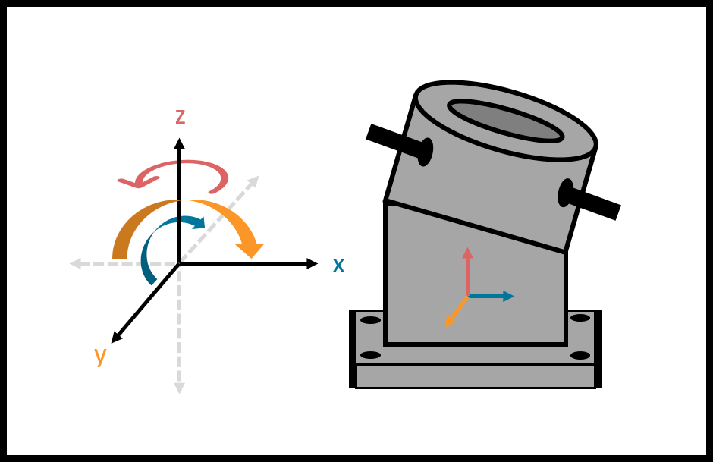
Figure 2: Lazy SUSAN

Chapter Two: EML 4552C

2.1 Spring Plan

Project Plan
Shown below in Figure 3 is the Spring semester project plan, indicating which team member is responsible for which task and what date each assignment will be accomplished. 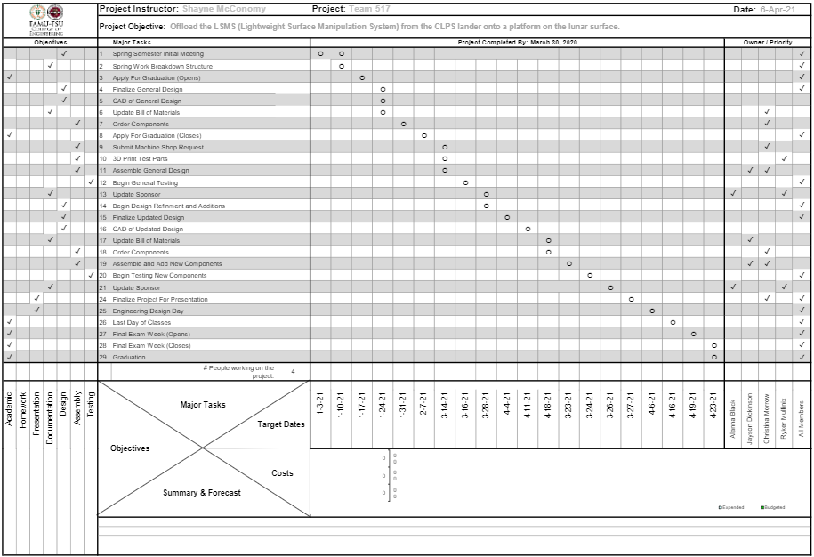
Figure 3: Spring Project Plan

Build Plan
The build plan for this project begins with completing the CAD model for the ARROW design, ensuring that the assembly will allow for ease of machining and can provide the range of motion necessary to meet all motion targets. Next, detail drawings for all the machined parts were created; these drawings are available in Appendix F. A total of twenty-one machined parts were created by the machine shop at the FAMU-FSU College of engineering for this design.
After all the parts were retrieved from the machine shop, a full assembly began. The chassis was constructed, and the linear actuators were installed with press fit pins. All hardware, such as the Arduino Mega 2560, motor driver, and rack and pinion were also installed.
After some initial testing, two parts required additional machining modifications. This was due to inaccurate dimensions for the linear actuators. Once the true values were gathered, the rack panel and the turntable plate were modified to accommodate these values.

2.2 Restated Project Charter
Project Description
NASA, partnered with Commercial Landing Payload Services (CLPS), has developed an autonomous means of payload transportation to operate on the lunar surface, called the LSMS (Lightweight Surface Manipulation System). This project is concerned with offloading the LSMS from the CLPS lander, so that it may be used for a wider range of tasks. This is necessary for establishing a lunar presence and building the foundation for future missions to Mars. NASA wants to create a means of building a base at one of the poles on the Moon and develop a method of rapid assembly of the base. In order to do this, the LSMS must be relocated onto a mobile platform. This will be done with a design called the ARROW (Automated and Ranged Relocation of the LSMS for Wider application).
Project Objective
The objective of this project is to offload the LSMS from the CLPS lander onto a platform on the lunar surface.
Key Goals
A key goal is to design the ARROW to be capable of off-loading the LSMS. Making this a key goal is a direct result of the customer statement regarding the project requirements.
Another key goal of this project is to design the ARROW to be scalable for any size LSMS. In the virtual simulation there should be a 1:1 lifting capability to weight ratio for the ARROW relative to each LSMS size. There should be the ability to create ARROWs of various sizes so that money can be saved in the creation of smaller models and a prototype can be delivered to the customer that works exactly as the final product would work. This allows for potential issues to be addressed prior to the creation of the final product assembly.
The final key goal is for the ARROW to be completely autonomous with human control being activated fail-safes. The machine or mechanism would operate without any human intervention needed. Keeping the ARROW completely autonomous also means it must be able to communicate with other devices on the lander if the design is not completely mechanical.
Primary Market
The primary market for this project is NASA at their Marshall Space Flight Center and the Commercial Landing Payload Services (CLPS). These are the organizations most involved in the establishing of the ARROW to relocate the LSMS.
Secondary Markets
One of the secondary markets for the project is the commercial construction, shipping, and manufacturing industries. The ARROW would help enable them to perform their respective transporting functions as necessary. Another secondary market is the military, which can utilize the ARROW in transporting equipment, machines, and other necessities. The research field is also a market for this project. For example, research being done in Antarctica’s McMurdo military base could utilize the ARROW to transport food, supplies, and experimental machinery.
Assumptions

Some assumptions were made to narrow the scope of the teams’ efforts. It is assumed that the team is not responsible for transportation of the ARROW to the lunar surface and operation of the ARROW will take place on the moon. It is also assumed that the ARROW will be stationary, with access to a power from the CLPS lander. Another assumption is that reusability of the ARROW is not a concern. Additionally, it is assumed that the LSMS will send a ready signal to the ARROW and the duties of the ARROW will occur as part of the automated landing sequence. It is also assumed that an existing end effector will be utilized, to increase time spent on other design aspects. The LSMS and ARROW locations on the lander are at the discretion of the design team and the LSMS can dock to the lunar platform. Environmental factors such as regolith and temperature changes are also assumed to not be a concern for this project design.
Stakeholders
The stake holders of this project include: NASA, the FAMU-FSU College of Engineering, senior design coordinator Dr. Shayne McConomy, academic advisor Dr. Eric Hellstrom, and Commercial Landing Payload Services (CLPS) (and its providers: SpaceX, Lockheed Martin, Blue origin, and other space companies). Thomas Carno and his team at the Langley Research Center are the creators of the LSMS and another stakeholder for this project.
NASA is the sponsor of the project and was approached by CLPS who is interested in this project's possible applications. Dr. Shayne McConomy, FAMU-FSU College of Engineering, and Dr. Eric Hellstrom are being represented; therefore, they are interested in the project as well.

2.3 Results
The following section outlines the methods of validation used and the percent error from those tests.
Motion System
Targets for this system were validated by measuring the lander demonstration model. For movement about axes angles were measured using an electronic level. For measuring the distances required for LSMS movement, a tape measure was used. The table below shows the total measurements achieved by the ARROW.
Table 20: Motion System Validation
Action | X-Axis | Y-Axis | Z-Axis | Method of Validation
Move About Axes | 0 [deg] | 44 [deg] | 90 [deg] | Measuring via angle finder
Relocate LSMS | 0.57 [m] | 0.22 [m] | 1.07 [m] | Measuring with tape measure
This table shows the targets of this system and their method of validation. The targets of this system were within 2.26% of intended.
Support System
Targets for this system were validated through a combination of Creo simulation and physical measurements.
Table 20: Support System Validation
Action | Target Values |  | Method of Validation
Decrease LSMS Position Error | ±2.54 [cm] | ±10 [deg] | Measuring Physical Model
Secure LSMS | 41 [N] |  | Creo Simulation
Release LSMS | ±2.54 [cm] |  | Written procedure
Scale for Variable LSMS Size | 1.1 weight to lifting capability |  | Parts Specification
The table shown previously shows the targets for this system and their method of validation. The next paragraph begins explaining the Creo Simulation used to validate securing the LSMS.
It was determined that the connection plate would need to be capable of withstanding a 41 N force. Figure 1 and 2, shown below, show the shear and internal stresses on the connection plate when a 41 N force is applied to it. This is representative of the force the plate needs to be able to handle to safely support the LSMS.
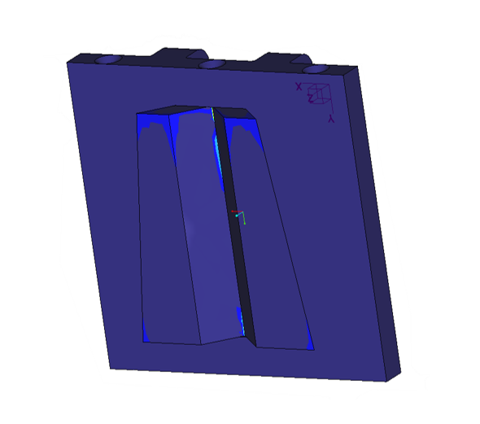
Fig. 1 Maximum Shear Stress
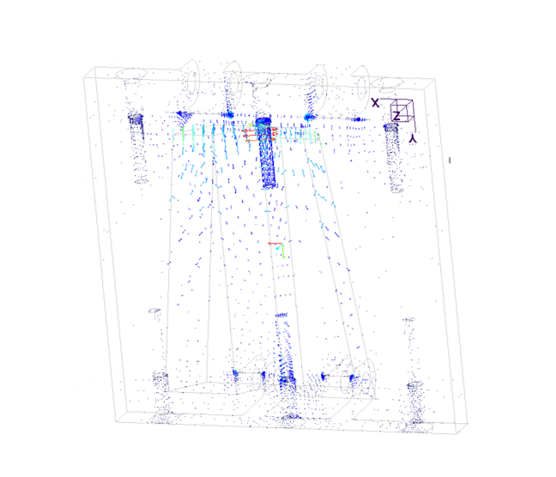
Fig. 2 Internal Stress
The highest concentration of stress is in the center of the dovetail cut at 6 MPa, far below the 207 MPa that the aluminum can handle. The internal stresses are at the threads of the screws but is considered nominal.
The position error final results found that the final location of the LSMS averaged to be 0.97 cm from center, below the 2.54 cm desired. The average vertical alignment was 2.75 deg, which is again below the desired 10 degrees. The closer to zero these alignments are, the better as it allows for greater accuracy and precision for the components. Had these results been too large, corrective measures would be taken in the code to allow for finer movements. Pictures of the validation are on slide 79 of DR6.
Power System
The power system was validated completely by the ARROW’s ability to rotate the LSMS model without problems and power on. This system can be accurately validated in the future by using a force measuring device to see the total amount of force the ARROW can lift before stall occurs. Another method of doing this would be to put a mass that it is known the ARROW cannot lift and have a scale under the weight. Once the ARROW tries to lift the mass, the change in weight can be calculated to see the total torque the ARROW can produce before failure.
Table 21, below, shows the targets and their respective methods of validation for the power system.
Table 21: Power System Validation
Action | Target | Method of Validation
Receiving Power | 1800 [Watts] | Verifying power supply capabilities
Convert Power to Torque | 33 [Nm] | Demonstration model functionality

Communication System
Table 22: Communication System Validation
Action | Target | Method of Validation
Transmit Signal | 2.4 [GHz] | N/A
Receive Signal | 2.4 [GHz] | N/A
Transduce Signal | 120 Volts | Verifying Power Supply Capabilities
Process Signal | 18 [milliseconds] | Timing Video
For communication, the ARROW successfully validated two of the four targets. The processing speed was measured to be 16 milliseconds, 2 milliseconds quicker than the desired number of 18 milliseconds. This was measured by recording the time it took for the ARROW to move after hitting the spacebar to simulate the LSMS sending the “ready” signal. Slide 82 of DR6 (Mullinix) shows the video with timestamps. Transduce signal was validated by the ability to run off wall power. Transmit and receiving signal were not validated as the design did not incorporate Bluetooth. This can be implemented in future iterations of the ARROW.

Discussion
The ARROW successfully offloaded the LSMS as was shown in the validation portion of this paper. The final design weighed in at 18.7 pounds, or 8.5 kilograms. The offloading process is completely autonomous and can be scaled with few modifications.
Errors
The model LSMS created by the team is a semi-accurate representation of NASAs actual crane. There is flexing of the wood, inadequacies in the distribution of the weight, and the joint connections are very different than the LSMS. Because of this, certain disparities are present in the demonstration and validation methods. To alleviate this, a better model of the crane should be developed or the actual miniature LSMS should be used for final testing. Other errors present are in the model of the payload deck. The model created does not feature the triangular pattern seen on the Peregrine Lander and so the attachment of the Quiver to the deck. The final Quiver should be designed to mount to the lander deck, but the overall design can stay the same.

Conclusion
The successful offloading of the LSMS will allow for the lunar base setup in the Artemis to be completed. Without the crane being offloaded, the Artemis mission will fail because of the base being unable to be created prior to astronaut arrival on the moon. Team 517’s ARROW provides pivotal information into how the crane should be removed from the lander onto a rover on the lunar surface. The utilization of previous components developed by and available to NASA allows for this design to integrate easily into the Artemis mission near-seamlessly, with only a few changes to be able to have the design be space-ready.

Future Work
The continuing stages of this project would go on to incorporate a space rated bill of materials, adhering to the standards that NASA has established regarding material selection. In that same vein, the environmental factors should be taken into consideration for the next design iteration. These environmental factors include, but are not limited to acceleration due to gravity, temperature ranges, and regolith. The design can be modified to improve resilience to this environment.
The next stage in the project, is to incorporate the LSMS power integration. One of the caveats of this project was that the LSMS can receive power via the wrist connection at the ARROW. This allows the LSMS to maneuver itself, while the base is disconnected. Developing this power connection is a crucial stage in seeing this project through to fruition.
Lastly, system integration is the final stage in the process. Incorporating the ARROW into the operating system of the Peregrine lander and developing the power connection between the two. The goal is to create a cohesive system that includes the lander, the ARROW, and the LSMS so that they can work in junction to achieve a common goal.
To aid in the scalability of the ARROW, certain design aspects should be changed. The lower module’s linear actuator and rack and pinion should be replaced with a motor driven worm gear. This would allow essentially infinite rack travel to keep the length of the ARROW to a minimum. The rest of the design could be utilized the same way, simply strengthen the material, increase the size of top linear actuator, and increase the strength of the gear train to allow for a smaller motor to be used to power the worm gear.

Appendices

Appendix A: Code of Conduct
Mission Statement
Team 517 is intent on cultivating a team dynamic in which members are heard, valued, and respected. Each member will be encouraged in their individual academic and personal strengths, fostering a spirit of camaraderie and productivity. Collectively, we are committed to giving as much time and effort as possible to this project, while producing the highest quality work possible.
Team Members and Roles
Alanna Black – Robotics and Controls Engineer
The lead robotics engineer is responsible for control design, systems engineering, and automation; this entails work on logical structure flow and writing appropriate command codes for the system. As an ENTJ personality type, Alanna is well suited to this role, gathering information to construct creative solutions to any problem presented.
Jayson Dickinson - Team Manager and Fluids Engineer
As team manager, Jayson will ensure that the team stays on track, accomplishing project goals by the set deadline. He will monitor attendance and will be the main point of contact between the group members and the advisor/sponsor. As the lead fluids engineer, Jayson will also focus on the hydraulic fluids potentially used in the project as well as work with the design engineer to model flows throughout the design. He will utilize CAD software and fluid dynamics to allow for advanced simulations of the project in motion. As an ESTP personality type, Jayson is well suited to this role as he embodies an entrepreneurial spirit lending him the skillset of a leader.
Christina Morrow – Design and Test Engineer
As the design and test engineer, Christina is responsible for fine-tuning any potential design, while ensuring that the tolerances fall within the established range of acceptability. She will create all CAD parts, assemblies, and sub-assemblies; she will also be responsible for creating detail drawings of all parts. Christina is also responsible for performing stress and strain analysis, to ensure the design will not deform under performance. As an INFJ personality type, Christina is equipped with a rich imagination enabling her to excel at envisioning any design and turning it into a 3D CAD representation.
Ryker Mullinix - Materials Engineer
As the lead materials engineer, Ryker will focus on the material properties of components utilized in the project design, ensuring that the most appropriate material is chosen based on projected use and environmental factors. He will also be responsible for scouting vendors and ensuring that material costs fall within the project budget. As an INTJ personality type, Ryker is well suited to fine details and attention to the bare bones of any design, enabling him to best understand the materials needed for any project.
All Team Members
All members are to actively perform certain duties as project needs arise and perform them to the best of their abilities. Team members are to uphold a high-quality standard in every task they complete and carry out commitments with confidence. Specific duties for each member are to be decided upon and ultimately distributed by team leaders as project needs take shape.
Communication
Team members will communicate through text message or email and meet virtually via Zoom calls for nearly all project needs. Members are to respond within 24 hours of formal team project planning communication. Any in-person meetings will be held at the FAMU-FSU College of Engineering and will be arranged through text, email, or Zoom. In-person meetings will only take place during instances of absolute necessity to prevent the potential spread of COVID-19.
Dress Code
For team meetings and meeting with our academic advisor, the dress code will not be enforced, and members will be in casual clothing unless otherwise instructed. Business professional will be worn for meetings with the sponsor as well as for presentations; this entails a white button down or blouse, black trousers or skirt, and black shoes. Any changes to the dress code will be noted in the meeting notes and will be communicated via Zoom or text.
Attendance Policy
Attendance will be mandatory for all members of the group for every presentation, meeting, and Zoom call. The team lead will oversee tracking attendance via an excel document on OneDrive. If a group member cannot make a meeting or call, it will be communicated a minimum of 24 hours in advance unless an emergency arises, in which case it will be addressed as deemed necessary. Should a group member miss more than 3 meetings or calls, group members will contact Dr. McConomy to notify him of the absences, asking him to intervene should the group member fail to respond to the rest of the group. Holidays will be considered as “off-days” unless otherwise unanimously agreed upon.
Member Discourse
Should discourse begin to grow between group members, time will be allotted for the members to express their concerns in an environment that encourages growth rather than hinderance. If this proves not beneficial to the group, other methods, such as discussing with Dr. McConomy, will be utilized to smooth over any issues that should arise.
Code of Conduct Amendments
Should the Code of Conduct need to be amended, a unanimous agreement must be reached between the group members before the amendment is added.
Statement of Understanding:
By signing below, you acknowledge that you have read the documented code of conduct and will adhere to the guidelines specified.
Alanna Black: Date: 9/8/20
Jayson Dickinson: 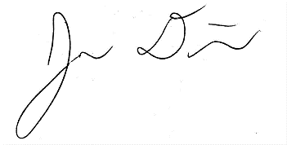 Date: 9/8/20
Christina Morrow: Date: 9/8/20

Ryker Mullinix: Date: 9/8/20

Appendix B: Functional Decomposition
Figure 1: Function Decomposition Flow Chart
Table 1: Functional Decomposition Cross Reference Chart

Appendix C: Target Catalog
Table1: Targets and Metrics Breakdown
System | Function | Target | Metric
Motion | Relocate the LSMS | 0.525 in the x direction [m]  0.225 in the y direction [m]  0.75 in the z direction [m] | Length
Motion | Move about Axes | 0-180 [deg] about x-axis  0-180 [deg] about y-axis  0-360 [deg] about z-axis | Angle
Power | Convert Power to Torque | 3335 [N*m] | Force
Power | Receive Power | 9 [Watts] | Power
Support | Decrease LSMS Position Error | ± 2.54 [cm]  ± 10 [deg] | Length  Angle
Support | Secure LSMS | 1334 [N] | Grip Force
Support | Release LSMS | ± 2.54 [cm] | Length
Support | Scale for Variable LSMS Size | 1:1 [m/m] | Ratio of Lengths
Communication | Transmit Signal | 2.4[GHz] | Frequency
Communication | Receive Signal | 2.4[GHz] | Frequency
Communication | Transduce Signal | 120 Volts | Electrical Potential
Communication | Process Signal | 18 [ms] | Response Time

Appendix D: Concept Generation & Selection

Concept Generation List
BRAINSTORM
- Hovering platform that will lift and move the LSMS.
- Conveyer belt ramp to lift LSMS onto platform.
- Human operated palette lift.
- Window washer mechanical lift platform (aerial work platform)
- Scissor lift platform
- Magnetic lift attachment that attaches to magnetic spot on the LSMS.
- Intense friction creates attraction to lift LSMS.
- Suction cup lift attachment for lifting the LSMS.
- Ironman type suit that makes you super strong, so you can lift the LSMS.
- Sticky substance that adheres to the LSMS and the LSMS stick to a point on the lander and offloads itself.
- Crane that drills into the ground for stability, can be relocated, but doesn’t require a large base. Offloads the LSMS.
- Forklift-based device that can lift and move LSMS to where it belongs.
- Wheeled carry device that goes under LSMS and a winch that is drilled into the ground to drag LSMS to desired location.
- Low-gravity “shoes” to put on the bottom of the LSMS so it can “float” off of the CLPS lander.
- A robot that can lift the LSMS and place it in set location.
- Silicon ingot material lifting device that can be adapted to fit different types of payloads.
- The LSMS does a robotic handstand on the Lunar surface to pivot it’s base onto the mobile chassis.
- The LSMS attaches onto the “foot” of the CLPS lander and does option #17.
- The ARROW drills into the ground for stability and the LSMS does a robotic handstand and pivots onto the mobility chassis.
- Robotic legs for the LSMS to walk off the CLPS lander.
- A slide down the side of the CLPS lander that the LSMS slides down onto the mobility chassis.
- Create an elevator platform for the LSMS to be lowered down with.
- There’s a “spatula” type thing that scoops up the LSMS.
- There are components to build another LSMS, and LSMS #1 assembles LSMS #2 on the mobility chassis
BIOMIMICRY
- Create a code that allows the LSMS to grab something, fold, and rotate off the lander similar to how a caterpillar moves.
- A device that allows the LSMS to balance on one “leg” similar to how a crane or flamingo stands
- End-effector for the LSMS that has gecko hand connective properties, so that the LSMS can attach to any surface and offload itself.
- The LSMS has a “web” producing ability and can travel via web, similar to a spider.
- The LSMS has a slingshot/grappling mechanism that targets an anchor, then the LSMS can pull itself to the anchor. Like a chameleon's tongue.
- A gliding suit attachment for the LSMS, similar to a manta ray or flying squirrel, that supports the LSMS as it falls off the lander.
- A swarm of ant-like robots that band together to lift up the LSMS and offload it from the CLPS lander.
- The LSMS has an octopus suction cup like end effector that can attach to any surface and allow the LSMS to offload itself from the lander.
- There’s a blowhole, similar to a whale, positioned under the base of the LSMS that forces the LSMS off of the CLPS lander.
- An elephant trunk / vertebrated end effector that allows the LSMS to attach to a nearby surface and offload itself from the CLPS lander.
- The LSMS has a tail (like a cat or a kangaroo) that allows the LSMS to balance itself as falls to the ground.
- The LSMS is propelled off the CLPS lander by utilizing a propulsion mechanism similar to a squid’s water jet.
- The LSMS glides off of the CLPS lander with geometry similar to a maple seed.
- Make an attachment for the LSMS that has geometry similar to a praying mantis that allows it to leap off of the CLPS lander.
- Make an attachment for the LSMS that has geometry similar to a flea that allows it to leap off of the CLPS lander.
- Modify the LSMS’s folding position to be similar to a rolly-polly, so that it can roll off of the CLPS lander and reopen again.
- An end effector for the LSMS that burrows into the ground (like a mole) to support the weight of the LSMS as it offloads itself from the lander.
CRAP SHOOT
- LSMS acrobats it way to the platform
- Gear box turn table thing that end effector connect to rotate the LSMS around onto the platform
- A sail on the LSMS. A fan would blow to fly it to the platform
- A ball joint with a stick on the end to nudge the LSMS to the desired location
- “Shoot the Moon” game inspired concept where two parallel sticks guide the LSMS to the platform
- Arrow ARROW. Fold the LSMS in such a way that it is straight and has wings to guide it. Although not in the scope a sharp point may be put on the end for the LSMS to stick to the platform.
- Water wheel inspired design. Some working fluid may be used to move a wheel that will rotate to move the LSMS to its desired location
- Small, directional explosion to move the LSMS to its desired location
- Fun slide for LSMS to momentarily enjoy while on its way to its desired location.
- Wind-up toy inspired design in which the LSMS end effector would wind the mechanism, then be moved to the desired location.
- The LSMS teleports off the lander
- Rubber popper inspired design. Rubber popper may be under the LSMS in such a way that it is propelled to the desired location upon popping.
- Pop up toy inspired design. A spring in conjunction with some kind of releasing mechanism to launch the LSMS to its desired location.
Parachute in conjunction with some kind of launching mechanism to allow the LSMS to safely float to its desired location
- Loose bladder that fills with some kind of working fluid to move the LSMS to its desired location. Think of the arm of an inflatable arm flailing tube man.
- Long bar with slider. The LSMS may slide along a bar to tip it to its desired location.
- Pneumatic actuator that pushes LSMS to its desired location.
- Zipline inspired. The LSMS hangs from and slides down a string to its desired location
- Four bar mechanism to move LSMS to desired location.
- Telescoping arm that pushes LSMS to desired location
- Lead screw pushing mechanism.
- Tape measure inspired pushing mechanism
MORPHOLOGICAL CHART:
- 15623: The ARROW will be screwed to the lander and use a color sensor to detect the LSMS. FLEEs will hold the LSMS and raise it to the desired location before unlatching.
- 23415: The ARROW will hold onto the lander with sticky pads and detect the LSMS with RFID technology. FLEEs will hold onto the crane as is rotated to the desire location before letting gravity cause the LSMS to fall, releasing it.
- 21453: The ARROW will attach to the lander via sticky pads and use an infrared sensor to locate the LSMS. Magnets will attract the LSMS to move via magnetic and gravitational forces before power is cut to the device, allowing the LSMS to settle in the desired location.
- 16342: The ARROW will be screwed to the lander and use a laser sensor to detect the LSMS. Magnets will hold the LSMS in pace as gravity allows the LSMS to move towards the ground before the magnets let go of the crane.
- 33432: The ARROW will be welded to the lander and will locate the LSMS via RFID technology. FLEE’s will hold the crane as it prepares to slingshot the crane and unlatch as the slingshot releases.
- 35214: The ARROW will be welded to the lander and will locate the LSMS via a color sensor. It will then be inserted into a holder as it is rotated before gravity allows it to settle to where it is desired.
- 46321: The ARROW will be clipped on to the lander and will locate the LSMS via laser sensors. Magnets will hold the LSMS as it is raised before centrifugal force causes the crane to release
- 14112: The ARROW will be screwed to the lander and will locate the LSMS via a plug connection, I.e. the LSMS will plug into the device. A claw mechanism will hold the LSMS as it is rotated to the desired location before then releasing the crane.
- 12213: The ARROW will be screwed to the lander and will locate the LSMS via magnetic detection. The LSMS will insert itself into the device so that it can be rotated to a location. The power can be cut to the LSMS, releasing it.
- 16254: The ARROW will be screwed to the lander and will locate the LSMS via laser sensors. The LSMS will insert itself into the device so it can use gravity to move it before gravity also causes it to release
- 12345: The ARROW will be screwed to the lander and will locate the LSMS via magnets. Magnets will hold the LSMS as gravity moves it before gravity also causes it to release.
- 53412: The ARROW will be clipped on to the lander and will locate the LSMS via RFID. FLEEs will hold the LSMS as it rotates to the desired location where the FLEEs will then unlatch, releasing the LSMS.
- 65324: The ARROW will be clipped on to the lander and will locate the LSMS via color sensors. Magnets will hold the LSMS as it is raised to a point gravity can cause it to release.
- 43612: The ARROW will be clipped on to the lander and will locate the LSMS via magnetic sensors. FLEEs will hold the LSMS as rotates before unlatching to release the crane.
- 24315: The ARROW will use sticky pads to hold on to the lander and will locate the LSMS via a plug connection. Magnets will hold the LSMS as it rotates until gravity causes it to release.
- 54162: The ARROW will be clipped on to the lander and will locate the LSMS via a plug connection. A claw mechanism will hold the LSMS as gravity causes it to move. Once moved, the claw will unlatch from the LSMS.
- 11325: The ARROW will be screwed to the lander and will locate the LSMS via infrared sensors. Magnets will hold the LSMS as it raises up before gravity causes it to release.
- 36412: The ARROW will be welded to the lander and will locate the LSMS via laser sensors. FLEEs will hold the LSMS as it is rotated until finally unlatched.
- 31425: The ARROW will be welded to the lander and will locate the LSMS via infrared sensors. FLEEs will hold the LSMS as it is raised until gravity releases it.
- 61532: The ARROW will be clipped on to the lander and will locate the LSMS via infrared sensors. FLEEs will hold the LSMS as it is preparing to slingshot the crane until unlatching.
- 24614: The ARROW will use sticky pads to hold on to the lander and will locate the LSMS via a plug connection. FLEEs will hold the LSMS as it is rotated until gravity causes it to release.
- 24625: The ARROW will use sticky pads to hold on to the lander and will locate the LSMS via a plug connection. FLEEs will hold the LSMS as it is raised until gravity causes it to release
- 35146: The ARROW will be welded to the lander and will locate the LSMS via color sensors. A claw mechanism will use gravity to move and release the crane.
- 41526: The ARROW will be clipped on to the lander and will locate the LSMS via infrared sensors. FLEEs will hold the LSMS as it is raised until gravity causes it to fall.
- 15341: The ARROW will be screwed to the lander and will locate the LSMS via color sensors. Magnets will hold the LSMS as gravity is used to create enough centrifugal force to release the crane.
- 24153: The ARROW will use sticky pads to hold on to the lander and will locate the LSMS via a plug connection. A claw mechanism will hold the LSMS as gravity moves the crane before cutting power to release it.
- 14524: The ARROW will be screwed to the lander and will locate the LSMS via a plug connection. FLEEs will hold the LSMS as it is raised until gravity allows it to fall.
- 16442: The ARROW will be screwed to the lander and will locate the LSMS via laser sensors. FLEEs will hold the LSMS as gravity moves it to the desired location before unlatching.
- 14533: The ARROW will be screwed to the lander and will locate the LSMS via a plug connection. FLEEs will hold the LSMS as it is slingshot before cutting power to release.
- 32165: The ARROW will be welded to the lander and will locate the LSMS via magnetic sensors. A claw mechanism will hold the LSMS as gravity both moves and releases it.
- 45612: The ARROW will be clipped on to the lander and will locate the LSMS via color sensors. FLEEs will hold the LSMS as it is rotated until finally unlatched.
- 41526: The ARROW will be clipped on to the lander and will locate the LSMS via infrared sensors. FLEEs will hold the LSMS as it is raised until gravity causes it to fall.
- 44225: The ARROW will be clipped on to the lander and will locate the LSMS via a plug connection. The LSMS will insert itself into a holder on the device and be raised until gravity lets it fall in the desired location.
- 52224: The ARROW will be clipped on to the lander and will locate the LSMS via magnetic sensors. The LSMS will insert itself into a holder on the device and be raised until gravity lets it fall in the desired location.
- 31253: The ARROW will be welded to the lander and will locate the LSMS via infrared sensors. The LSMS will insert itself into a holder on the device and be slingshot to the desired location after cutting power to the device
- 11334: The ARROW will be screwed to the lander and will locate the LSMS via infrared sensors. Magnets will hold the LSMS as it is slingshot to another location, using gravity to release it.
- 34213: The ARROW will be welded to the lander and will locate the LSMS via a plug connection. The crane will insert itself into a holder on the device and be rotated to the desired location before power is cut to release the LSMS.
- 11111: The ARROW will be welded to the lander and will locate the LSMS via an infrared sensor. A claw mechanism will hold the crane as it is rotated, and centrifugal force will cause it to release.

Concept Generation Tables & Figures
Table 2: Morphological Chart
Functions | Solutions
 | 1 | 2 | 3 | 4 | 5 | 6
Attach ARROW | Screw down | Sticky pads | Welded | Clipped on
Find LSMS | Infrared  sensor | Magnetic detection | RFID | Plug connection | Color sensor | Laser sensor
Hold LSMS | Claw Mechanism | Insert into holder | Magnets | Finger-like end effectors (FLEEs)
Move LSMS | Rotate | Raise along axis | Slingshot | Utilize gravity
Release LSMS | Centrifugal Force | Unlatch what is holding it | Cut power to device | Use gravity

Table 3: Medium Fidelity Concepts
Concept # | Description
99 | 34213: The ARROW will be welded to the lander and will locate the LSMS via a plug connection. The crane will insert itself into a holder on the device and be rotated to the desired location before power is cut to release the LSMS.
60 | Four bar mechanism to move LSMS to desired location.
75 | 53412: The ARROW will be clipped on to the lander and will locate the LSMS via RFID. FLEEs will hold the LSMS as it rotates to the desired location where the FLEEs will then unlatch, releasing the LSMS.
13 | Wheeled carry device that goes under LSMS and a winch that is drilled into the ground to drag LSMS to desired location.
5 | Scissor-lift platform

Table 4: High Fidelity Concepts
Concept # | Description
42 | The LSMS acrobats its way to the lunar platform.
43 | Gear driven turn-table that the end effector of the LSMS connects to and rotates the LSMS around onto the platform.
81 | The ARROW will be welded to the lander and will locate the LSMS via laser sensors. FLEEs will hold the LSMS as it is rotated until finally unlatched.

Figure 2: High Fidelity Concept # 43 Lazy-SUSAN

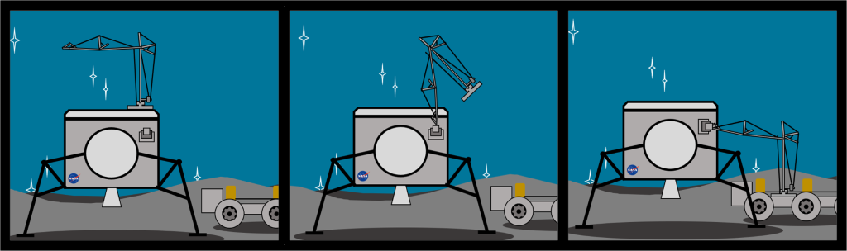Figure 3: High Fidelity Concept # 42: Acrobat

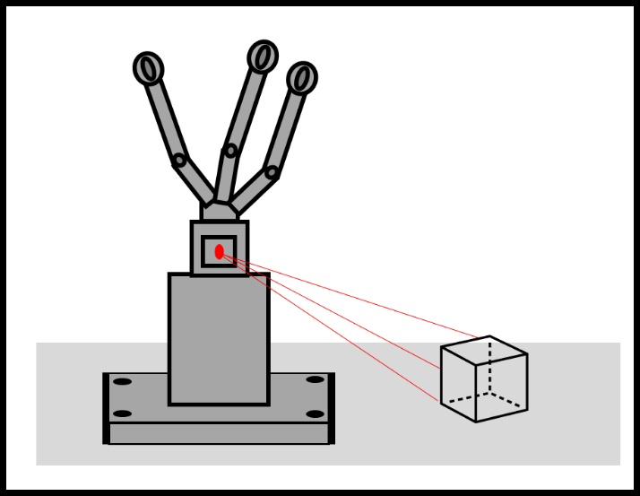
Figure 4: High Fidelity Concept #81 Laser FLEEs

Concept Selection Tables
Table 5: Customer Requirements and Engineering Characteristics
# | Customer Requirements | Engineering Characteristics
1 | The ARROW lifts up to 25 lbs | Relocate LSMS
2 | ARROW is scalable | Move about axe
3 | ARROW mates with LSMS | Convert power to torque
4 | ARROW connects to power | Receive power
5 | The ARROW will arrive at the moon, fully assembled. | LSMS position error
6 | The ARROW will have hard stops for operator on Earth. | Secure LSMS
7 | The ARROW weighs no more than 20lbs. | Clearance After Release LSMS
8 | The simulation will be made in Simulink. | Scale for variable size LSMS
9 | The ARROW’s functions will be fully automated. | Transmit signal
10 | The material selected is suitable for use in space and can withstand environmental factors. | Process signal
11 | The end effector will utilize the standard attachment used by NASA. | Transduce signal
12 | - | Receive signal

Table 6: Binary Pairwise Comparison
Binary Pairwise Comparison
Customer Needs | #1 | #2 | #3 | #4 | #5 | #6 | #7 | #8 | #9 | #10 | #11 | Total 2
#1 | - | 0 | 0 | 0 | 0 | 1 | 0 | 1 | 0 | 1 | 1 | 4
#2 | 1 | - | 1 | 1 | 1 | 1 | 1 | 1 | 0 | 1 | 1 | 9
#3 | 1 | 0 | - | 1 | 1 | 1 | 0 | 1 | 0 | 1 | 1 | 7
#4 | 1 | 0 | 0 | - | 0 | 1 | 0 | 1 | 1 | 1 | 1 | 6
#5 | 1 | 0 | 0 | 1 | - | 0 | 1 | 1 | 0 | 1 | 1 | 6
#6 | 0 | 0 | 0 | 0 | 1 | - | 1 | 1 | 0 | 1 | 1 | 5
#7 | 1 | 0 | 1 | 1 | 0 | 0 | - | 1 | 0 | 1 | 1 | 6
#8 | 0 | 0 | 0 | 0 | 0 | 0 | 0 | - | 0 | 1 | 0 | 1
#9 | 1 | 1 | 1 | 0 | 1 | 1 | 1 | 1 | - | 1 | 1 | 9
#10 | 0 | 0 | 0 | 0 | 0 | 0 | 0 | 0 | 0 | - | 0 | 0
#11 | 0 | 0 | 0 | 0 | 0 | 0 | 0 | 1 | 0 | 1 | - | 2
 | 6 | 1 | 3 | 4 | 4 | 5 | 4 | 9 | 1 | 10 | 8 | n-1 = 10

Table 7: House of Quality
House of Quality | Engineering Characteristics
Improvement Direction |  | ↓ | ↑ |  |  | ↓ |  |  |  |  | ↓
Units |  | m | deg | Nm | Watt | m & deg | N | m | m | Hz | Sec | V | Hz
Customer Requirements | IPF | #1 | #2 | #3 | #4 | #5 | #6 | #7 | #8 | #9 | #10 | #11 | #12
#1 | 4 | 3 | 3 | 9 | 3 |  | 9
#2 | 9 | 9 | 9 | 3 | 1 | 3 | 3 | 3 | 9
#3 | 7 | 9 | 9 |  |  |  | 9 | 9 | 3
#4 | 6 |  |  | 9 | 9 |  |  |  |  | 9 | 1 | 1 | 9
#5 | 5 |  |  |  |  |  |  |  | 9
#6 | 5 |  |  |  | 9 |  |  |  |  | 9 | 3 | 3 | 9
#7 | 6 | 3 | 3 |  |  |  | 3 |  | 3
#8 | 1 |  |  |  |  | 9 |  |  | 9
#9 | 9 |  |  | 3 | 9 |  | 3 | 3 | 3 | 9 | 9 | 9 | 9
#10 | 0 |  |  | 9 |  |  | 9
#11 | 2 | 9 | 9 |  |  | 3 | 3 | 3 | 3
Raw Score | 1842 | 192 | 192 | 144 | 201 | 42 | 177 | 123 | 207 | 180 | 102 | 102 | 180
Relative Weight |  | 10.4 | 10.4 | 7.8 | 10.9 | 2.3 | 9.6 | 6.7 | 11.2 | 9.8 | 5.5 | 5.5 | 9.8
Rank Order |  | 3 | 3 | 6 | 2 | 9 | 5 | 7 | 1 | 4 | 8 | 8 | 4

Table 8: Pugh Chart 1
Pugh Chart: Iteration 1
Function | LSMS | Concept
 |  | #99 | #60 | #75 | #13 | #5 | #42 | #43 | #81
Relocate LSMS | datum | - | - | - | S | - | - | + | S
Move about axes |  | + | - | + | - | - | S | - | -
Convert power to torque |  | S | + | S | + | + | S | S | S
Receive power |  | S | S | S | S | S | S | S | S
LSMS position error |  | - | - | - | - | - | S | + | -
Secure LSMS |  | + | - | + | S | - | S | S | +
Clearance After Release LSMS |  | S | S | + | - | + | + | + | S
Scale for variable size LSMS |  | S | + | S | + | + | + | S | S
Transmit signal |  | - | - | + | - | - | S | - | S
Process signal |  | - | - | + | - | - | S | - | S
Transduce signal |  | - | - | S | - | - | S | - | S
Receive signal |  | - | - | S | - | - | S | - | S
 | Plus (+) | 2 | 2 | 5 | 2 | 3 | 2 | 3 | 1
 | Satisfactory (S) | 4 | 2 | 5 | 3 | 1 | 9 | 4 | 8
 | Minus (-) | 6 | 8 | 2 | 7 | 8 | 3 | 6 | 3

Table 9: Pugh Chart 2
Pugh Chart: Iteration 2
Function | #75 | Concept
 |  | #42 | #43 | #81
Relocate LSMS | datum | + | S | S
Move about axes |  | + | S | S
Convert power to torque |  | + | + | S
Receive power |  | S | S | S
LSMS position error |  | - | + | -
Secure LSMS |  | - | S | S
Clearance After Release LSMS |  | + | S | S
Scale for variable size LSMS |  | + | + | S
Transmit signal |  | S | S | S
Process signal |  | S | S | S
Transduce signal |  | S | S | S
Receive signal |  | S | S | S
 | Plus (+) | 5 | 3 | 0
 | Satisfactory (S) | 6 | 9 | 11
 | Minus (-) | 2 | 0 | 1

Table 10: Pugh Chart 3
Pugh Chart: Iteration 3
Function | #42 (Acrobat) | Concept
 |  | #75 (RFID FLEE) | #43 (Lazy SUSAN)
Relocate LSMS | datum | - | S
Move about axes |  | - | +
Convert power to torque |  | + | +
Receive power |  | S | S
LSMS position error |  | + | +
Secure LSMS |  | + | S
Clearance After Release LSMS |  | - | -
Scale for variable size LSMS |  | - | +
Transmit signal |  | S | S
Process signal |  | S | S
Transduce signal |  | S | S
Receive signal |  | S | S
 | Plus (+) | 3 | 4
 | Satisfactory (S) | 5 | 7
 | Minus (-) | 4 | 1

Table 11: Analytical Hierarchy Process
Analytical Hierarchy Process
Criteria | #1 | #2 | #3 | #4 | #5 | #6 | #7 | #8 | #9 | #10 | #11 | Total | Avg2
#1 | 1.00 | 5.00 | 3.00 | 3.00 | 3.00 | 0.33 | 1.00 | 1.00 | 5.00 | 5.00 | 1.00 | 28.33 | 2.58
#2 | 0.20 | 1.00 | 0.33 | 0.20 | 1.00 | 3.00 | 0.33 | 1.00 | 5.00 | 5.00 | 1.00 | 18.07 | 1.64
#3 | 0.33 | 3.00 | 1.00 | 7.00 | 1.00 | 5.00 | 1.00 | 3.00 | 5.00 | 7.00 | 3.00 | 36.33 | 3.30
#4 | 0.33 | 5.00 | 0.14 | 1.00 | 0.20 | 0.33 | 0.14 | 0.33 | 1.00 | 1.00 | 0.33 | 9.82 | 0.89
#5 | 0.33 | 1.00 | 1.00 | 5.00 | 1.00 | 5.00 | 0.20 | 3.00 | 7.00 | 5.00 | 3.00 | 31.53 | 2.87
#6 | 3.00 | 0.33 | 0.20 | 3.00 | 0.20 | 1.00 | 0.33 | 5.00 | 5.00 | 7.00 | 3.00 | 28.07 | 2.55
#7 | 1.00 | 3.00 | 1.00 | 7.00 | 5.00 | 3.00 | 1.00 | 5.00 | 5.00 | 5.00 | 5.00 | 41.00 | 3.73
#8 | 1.00 | 1.00 | 0.33 | 3.00 | 0.33 | 0.20 | 0.20 | 1.00 | 5.00 | 7.00 | 1.00 | 20.07 | 1.82
#9 | 0.20 | 0.20 | 0.20 | 1.00 | 0.14 | 0.20 | 0.20 | 0.20 | 1.00 | 3.00 | 1.00 | 7.34 | 0.67
#10 | 0.20 | 0.20 | 0.14 | 1.00 | 0.20 | 0.14 | 0.20 | 0.14 | 0.33 | 1.00 | 0.20 | 3.76 | 0.34
#11 | 1.00 | 1.00 | 0.33 | 3.00 | 0.33 | 0.33 | 0.20 | 1.00 | 1.00 | 5.00 | 1.00 | 14.20 | 1.29
Total | 8.60 | 20.73 | 7.69 | 34.20 | 12.41 | 18.54 | 4.81 | 20.68 | 40.33 | 51.00 | 19.53
Average 1 | 0.78 | 1.88 | 0.70 | 3.11 | 1.13 | 1.69 | 0.44 | 1.88 | 3.67 | 4.64 | 1.78

Table 12: Normalized Comparison Matrix
Criteria | 1 | 2 | 3 | 4 | 5 | 6 | 7 | 8 | 9 | 10 | 11 | Crit Weight
1 | 0.12 | 0.24 | 0.39 | 0.09 | 0.24 | 0.02 | 0.21 | 0.05 | 0.12 | 0.10 | 0.05 | 0.15
2 | 0.02 | 0.05 | 0.04 | 0.01 | 0.08 | 0.16 | 0.07 | 0.05 | 0.12 | 0.10 | 0.05 | 0.07
3 | 0.04 | 0.14 | 0.13 | 0.20 | 0.08 | 0.27 | 0.21 | 0.15 | 0.12 | 0.14 | 0.15 | 0.15
4 | 0.04 | 0.24 | 0.02 | 0.03 | 0.02 | 0.02 | 0.03 | 0.02 | 0.02 | 0.02 | 0.02 | 0.04
5 | 0.04 | 0.05 | 0.13 | 0.15 | 0.08 | 0.27 | 0.04 | 0.15 | 0.17 | 0.10 | 0.15 | 0.12
6 | 0.35 | 0.02 | 0.03 | 0.09 | 0.02 | 0.05 | 0.07 | 0.24 | 0.12 | 0.14 | 0.15 | 0.12
7 | 0.12 | 0.14 | 0.13 | 0.20 | 0.40 | 0.16 | 0.21 | 0.24 | 0.12 | 0.10 | 0.26 | 0.19
8 | 0.12 | 0.05 | 0.04 | 0.09 | 0.03 | 0.01 | 0.04 | 0.05 | 0.12 | 0.14 | 0.05 | 0.07
9 | 0.02 | 0.01 | 0.03 | 0.03 | 0.01 | 0.01 | 0.04 | 0.01 | 0.02 | 0.06 | 0.05 | 0.03
10 | 0.02 | 0.01 | 0.02 | 0.03 | 0.02 | 0.01 | 0.04 | 0.01 | 0.01 | 0.02 | 0.01 | 0.02
11 | 0.12 | 0.05 | 0.04 | 0.09 | 0.03 | 0.02 | 0.04 | 0.05 | 0.02 | 0.10 | 0.05 | 0.05
Sum | 1.00 | 1.00 | 1.00 | 1.00 | 1.00 | 1.00 | 1.00 | 1.00 | 1.00 | 1.00 | 1.00 | 1.00

Table 13: Consistency Check
Ws | Cons V
2.00 | 13.53
1.03 | 15.04
2.21 | 14.88
0.63 | 14.79
1.86 | 15.43
1.58 | 13.66
2.77 | 14.60
0.87 | 13.06
0.34 | 12.66
0.23 | 13.39
0.75 | 13.58

Table 14: Consistent Comparison
Avg Consist | Con. Index | Con. Ratio
14.06 | 0.31 | 0.20

Table 15: Power to Torque Consistency Check
Power to Torque Consistency Check
Concept | 42 | 75 | 43
42 | 1.00 | 0.33 | 0.33
75 | 3.00 | 1.00 | 1.00 |  | n | 3
43 | 3.00 | 1.00 | 1.00 |  | RI | 0.52
Sum | 7.00 | 2.33 | 2.33
Concept | 42 | 75 | 43 | Crit Weight | ws | V
42 | 0.14 | 0.14 | 0.14 | 0.14 | 0.43 | 3 | Lamda | 3.00
75 | 0.43 | 0.43 | 0.43 | 0.43 | 1.29 | 3 | Con. Index | 0.00
43 | 0.43 | 0.43 | 0.43 | 0.43 | 1.29 | 3 | Con. Ratio | 0.00
Sum | 1.00 | 1.00 | 1.00

Table 16: Criteria Consistency Ratio Tables
Criteria | Consistency Ratio
Relocate LSMS | 0.29
Move about axes | 0.29
Convert power to torque | 0.00
Receive power*
Secure LSMS | 0.29
Clearance After Release LSMS | 0.01
Scale for variable size LSMS | 0.23
Transmit signal*
Process signal*
Transduce signal*
Receive signal*

Table 17: Final Rating Matrix
Final Rating Matrix
Criteria | Concept
 | #42 (Acrobat) | #75 (RFID FLEE) | #43 (Lazy SUSAN)
Relocate LSMS | 0.33 | 0.12 | 0.55
Move about axes | 0.33 | 0.52 | 0.12
Convert power to torque | 0.14 | 0.43 | 0.43
Receive power* | 0.33 | 0.33 | 0.33
Secure LSMS | 0.12 | 0.55 | 0.33
Clearance After Release LSMS | 0.75 | 0.12 | 0.13
Scale for variable size LSMS | 0.59 | 0.08 | 0.33
Transmit signal* | 0.33 | 0.33 | 0.33
Process signal* | 0.33 | 0.33 | 0.33
Transduce signal* | 0.33 | 0.33 | 0.33
Receive signal* | 0.33 | 0.33 | 0.33

Table 18: Alternate Value Rating
 | Concept
Weights | #42 (Acrobat) | #75 (RFID FLEE) | #43 (Lazy SUSAN)
10.42 | 3.4386 | 1.2504 | 5.731
10.42 | 3.4386 | 5.4184 | 1.2504
7.82 | 1.0948 | 3.3626 | 3.3626
10.91 | 3.6003 | 3.6003 | 3.6003
9.61 | 1.1532 | 5.2855 | 3.1713
6.68 | 5.01 | 0.8016 | 0.8684
11.24 | 6.6316 | 0.8992 | 3.7092
9.77 | 3.2241 | 3.2241 | 3.2241
5.54 | 1.8282 | 1.8282 | 1.8282
5.54 | 1.8282 | 1.8282 | 1.8282
9.77 | 3.2241 | 3.2241 | 3.2241
Alt. Value | 34.4717 | 30.7226 | 31.7978

Appendix E: Operations Manual

Team 517 Operation Manual
Alanna Black, Jayson Dickinson, Christina Morrow, Ryker Mullinix FAMU-FSU College of Engineering

Overview
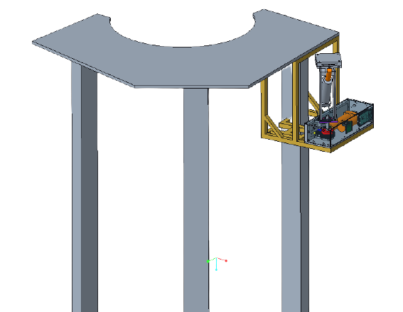
Figure 1: ARROW Orientation

Acronyms
ARROW – Automated and Ranged Relocation of the LSMS for Wider application
CAD – Computer Aided Design
CLPS – Commercial Landing Payload Services
DC – Direct Current
EVA - Extra-Vehicular Activity
LSMS – Lightweight Surface Manipulation System
LED – Light Emitting Diode
NASA - National Aeronautics and Space Administration
RGB – Red Green Blue

Project Description
NASA, partnered with CLPS, has developed an autonomous means of payload transportation to operate on the lunar surface, called the LSMS. This project is concerned with offloading the LSMS from the CLPS lander, so that it may be used for a wider range of tasks. This is necessary for establishing a lunar presence and building the foundation for future missions to Mars. NASA wants to create a means of building a base at one of the poles on the Moon and develop a method of rapid assembly of the base. In order to do this, the LSMS must be relocated onto a mobile platform. This will be done with a design called the ARROW.

Project Objective
The objective of this project is to offload the LSMS from the CLPS lander onto a platform on the lunar surface.

Key Goals
A key goal is to design the ARROW to be capable of off-loading the LSMS. Making this a key goal is a direct result of the customer statement regarding the project requirements.
Another key goal of this project is to design the ARROW to be scalable for any size
LSMS. In the virtual simulation there should be a 1:1 lifting capability to weight ratio for the ARROW relative to each LSMS size. There should be the ability to create ARROWs of various sizes so that money can be saved in the creation of smaller models and a prototype can be delivered to the customer that works exactly as the final product would work. This allows for potential issues to be addressed prior to the creation of the final product assembly.
The final key goal is for the ARROW to be completely autonomous with human control being activated fail-safes. The machine or mechanism would operate without any human intervention needed. Keeping the ARROW completely autonomous also means it must be able to communicate with other devices on the lander if the design is not completely mechanical.

Assumptions
Some assumptions were made to narrow the scope of the teams’ efforts. It is assumed that the team is not responsible for transportation of the ARROW to the lunar surface and operation of the ARROW will take place on the moon. It is also assumed that the ARROW will be stationary, with access to power from the CLPS lander. Another assumption is that reusability of the ARROW is not a concern. Additionally, it is assumed that the LSMS will send a ready signal to the ARROW and the duties of the ARROW will occur as part of the automated landing sequence. It is also assumed that an existing end effector will be utilized, to increase time spent on other design aspects. The LSMS and ARROW locations on the lander are at the discretion of the design team and the LSMS can dock to the lunar platform. Environmental factors such as regolith and temperature changes are also assumed to not be a concern for this project design. It was also assumed that in-space and in-space EVA assembly will not be required. For the demonstration it was also assumed that the weight of the miniature LSMS is 25% of its lifting capability at the wrist.

Component/Module description

Cad Overview
This section includes CAD information of the ARROW and the demonstration components. The following CAD models are of the fully assembled design of the ARROW.
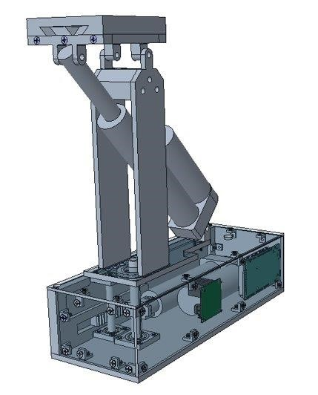
Figure 2: Front View of the ARROW

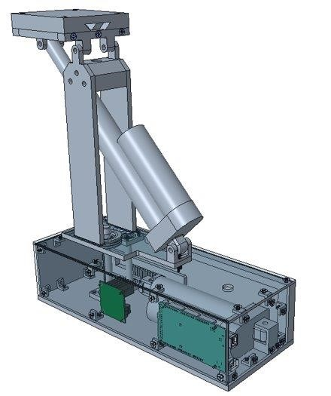
Figure 3: Rear View of the ARROW The model below is the full exploded view of the ARROW.

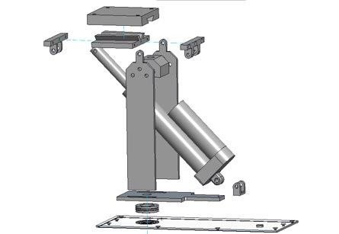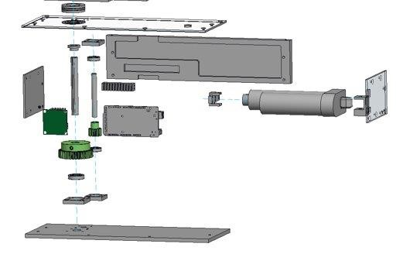

Figure 4: Exploded View of the Full Assembly
The following CAD shows the assembled model of the planar rotation system of the offloader.
This includes one of the linear actuators, the rack and pinion, the gear, and the thrust bearing.
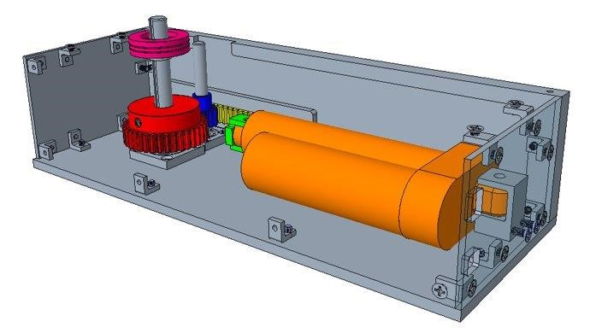
Figure 5: Lower Module Detail View
The zoomed in top-view of the rack and pinion assembly is shown below.
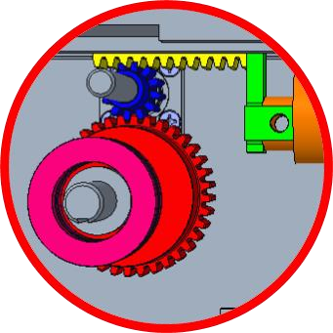
Figure 6: Top View of the Rack and Pinion Assembly Drawings of this CAD model are shown in Appendix A.

Modules
The following modules include parts of the ARROW that are utilized in the demonstration of the offloading system. The electrical module includes the wiring information, electrical components used, and a connection diagram. The vertical rotation module includes the rack and pinion system, gearing, and one of the linear actuators. The horizontal rotation module includes information about the other linear actuator and the connector plate. The demonstration module disseminates information regarding the components that are separate from the ARROW but are necessary to the demonstration of the final product.

Electrical Module
The electrical module consists of the following parts: two RGB LEDs, one dual H-bridge DC motor driver, one Arduino MEGA 2560 microcontroller, and one 9V DC power supply. A wiring diagram containing these components is shown next.
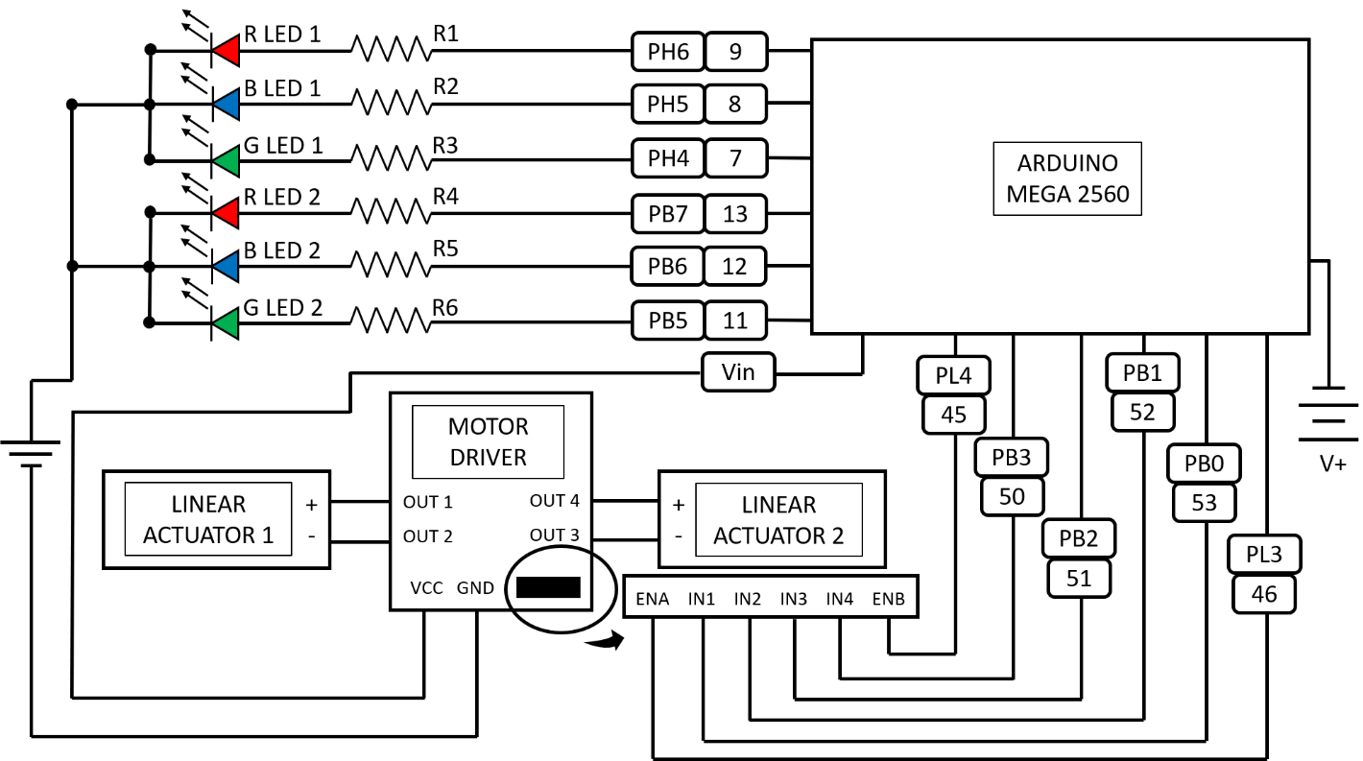
Figure 7: Wiring Diagram
This wiring diagram shows how the various component connect. In the diagram V+ is used to represent the 9V DC power supply plugged into an electrical outlet.

Vertical Rotation Module
This module controls rotation about the vertical axis using a linear actuator in conjunction with a rack and pinion gear system. The rack and pinion system is used to convert the linear motion of the actuator to rotational motion. The gears also allow for the force transmitted by the linear actuator to be increased threefold. The additional gearing is required for the system to output the required torque. This system is used to rotate the turntable mount plate. The motion of this module allows the LSMS to be rotated the required 90 degrees.

Horizontal Rotation module
This module controls rotation about the horizontal axis using a linear actuator in conjunction with the LSMS connector plate. The horizontal rotation module is mounted on top of the turntable mount plate, tower side plates are used to secure the system to this plate. The linear actuator for this system is at angle to allow the system to rotate down 44 degrees while still minimizing the device height.

Demonstration Module
This module contains components that are used to demonstrate the ARROWs functionality. LSMS model
The LSMS model consists of three sections: the kingpost, shoulder, and forearm. The model simulates the weight distribution of the miniature LSMS on the moon. The next figure depicts the crane model.
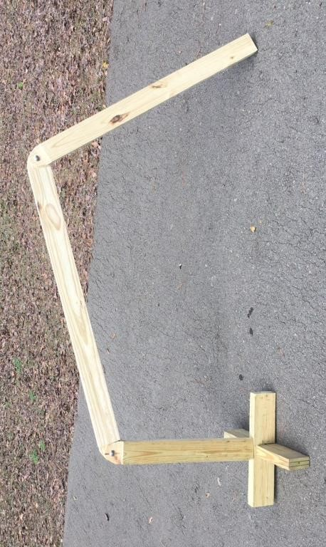
Figure 8: LSMS model

Payload Deck model
The payload deck model is used to simulate the height and shape of the payload landing deck on the peregrine lander. The model of the payload deck is shown next.
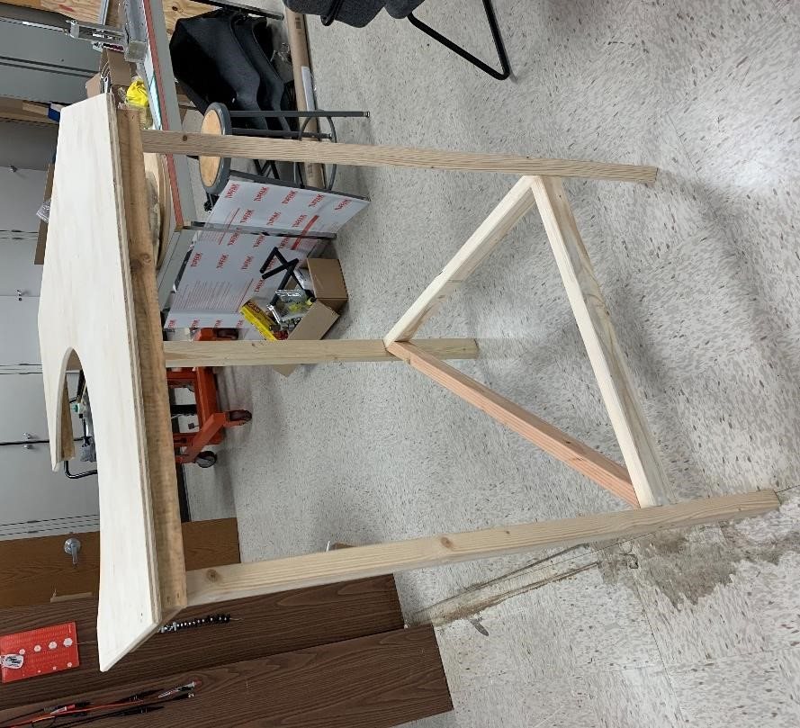
Figure 9: Peregrine Payload Deck Model

Cradle
The cradle is a bracket used in the demonstration to mount the ARROW to the payload deck model. It is necessary for simulating a properly mounted ARROW that is ready for use. The cradle is composed of T-slot aluminum profiles. See next figure.
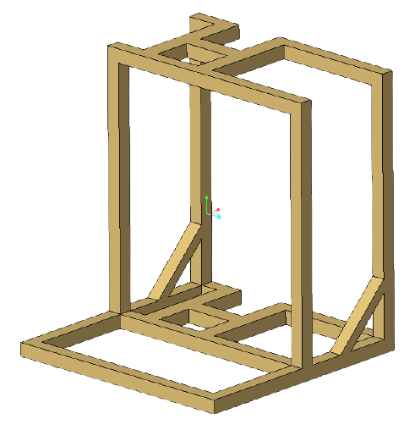
Figure 10: Cradle Design

Automation Code
The following information describes the code that is used to automate the LSMS offloading system. This code can be seen in appendix B.

State Diagram
Shown next is the state diagram of the ARROW automation code, which details each state or stage of the automation process. The ARROW starts in the off and idle state 0. When the LSMS is connected to power via the wrist, this triggers the transition to state 1 where the LSMS is powered and sending the “ready” signal to the ARROW. Once the ARROW receives the ready signal, this triggers the transition to state 2, where the first linear actuator will be activated, and the ARROW will spin the LSMS 90 degrees about the vertical axis. Spinning the LSMS has been defined as Stage 1. Once Stage 1 is complete, this triggers the system to move to state 3, which houses Stage 2: lowering the LSMS. The second linear actuator is activated, pivoting the connector plate 44 degrees towards the ground. Once Stage 2 is complete, the ARROW will revert to the off and idle state 0. At any given point, if the power connection between the LSMS and the ARROW is severed, the ARROW will revert to the off and idle state 0.
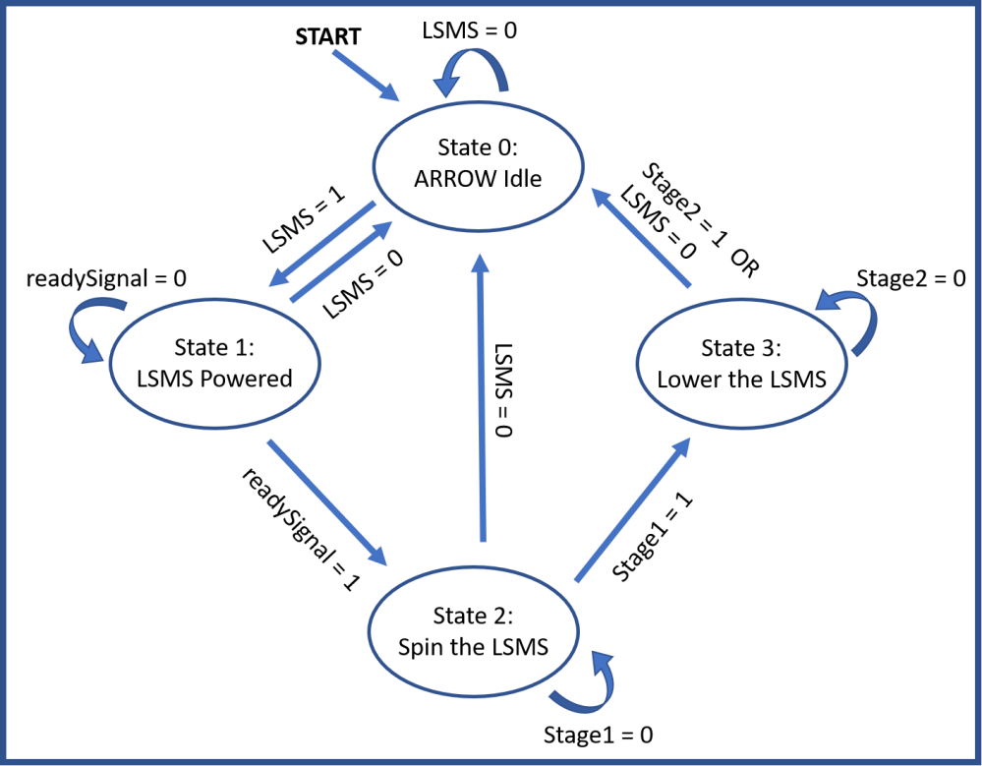
Figure 11: State Diagram

Integration

Assembly
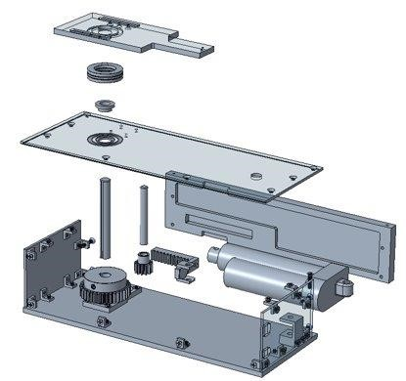
Figure 12: Lower Module Assembly
For assembling the lower module of the ARROW, 8-32 screws will be used for every bracket. This includes the 16 L-brackets, attaching the lid to the side walls, the bearing brackets to the bottom plate and the lid, and the mounting bracket for the bottom linear actuator.
Affixing the Arduino and motor driver to the front panel will use 8 4-40 screws and 2 more will be used to attach the rack connector plate to the rack itself.
To attach the upper linear actuator mount to the turntable plate as well as the tower to the plate, 8 6-32 screws are utilized.
The 6 screws used to bolt the tower together are size ¼-20.
The torque specs for each screw are in Table 1, shown below. Each screw should have a dab of Loc-Tite applied to in to ensure the screws do not back-out during transport or use. Table 1: Torque Specs
Screw | Max Tightening Torque [ft-lbs]
4-40 | 2.9
6-32 | 5.3
8-32 | 10.8
¼-20 | 45.6

Operation
The cradle will be attached to the corner of the payload deck on the side that is 28 inches or 0.71 meters. It will be at the far edge of it so that the ARROW can be 0.95 meters from the LSMS when the crane is attached. The ARROW will have the front panel with the Arduino away from the payload deck as this allows the proper rotation direction. The port for feeding power from the lander to the ARROW will be free to have a cable run along the cradle into the ARROW. The top of the connection plate, once the ARROW is attached to the cradle, should be near the corner of the deck and they should be level with each other. See Figure 1 for what the final result should look like.
When the lander has touched down on the lunar surface, the LSMS will offload the payloads. Once this process is complete, the LSMS will attach to the connection plate of the ARROW. The dovetail connection will support the crane as it is rotated 90 degrees off the lander and then lowered to the Chariot mobility chassis.

Troubleshooting
If there are issues running the full offloading operation, there are a few aspects to check for that may be causing the problem. First, it would be a good idea to check the wiring connections between the Arduino, the linear actuators, the motor driver, and the power supply. You can double check that the wiring is properly arranged by referring to the wiring diagram shown in the Component/Module section. Another troubleshooting problem may involve automation errors, which you can check to see by debugging the code or redownloading the code found in the Component/Module section. When using the ARROW for the first time, select “no” when prompted to reset the arrow. This will allow for verification that the ARROW has been set up properly and there are no snags in the wiring, stuck bearings, loose screws, etc. Another possible issue would be any obstructions in the way of the linear actuators being able to rotate and offload the LSMS, in which the surrounding area of the demonstration should be cleared.

Appendix F: Engineering Drawings
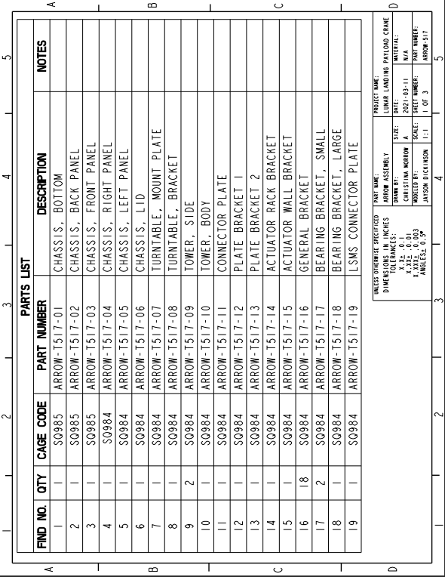
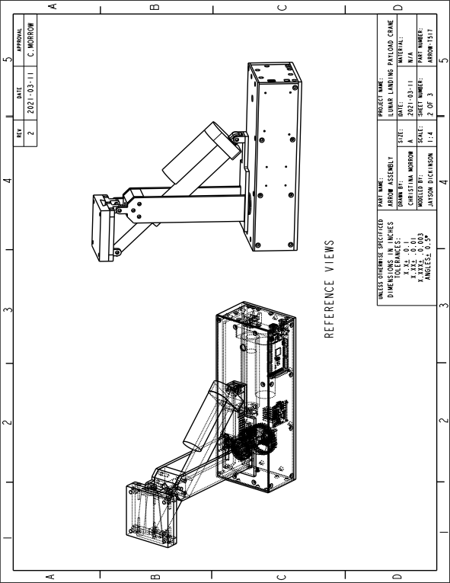
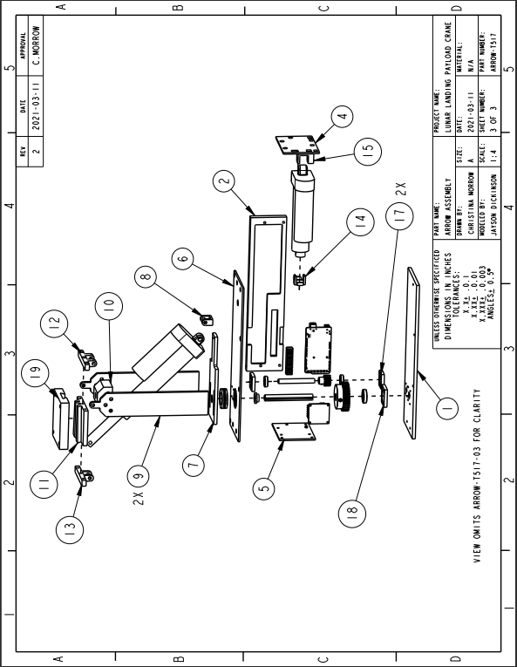
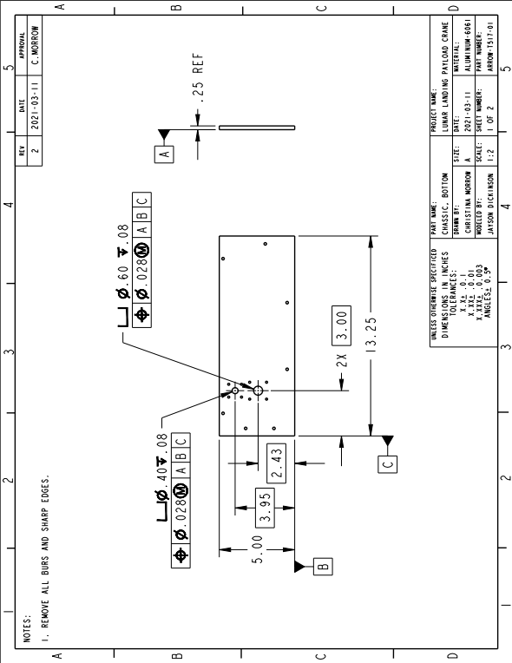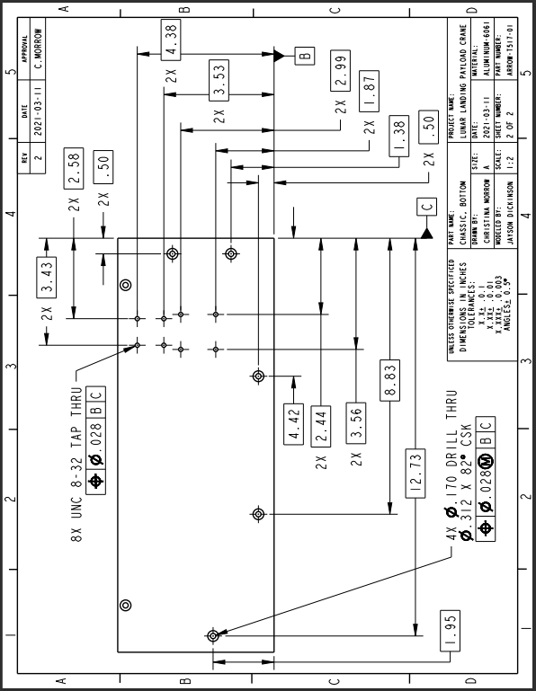
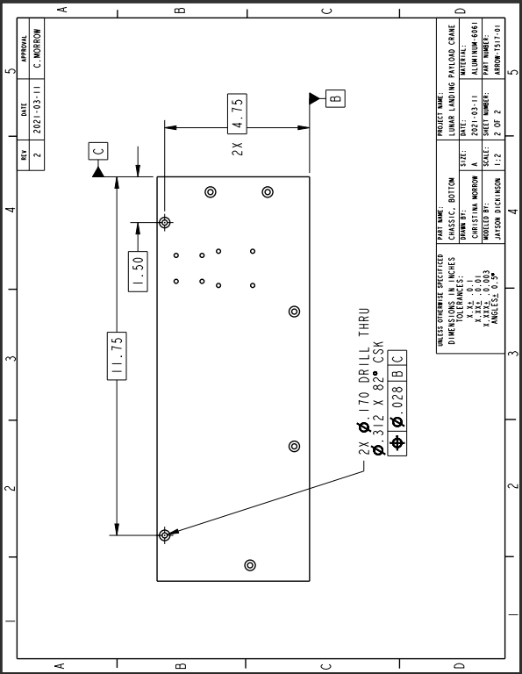
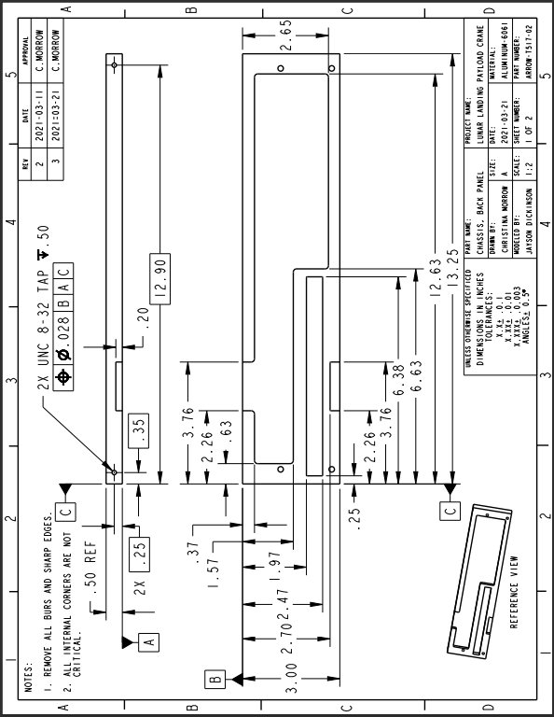
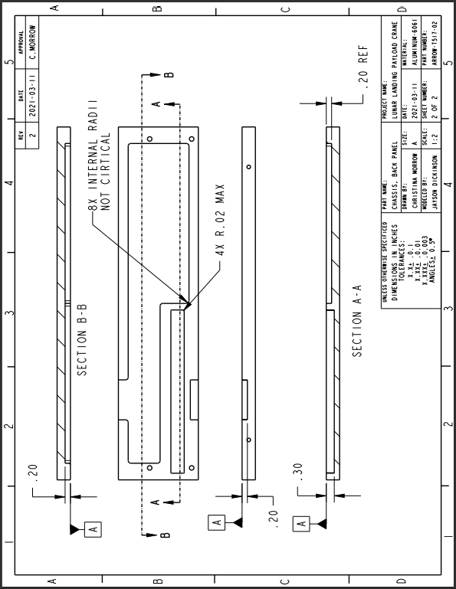
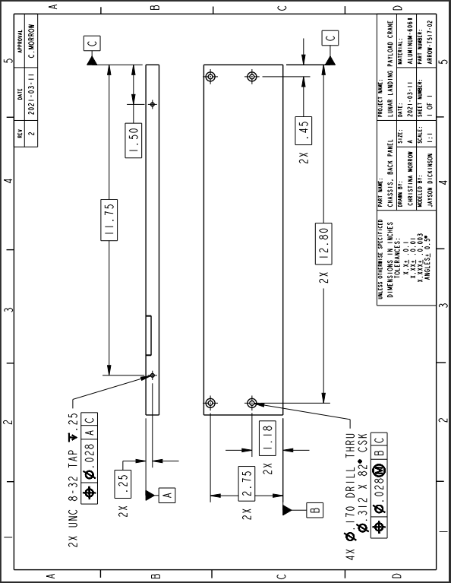
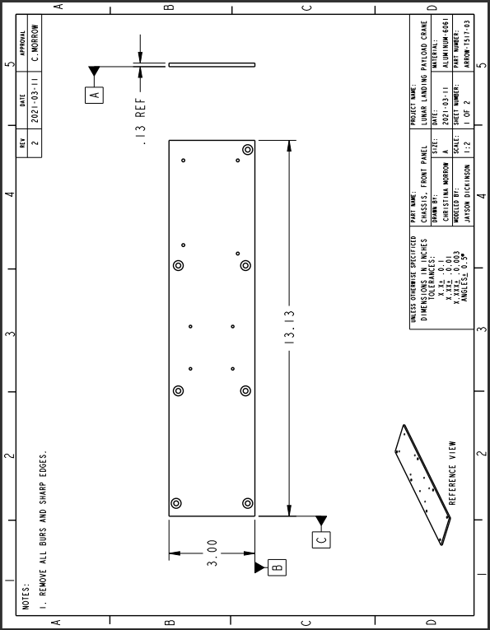
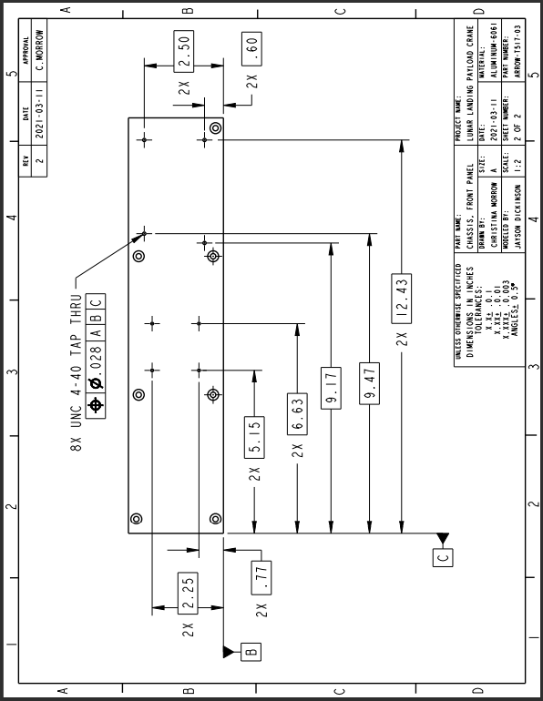
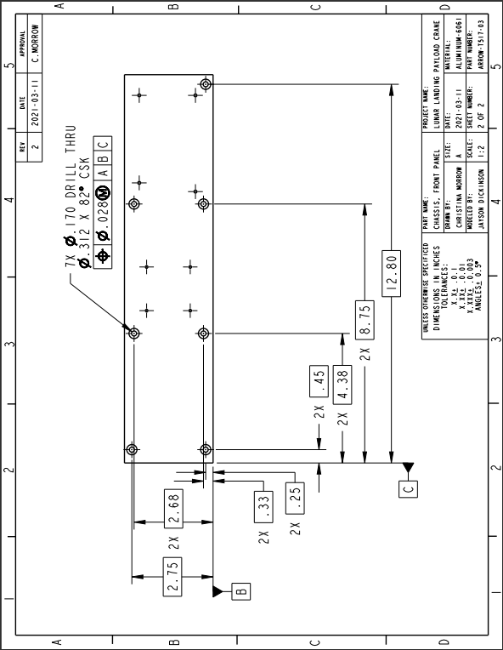
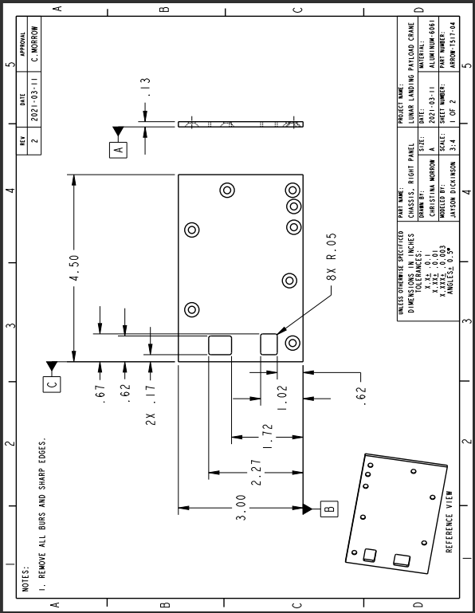
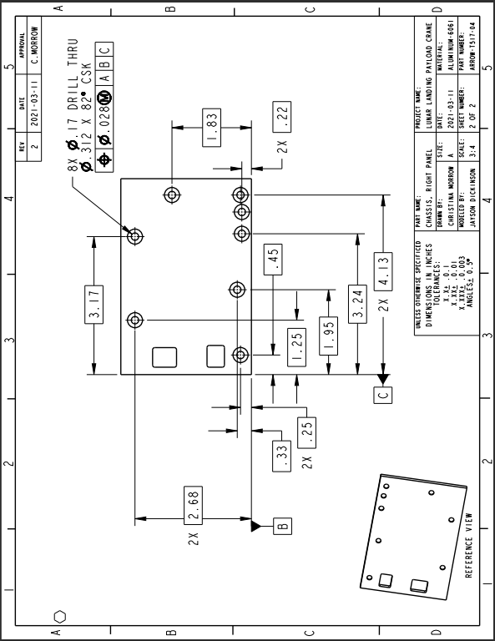
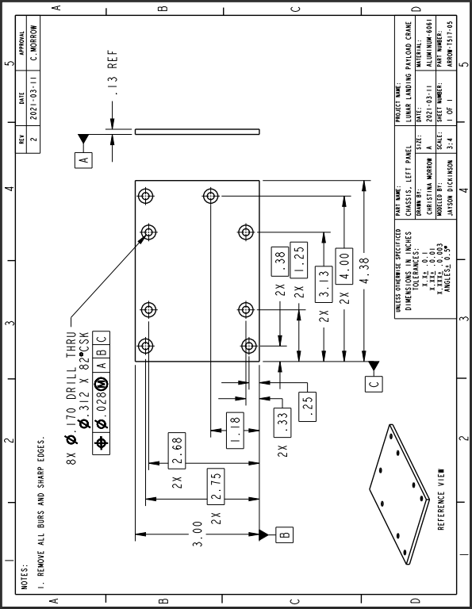
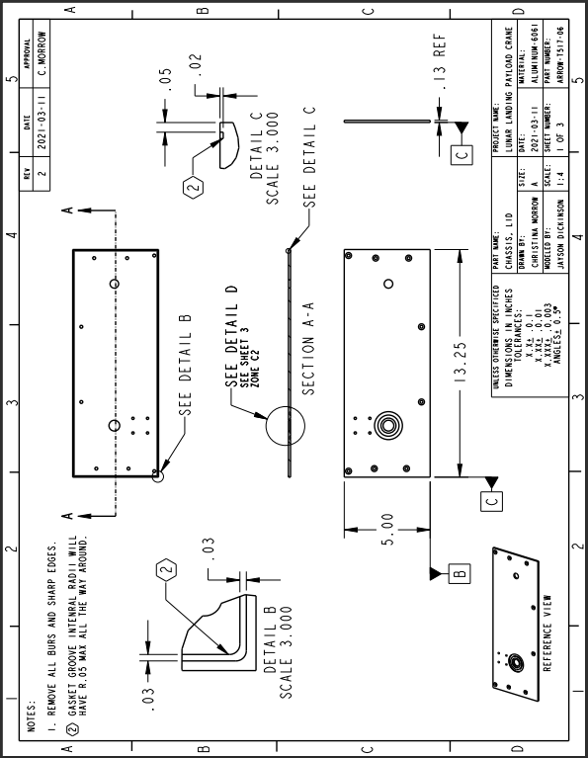
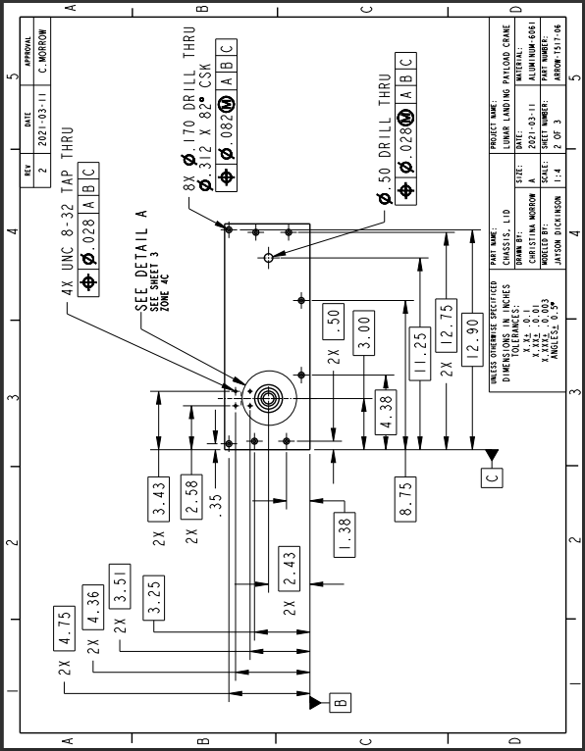
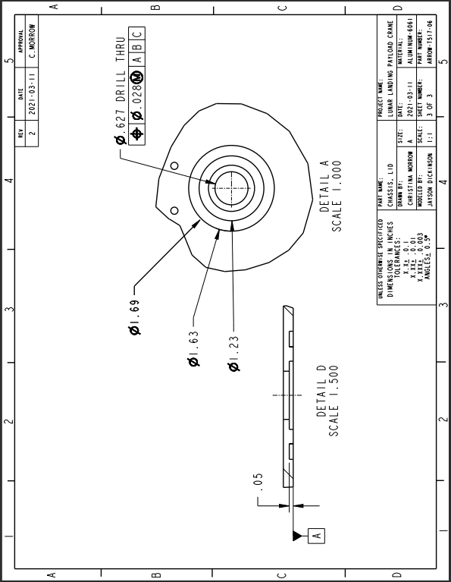
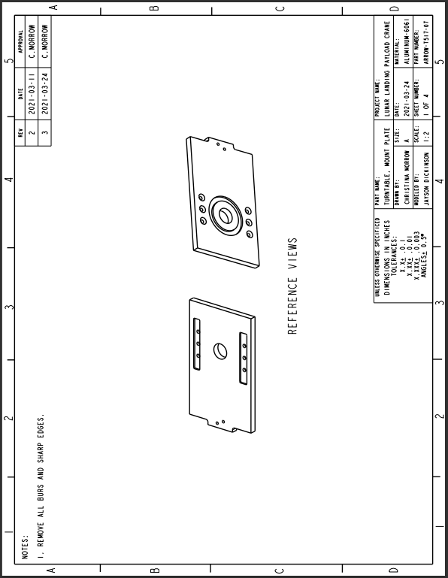
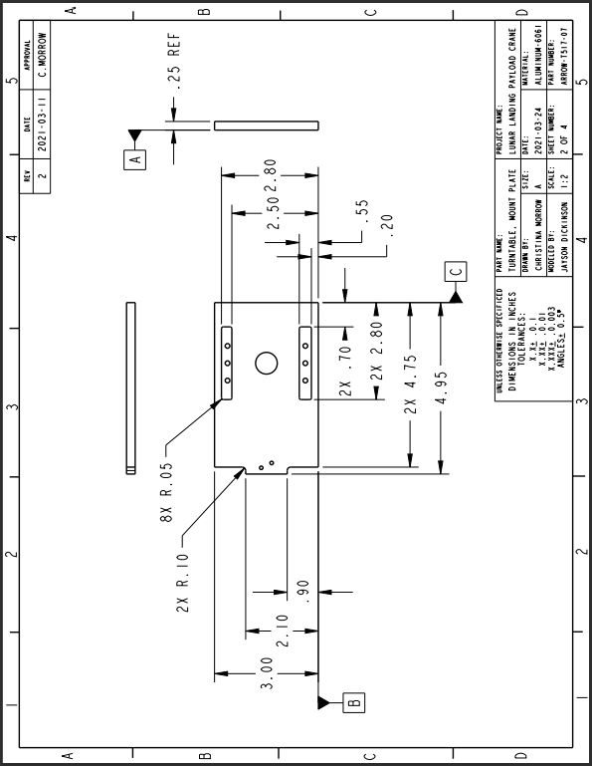
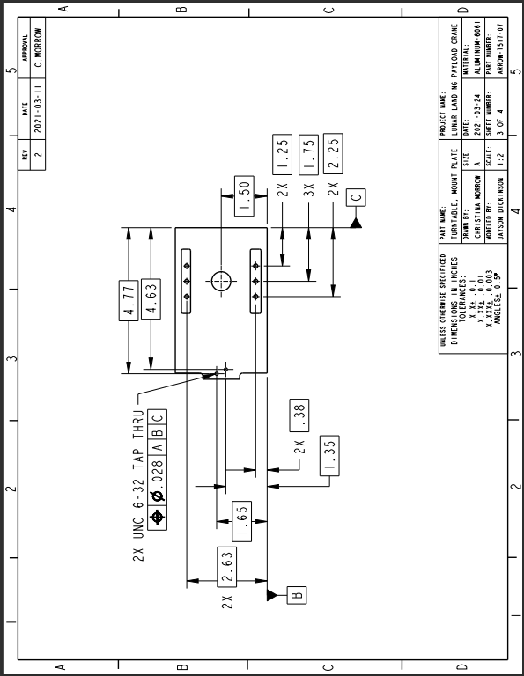
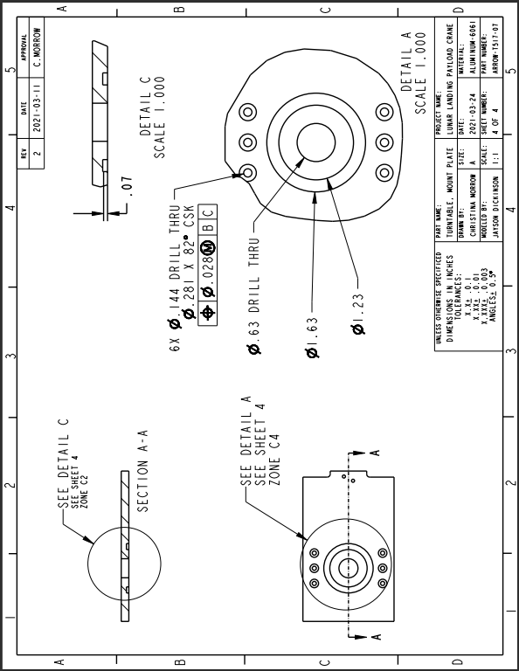
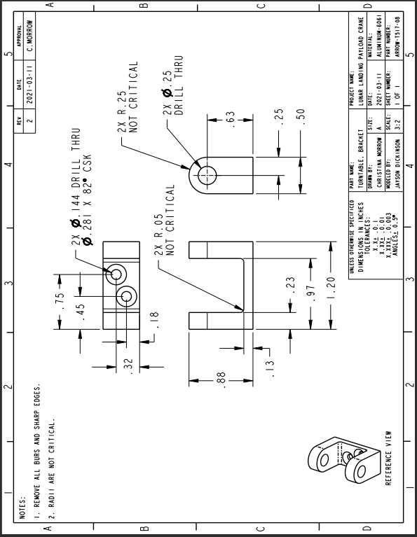
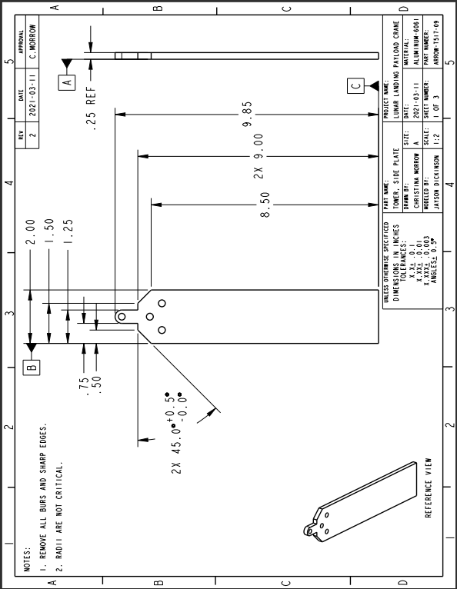
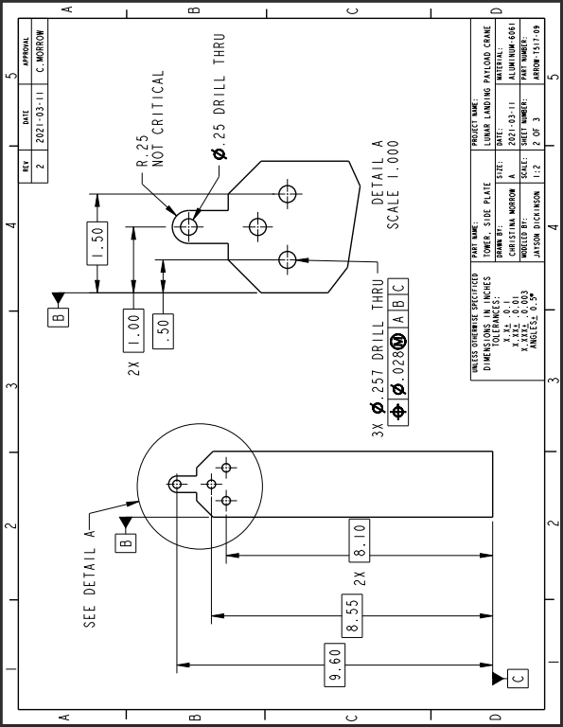
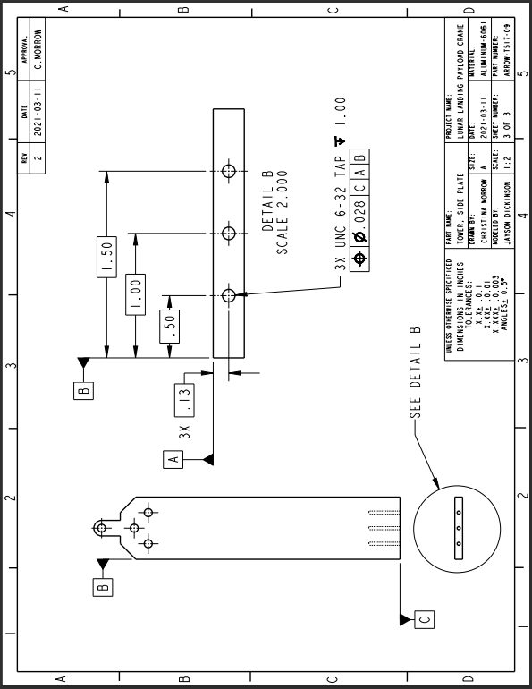
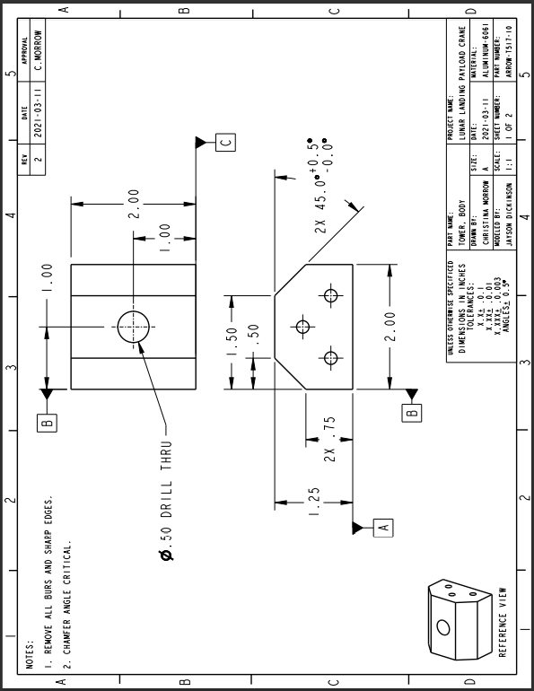
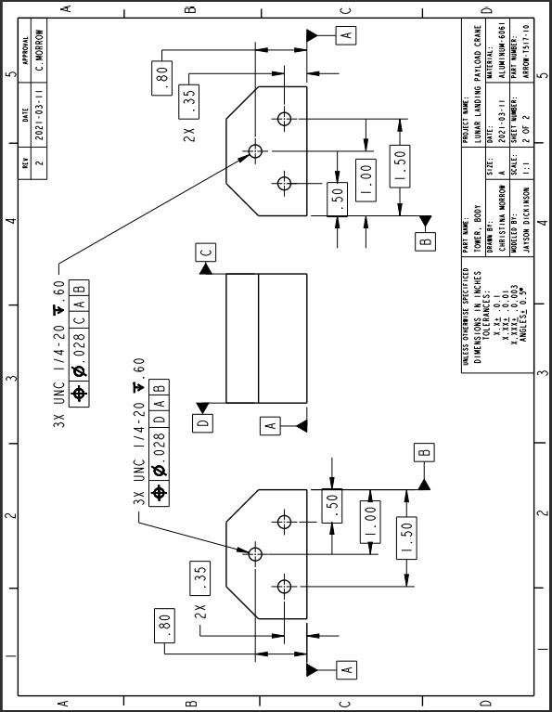
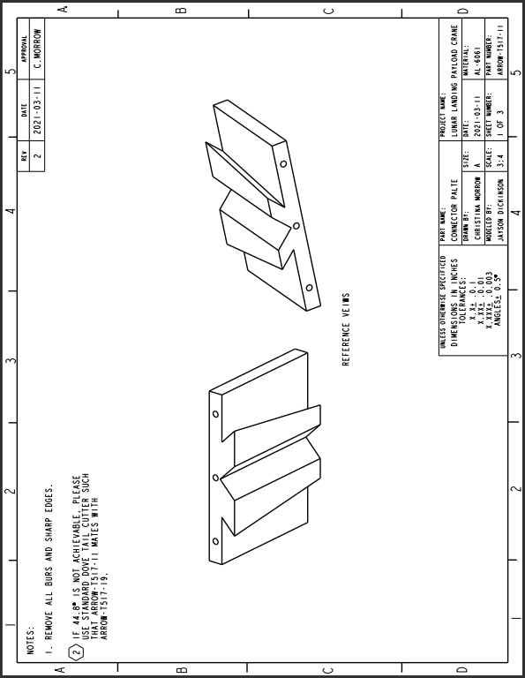
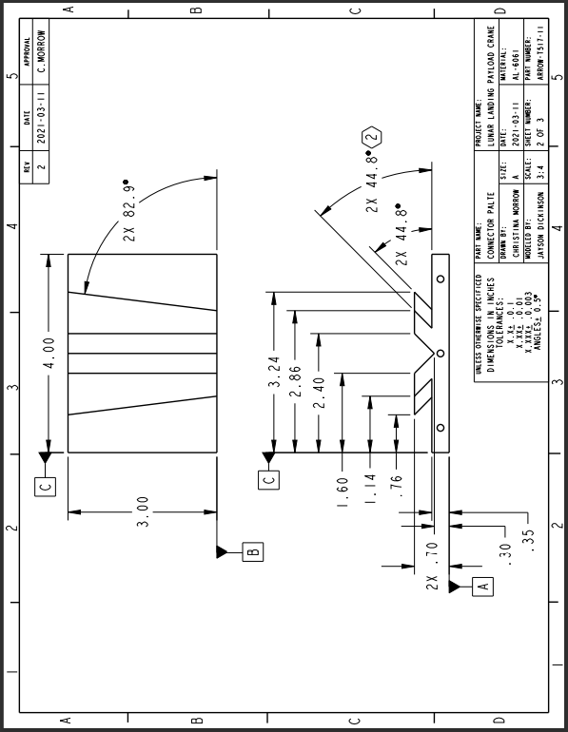
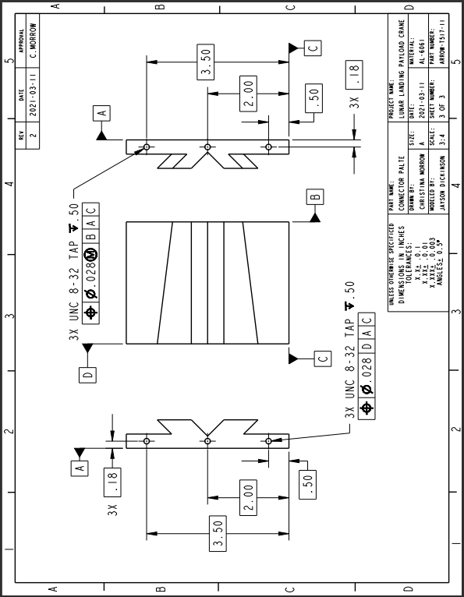
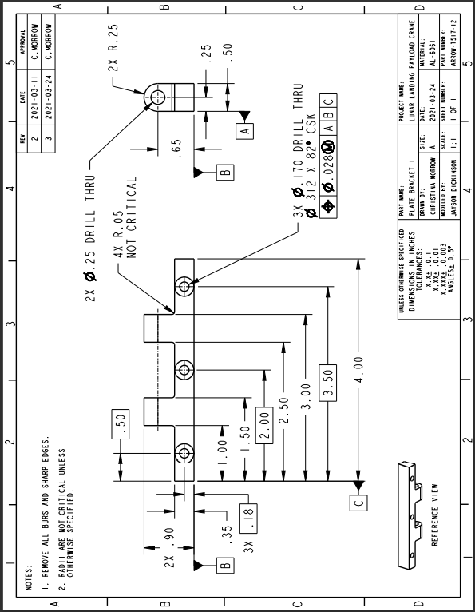
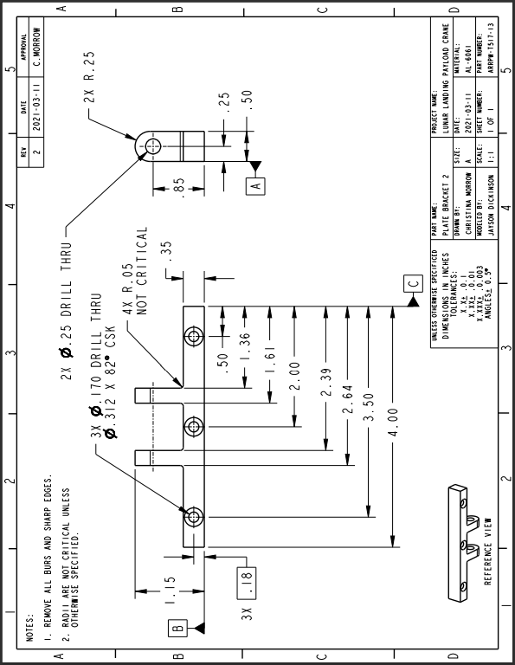
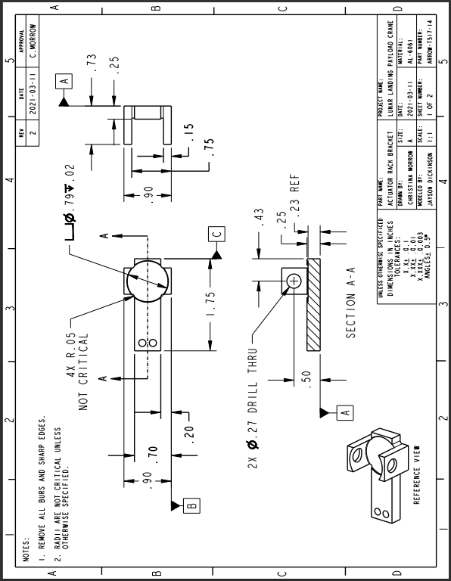
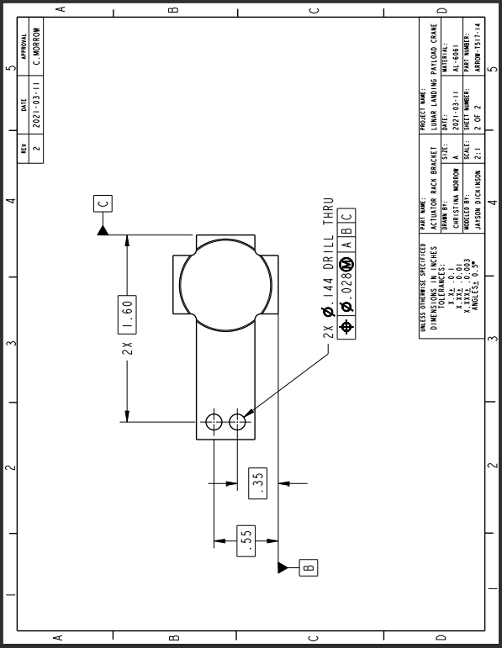
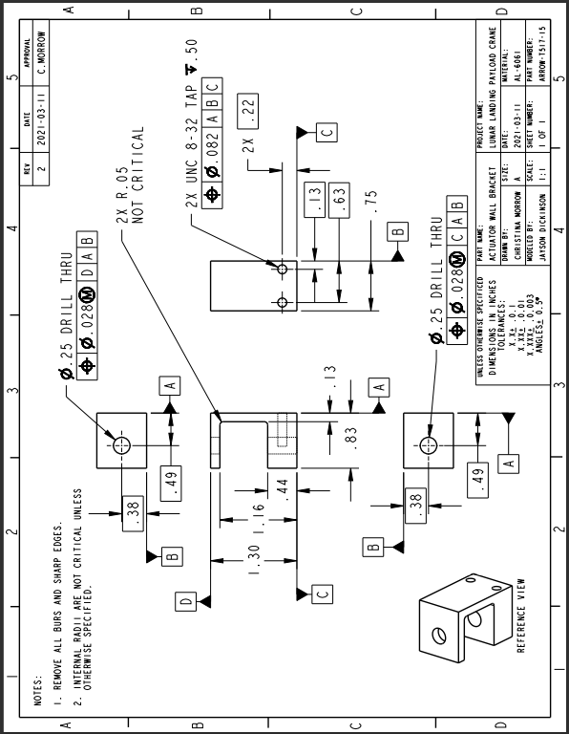
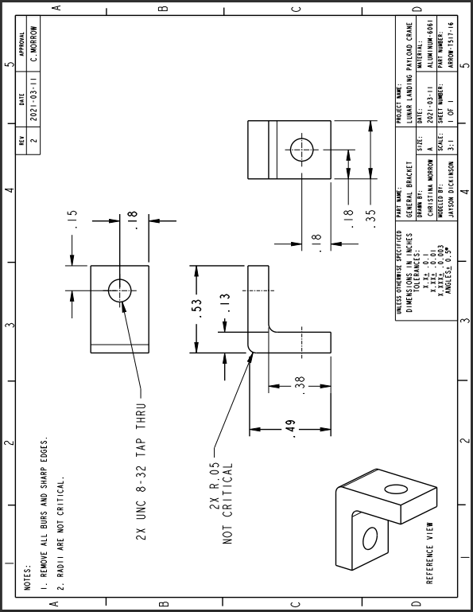
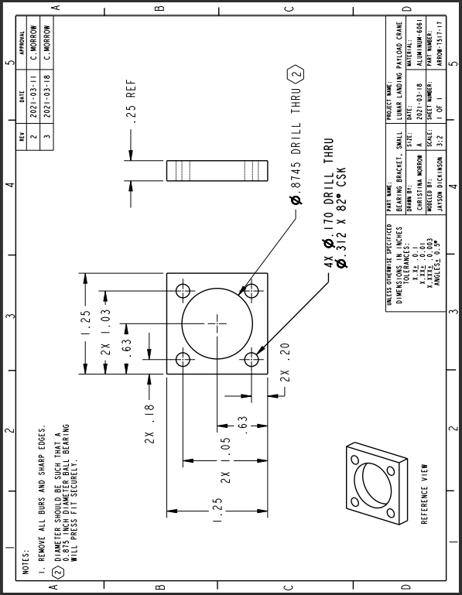
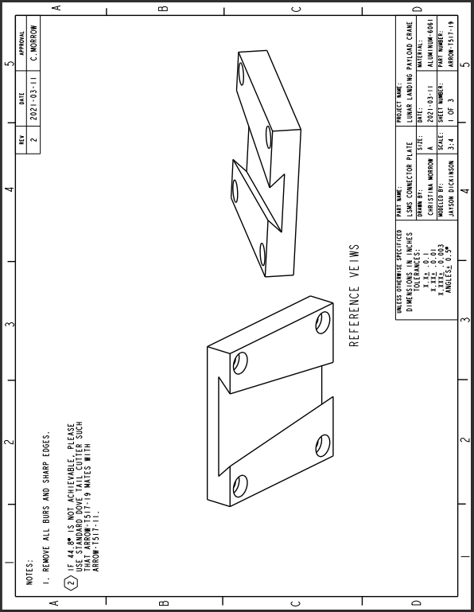
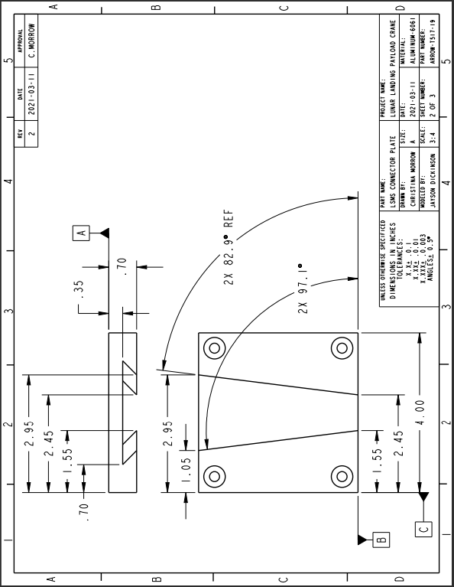
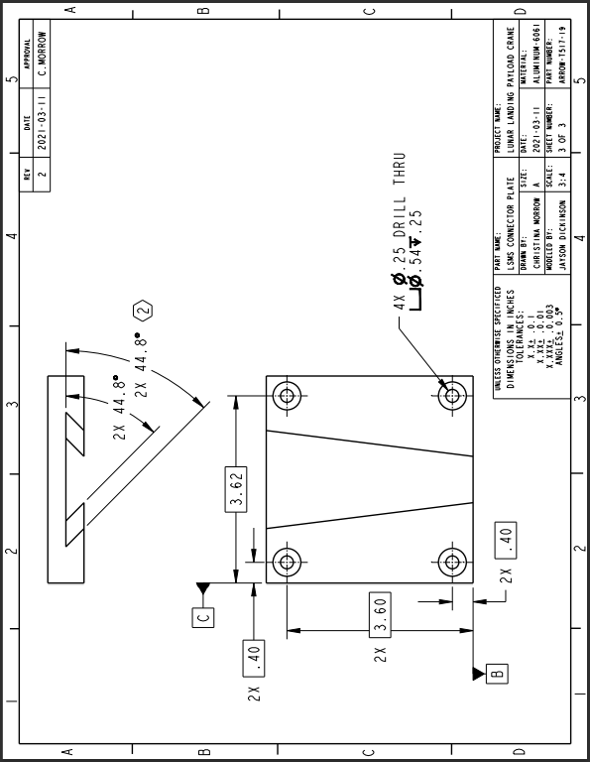
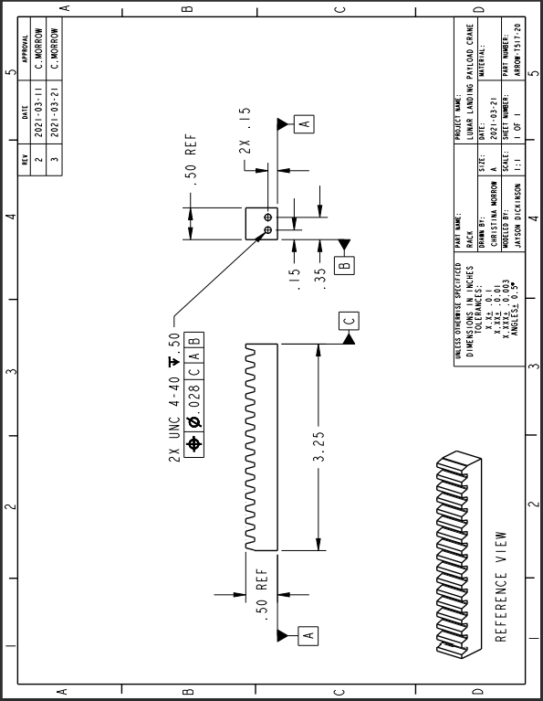

Appendix G: Calculations
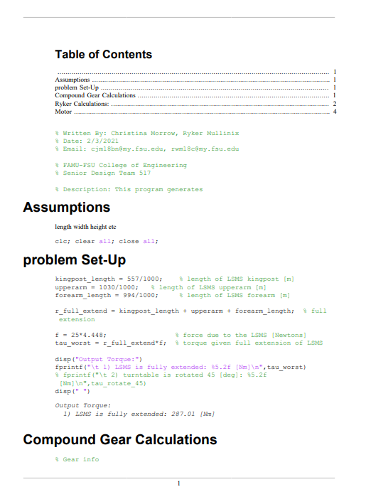
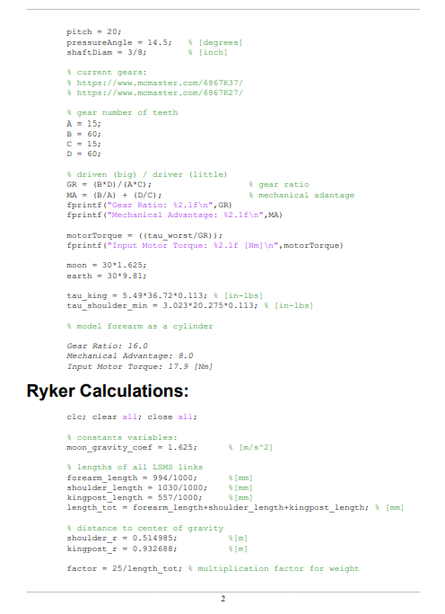
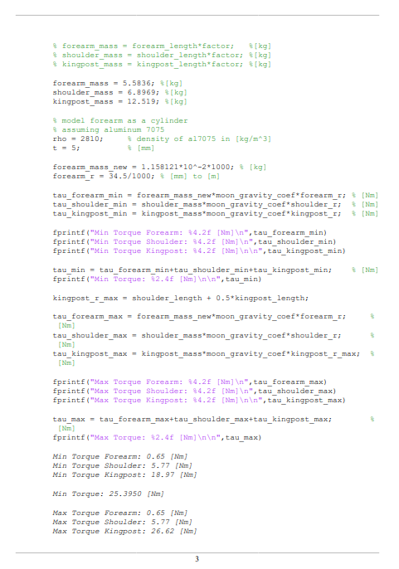

Appendix H: Risk Assessment
FAMU-FSU College of Engineering
Project Hazard Assessment Policy and Procedures
INTRODUCTION
University laboratories are not without safety hazards. Those circumstances or conditions that might go wrong must be predicted and reasonable control methods must be determined to prevent incident and injury. The FAMU-FSU College of Engineering is committed to achieving and maintaining safety in all levels of work activities.

PROJECT HAZARD ASSESSMENT POLICY
Principal investigator (PI)/instructor are responsible and accountable for safety in the research and teaching laboratory. Prior to starting an experiment, laboratory workers must conduct a project hazard assessment (PHA) to identify health, environmental and property hazards and the proper control methods to eliminate, reduce or control those hazards. PI/instructor must review, approve, and sign the written PHA and provide the identified hazard control measures. PI/instructor continually monitor projects to ensure proper controls and safety measures are available, implemented, and followed. PI/instructor are required to reevaluate a project anytime there is a change in scope or scale of a project and at least annually after the initial review.

PROJECT HAZARD ASSESSMENT PROCEDURES
It is FAMU-FSU College of Engineering policy to implement followings:
- Laboratory workers (i.e. graduate students, undergraduate students, postdoctoral, volunteers, etc.) performing a research in FAMU-FSU College of Engineering are required to conduct PHA prior to commencement of an experiment or any project change in order to identify existing or potential hazards and to determine proper measures to control those hazards.
- PI/instructor must review, approve and sign the written PHA.
- PI/instructor must ensure all the control methods identified in PHA are available and implemented in the laboratory.
- In the event laboratory personnel are not following the safety precautions, PI/instructor must take firm actions (e.g. stop the work, set a meeting to discuss potential hazards and consequences, ask personnel to review the safety rules, etc.) to clarify the safety expectations.
- PI/instructor must document all the incidents/accidents happened in the laboratory along with the PHA document to ensure that PHA is reviewed/modified to prevent reoccurrence. In the event of PHA modification a revision number should be given to the PHA, so project members know the latest PHA revision they should follow.
- PI/instructor must ensure that those findings in PHA are communicated with other students working in the same laboratory (affected users).
- PI/instructor must ensure that approved methods and precautions are being followed by :
  - Performing periodic laboratory visits to prevent the development of unsafe practice.
  - Quick reviewing of the safety rules and precautions in the laboratory members meetings.
  - Assigning a safety representative to assist in implementing the expectations.
  - Etc.
- A copy of this PHA must be kept in a binder inside the laboratory or PI/instructor’s office (if experiment steps are confidential).

Project Hazard Assessment Worksheet
PI/instructor: Dr. Shayne McConomy | Phone #: 850-410-6624 | Dept.: Mechanical | Start Date: 11/30/2020 | Revision number: 1
Project: Team 517: Lunar Landing Payload Crane |  |  | Location(s):  FAMU FSU College of Engineering (COE), FSU Innovation Hub, NASA Marshal Center  Marshall Space Flight Center, Martin Rd SW, Huntsville, AL 35808
Team member(s): Jayson Dickinson, Alanna Black, Christina Morrow, Ryker Mullinix |  |  | Phone #: 980-229-8889 | Email: jpd15e@my.fsu.edu

Experiment Steps | Location | Person assigned | Identify hazards or potential failure points | Control method | PPE | List proper method of hazardous waste disposal, if any. | Residual Risk | Specific rules based on the residual risk
Wiring/Soldering | COE Mechatronics Lab | Ryker Mullinix | Electrocution,  Burns,  Hazardous Fume Inhalation | Multimeter for current testing. Manufacturer Specifications will be noted and followed. Multisim or other program may | Safety  Glasses, Fume Fan | Soldering waste will be properly disposed of in the mechatronics lab. | HAZARD:3  CONSEQ:  Significant | A written Project Hazard Control is required and must be approved by the PI before proceeding. A copy must be sent to the Safety Committee before proceeding. A second worker must be in place before work can proceed (buddy system). Limit the number of authorized workers in the hazard area.
Residual:
Medium
Cutting/Drilling Plywood/Aluminum | COE Machine Shop | Ryker Mullinix | Cuts, Splinters, Dust Inhalation | Most metalwork will be done by the machine shop. Minor metalwork will be done in the senior design lab. Power Tools used for plywood processing by team members will have blade guards if applicable. | Work Gloves,  Safety  Glasses, Respirator, Ear Protection | N/A | HAZARD:3  CONSEQ:  Significant | After approval by the PI, a copy must be sent to the Safety Committee. A written Project Hazard Control is required and must be approved by the PI before proceeding. A copy must be sent to the Safety Committee before proceeding. A second worker must be in place before work can proceed (buddy system). Limit the number of authorized workers in the hazard area
Residual:
Medium
Coding and CAD | Remote | Christina Morrow | Eye strain, Carpal Tunnel, | After every 20 mins of screen time, look away from screen for 20 seconds to reduce eye strain. After every hour of repetitive computer mouse work gently stretch hands and wrists. | N/A | N/A | HAZARD:1  CONSEQ:  Negligible | Safety controls are planned by both the worker and supervisor. Proceed with supervisor authorization.
Residual:
Low
3D Printing | Innovation Hub | Jayson Dickinson | Hazardous Fume Inhalation, Burns | Innovation hub rules/policies will be followed. | N/A | N/A | HAZARD:1  CONSEQ:  Negligible | Safety controls are planned by both the worker and supervisor. Proceed with supervisor authorization.
Residual:
Low
Laser Cutting | Innovation Hub | Alanna Black | Immediate skin hazard and eye hazard from exposure to either the direct or reflected beam; may also present a fire hazard (OSHA). | Innovation hub rules/policies will be followed. | Eye Protection | N/A | HAZARD:3  CONSEQ:  Significant | After approval by the PI, the Safety Committee and/or EHS must review and approve the completed PHA. A written Project Hazard Control is required and must be approved by the PI and the Safety Committee before proceeding. Two qualified workers must be in place before work can proceed. Limit the number of authorized workers in the hazard area.
Residual:
Med High

Lander/ARROW Demonstration Transportation | NASA Marshal Center | Christina Morrow | Lifting Heavy Objects, Crushed Appendages | Objects over 20 lbs. will be a two-person lift. | N/A | N/A | HAZARD:1  CONSEQ:  Moderate | Safety controls are planned by both the worker and supervisor. A second worker must be in place before work can proceed (buddy system). Proceed with supervisor authorization.
Residual:
Low Med
Lander/ARROW Demonstration Assembly | COE | Alanna Black | Lifting Heavy Objects, Crushed Appendages, Cuts | Objects over 20 lbs. will be a two-person lift. | N/A | N/A | HAZARD:1  CONSEQ:  Moderate | Safety controls are planned by both the worker and supervisor. A second worker must be in place before work can proceed (buddy system). Proceed with supervisor authorization.
Residual:
Low Med

Principal investigator(s)/ instructor PHA: I have reviewed and approved the PHA worksheet.
Name | Signature | Date | Name | Signature | Date
__________________________________ | ____________________ | ____________ | __________________________________ | ____________________ | ____________
Team members: I certify that I have reviewed the PHA worksheet, am aware of the hazards, and will ensure the control measures are followed.

Name Signature Date
Alanna Black: 12/3/20
Jayson Dickinson: 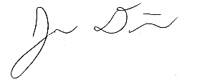 12/3/20
Christina Morrow: 12/3/20

Ryker Mullinix: 12/3/20

DEFINITIONS:
Hazard: Any situation, object, or behavior that exists, or that can potentially cause ill health, injury, loss or property damage e.g. electricity, chemicals, biohazard materials, sharp objects, noise, wet floor, etc. OSHA defines hazards as “any source of potential damage, harm or adverse health effects on something or someone". A list of hazard types and examples are provided in appendix A.
Hazard control: Hazard control refers to workplace measures to eliminate/minimize adverse health effects, injury, loss, and property damage. Hazard control practices are often categorized into following three groups (priority as listed):
- Engineering control: physical modifications to a process, equipment, or installation of a barrier into a system to minimize worker exposure to a hazard. Examples are ventilation (fume hood, biological safety cabinet), containment (glove box, sealed containers, barriers), substitution/elimination (consider less hazardous alternative materials), process controls (safety valves, gauges, temperature sensor, regulators, alarms, monitors, electrical grounding and bonding), etc.
- Administrative control: changes in work procedures to reduce exposure and mitigate hazards. Examples are reducing scale of process (micro-scale experiments), reducing time of personal exposure to process, providing training on proper techniques, writing safety policies, supervision, requesting experts to perform the task, etc.
- Personal protective equipment (PPE): equipment worn to minimize exposure to hazards. Examples are gloves, safety glasses, goggles, steel toe shoes, earplugs or muffs, hard hats, respirators, vests, full body suits, laboratory coats, etc.
Team member(s): Everyone who works on the project (i.e. grads, undergrads, postdocs, etc.). The primary contact must be listed first and provide phone number and email for contact.
Safety representative: Each laboratory is encouraged to have a safety representative, preferably a graduate student, in order to facilitate the implementation of the safety expectations in the laboratory. Duties include (but are not limited to):
- Act as a point of contact between the laboratory members and the college safety committee members.
- Ensure laboratory members are following the safety rules.
- Conduct periodic safety inspection of the laboratory.
- Schedule laboratory clean up dates with the laboratory members.
- Request for hazardous waste pick up.
Residual risk: Residual Risk Assessment Matrix are used to determine project’s risk level. The hazard assessment matrix (table 1) and the residual risk assessment matrix (table 2) are used to identify the residual risk category.
The instructions to use hazard assessment matrix (table 1) are listed below:
- Define the workers familiarity level to perform the task and the complexity of the task.
- Find the value associated with familiarity/complexity (1 – 5) and enter value next to: HAZARD on the PHA worksheet.
Table 1. Hazard assessment matrix.
 |  | Complexity
 |  | Simple | Moderate | Difficult
Familiarity Level | Very Familiar | 1 | 2 | 3
 | Somewhat Familiar | 2 | 3 | 4
 | Unfamiliar | 3 | 4 | 5

The instructions to use residual risk assessment matrix (table 2) are listed below:
- Identify the row associated with the familiarity/complexity value (1 – 5).
- Identify the consequences and enter value next to: CONSEQ on the PHA worksheet. Consequences are determined by defining what would happen in a worst case scenario if controls fail.
  - Negligible: minor injury resulting in basic first aid treatment that can be provided on site.
  - Minor: minor injury resulting in advanced first aid treatment administered by a physician.
  - Moderate: injuries that require treatment above first aid but do not require hospitalization.
  - Significant: severe injuries requiring hospitalization.
  - Severe: death or permanent disability.
- Find the residual risk value associated with assessed hazard/consequences: Low –Low Med – Med– Med High – High.
- Enter value next to: RESIDUAL on the PHA worksheet.
Table 2. Residual risk assessment matrix.
Assessed Hazard Level | Consequences
 | Negligible | Minor | Moderate | Significant | Severe
5 | Low Med | Medium | Med High | High | High
4 | Low | Low Med | Medium | Med High | High
3 | Low | Low Med | Medium | Med High | Med High
2 | Low | Low Med | Low Med | Medium | Medium
1 | Low | Low | Low Med | Low Med | Medium

Specific rules for each category of the residual risk:
Low:
- Safety controls are planned by both the worker and supervisor.
- Proceed with supervisor authorization.
Low Med:
- Safety controls are planned by both the worker and supervisor.
- A second worker must be in place before work can proceed (buddy system).
- Proceed with supervisor authorization.
Med:
- After approval by the PI, a copy must be sent to the Safety Committee.
- A written Project Hazard Control is required and must be approved by the PI before proceeding. A copy must be sent to the Safety Committee.
- A second worker must be in place before work can proceed (buddy system).
- Limit the number of authorized workers in the hazard area.
Med High:
- After approval by the PI, the Safety Committee and/or EHS must review and approve the completed PHA.
- A written Project Hazard Control is required and must be approved by the PI and the Safety Committee before proceeding.
- Two qualified workers must be in place before work can proceed.
- Limit the number of authorized workers in the hazard area.
High:
- The activity will not be performed. The activity must be redesigned to fall in a lower hazard category.

Appendix A: Hazard types and examples
Types of Hazard | Example
Physical hazards | Wet floors, loose electrical cables objects protruding in walkways or doorways
Ergonomic hazards | Lifting heavy objects Stretching the body  Twisting the body  Poor desk seating
Psychological hazards | Heights, loud sounds, tunnels, bright lights
Environmental hazards | Room temperature, ventilation contaminated air, photocopiers, some office plants acids
Hazardous substances | Alkalis solvents
Biological hazards | Hepatitis B, new strain influenza
Radiation hazards | Electric welding flashes Sunburn
Chemical hazards | Effects on central nervous system, lungs, digestive system, circulatory system, skin, reproductive system. Short term (acute) effects such as burns, rashes, irritation, feeling unwell, coma and death.  Long term (chronic) effects such as mutagenic (affects cell structure), carcinogenic (cancer), teratogenic (reproductive effect), dermatitis of the skin, and occupational asthma and lung damage.
Noise | High levels of industrial noise will cause irritation in the short term, and industrial deafness in the long term.
Temperature | Personal comfort is best between temperatures of 16°C and 30°C, better between 21°C and 26°C.  Working outside these temperature ranges: may lead to becoming chilled, even hypothermia (deep body cooling) in the colder temperatures, and may lead to dehydration, cramps, heat exhaustion, and hyperthermia (heat stroke) in the warmer temperatures.
Being struck by | This hazard could be a projectile, moving object or material. The health effect could be lacerations, bruising, breaks, eye injuries, and possibly death.
Crushed by | A typical example of this hazard is tractor rollover. Death is usually the result
Entangled by | Becoming entangled in machinery. Effects could be crushing, lacerations, bruising, breaks amputation and death.
High energy sources | Explosions, high pressure gases, liquids and dusts, fires, electricity and sources such as lasers can all have serious effects on the body, even death.
Vibration | Vibration can affect the human body in the hand arm with `white-finger' or Raynaud's Syndrome, and the whole body with motion sickness, giddiness, damage to bones and audits, blood pressure and nervous system problems.
Slips, trips, and falls | A very common workplace hazard from tripping on floors, falling off structures or down stairs, and slipping on spills.
Radiation | Radiation can have serious health effects. Skin cancer, other cancers, sterility, birth deformities, blood changes, skin burns and eye damage are examples.
Physical | Excessive effort, poor posture and repetition can all lead to muscular pain, tendon damage and deterioration to bones and related structures
Psychological | Stress, anxiety, tiredness, poor concentration, headaches, back pain and heart disease can be the health effects
Biological | More common in the health, food and agricultural industries. Effects such as infectious disease, rashes and allergic response.

Project Hazard Control- For Projects with Medium and Higher Risks
Name of Project: Team 517: Lunar Landing Payload Crane |  |  |  | Date of submission: 12/04/2020
Team member |  | Phone number |  | e-mail
Alanna Black |  | 904-627-6508 |  | anb16c@my.fsu.edu
Jayson Dickinson |  | 980-229-8889 |  | jpd15e@my.fsu.edu
Christina Morrow |  | 850-242-1603 |  | cjm18bn@my.fsu.edu
Ryker Mullinix |  | 850-797-8685 |  | rwm18c@my.fsu.edu
Faculty mentor |  | Phone number |  | e-mail
Dr. Shayne McConomy |  | 850-410-6624 |  | smcconomy@eng.famu.fsu.edu
Dr. Eric Hellstrom |  | 850-645-7489 |  | hellstrom@asc.magnet.fsu.edu
Rewrite the project steps to include all safety measures taken for each step or combination of steps. Be specific (don’t just state “be careful”).
The cutting and drilling of plywood as well as aluminum will be necessary in the creation of our ARROW and the Peregrine Lander model. This was decided to be a Medium risk and could result in dust inhalation, lacerations, contusions, splinters, and crushed appendages. The safety measures taken for this will involves proper training for different tools, PPE worn including gloves and goggles, and proper clothing will be worn. Cutting and drilling will take place outside of the FAMU-FSU College of Engineering, at one of the group member’s residence, and the area that will be worked in will be free of debris as well as have proper ventilation as well as have other members of the group present.

Laser cutting of gears and other precise components will be performed by the Innovation Hub. This is another Medium High risk and has the potential for burns, lacerations, splinters, and damage to the user’s eyes. The Innovation Hub employees will monitor all laser cutting and will give any required training for use of the laser cutter. The team members will also follow other rules, including performing these tasks with a partner, wearing proper PPE regardless of the rules of the Innovation Hub, and will allow adequate time for parts to cool prior to removing them from the laser cutter.

Wiring and soldering the electrical components of the ARROW has a Medium risk. The potential injuries include, but are not limited to electrocution, burns, and fume inhalation. To combat these risks, eyeglasses, masks, and non-loose clothing will be worn. A fan will be used to reduce the fumes, and all electrical equipment will be properly grounded prior to use. A partner will be present for all wiring/soldering, and no task will be done without getting approval from the Principal Investigator.

The demonstration transportation and assembly are considered Low Medium risk. The safety measures involved in the transportation include obeying all traffic laws, wearing a seat belt, securely fastening the demonstration inside the vehicle so as to avoid shifting during relocation, and having a passenger in the car in the event of an emergency. The assembly of the demonstration can result in muscle strains, crushed appendages, lacerations, and contusions. As a result of this, gloves will be worn, and the demonstration will be carried by two team members to share the load. A supervisor will be called to authorize any relocations as well as oversee the assembly process to ensure that FAMU-FSU College of Engineering protocols are being followed.
Thinking about the accidents that have occurred or that you have identified as a risk, describe emergency response procedures to use.
- Remove the injured person from location of accident if safe to do so
- Call the appropriate authority (supervisor, FSUPD, 911, Poison Control dependent on severity and injury)
- Call emergency contact of injured person and inform them of incident
- Shut down/close off source of injury if possible, in a safe and controlled manner
- Isolate scene until the responding authority arrives
- Ensure responding authority has all necessary information on the situation and assist them however they may need
- Compose an accident report with all team members present following the conclusion of the incident
- Share accident report with Faculty supervisor or Principal Investigator

List emergency response contact information:
- Call 911 for injuries, fires or other emergency situations
- Call your department representative to report a facility concern
Name | Phone number | Member Name | Faculty or other COE emergency contacts |  | Phone number
Kyle Prince | 904-451-0795 | Alanna Black | Dr. Shayne McConomy |  | 850-410-6624
Hannah Patten | 954-625-9837 | Jayson Dickinson | Donald Hollett |  | 850-410-6600
Michael Macedo | 850-499-0052 | Ryker Mullinix | Sahar Mohammadi |  | 850-410-6623
Ernest Morrow | 850-528-5914 | Christina Morrow | Jeremy Phillips |  | 850-410-6113

Safety review signatures
Team member | Signature | Date | Faculty mentor |  | Date
Alanna Black |  | 12/3/20
Jayson Dickinson |  | 12/3/20
Christina Morrow |  | 12/3/20
Ryker Mullinix |  | 12/3/20

Important Phone Numbers
FSUPD Non-Emergency Line | 850-644-1234
Poison Control | 800-222-1222
FSU Environmental Health and Safety | 850-644-6895
Leon County First Responders Non-Emergency Line | 850-606-5800

Report all accidents and near misses to the faculty mentor.

Appendix I: Automation Code
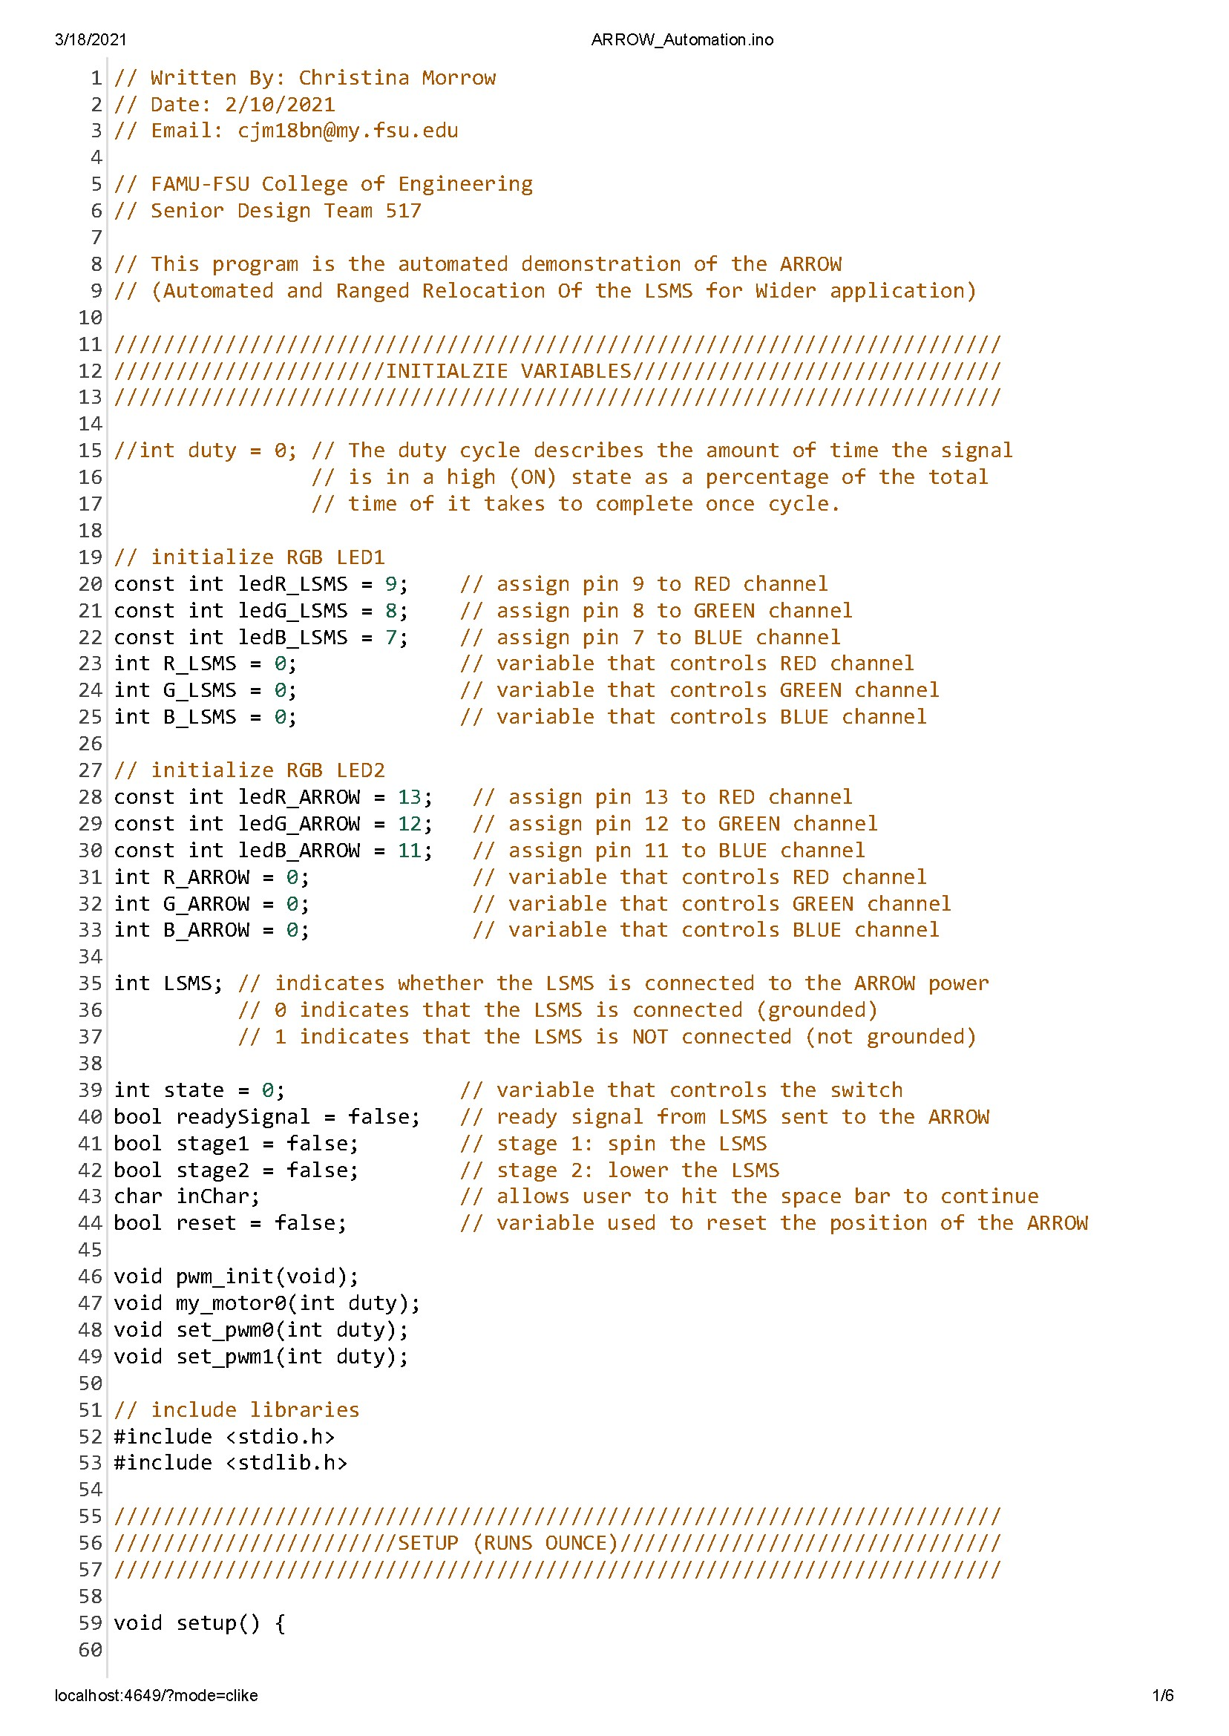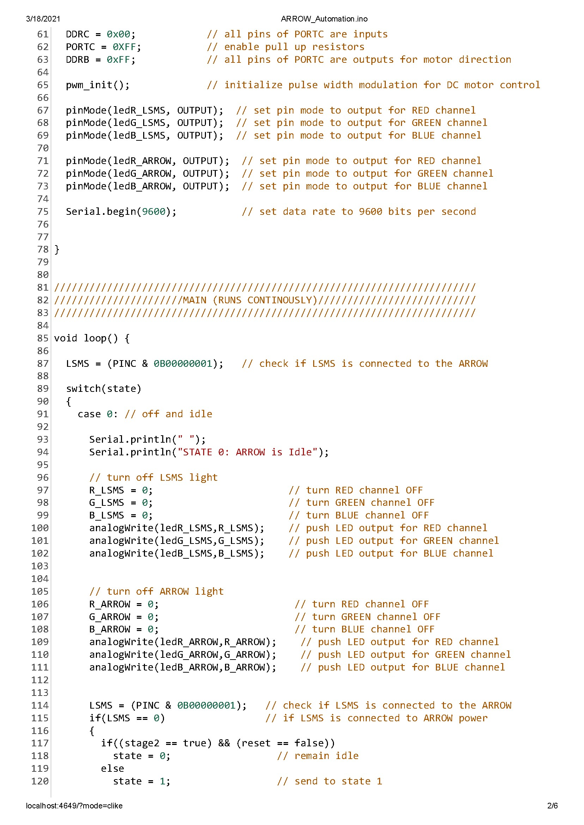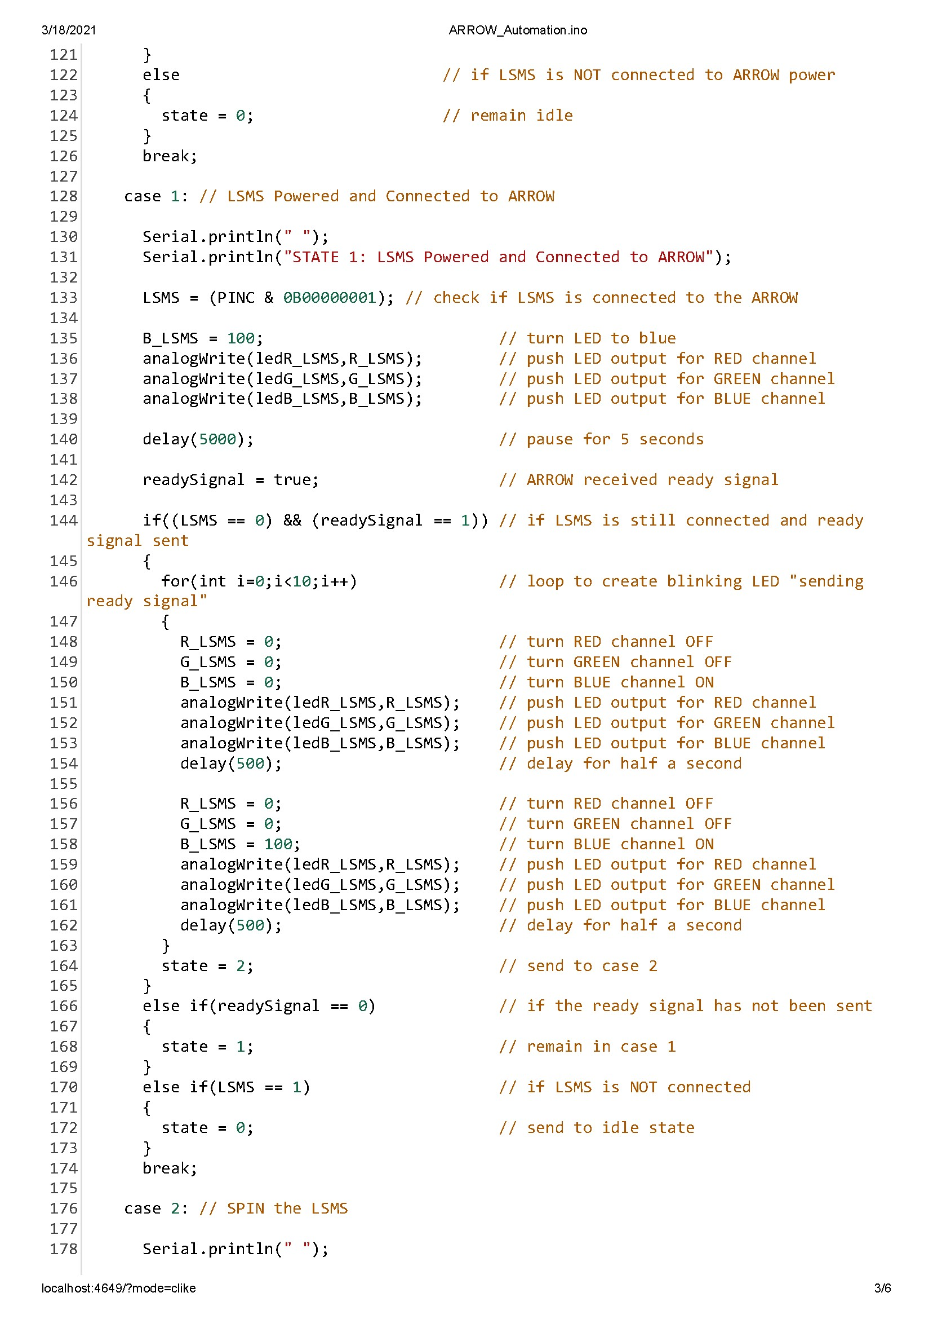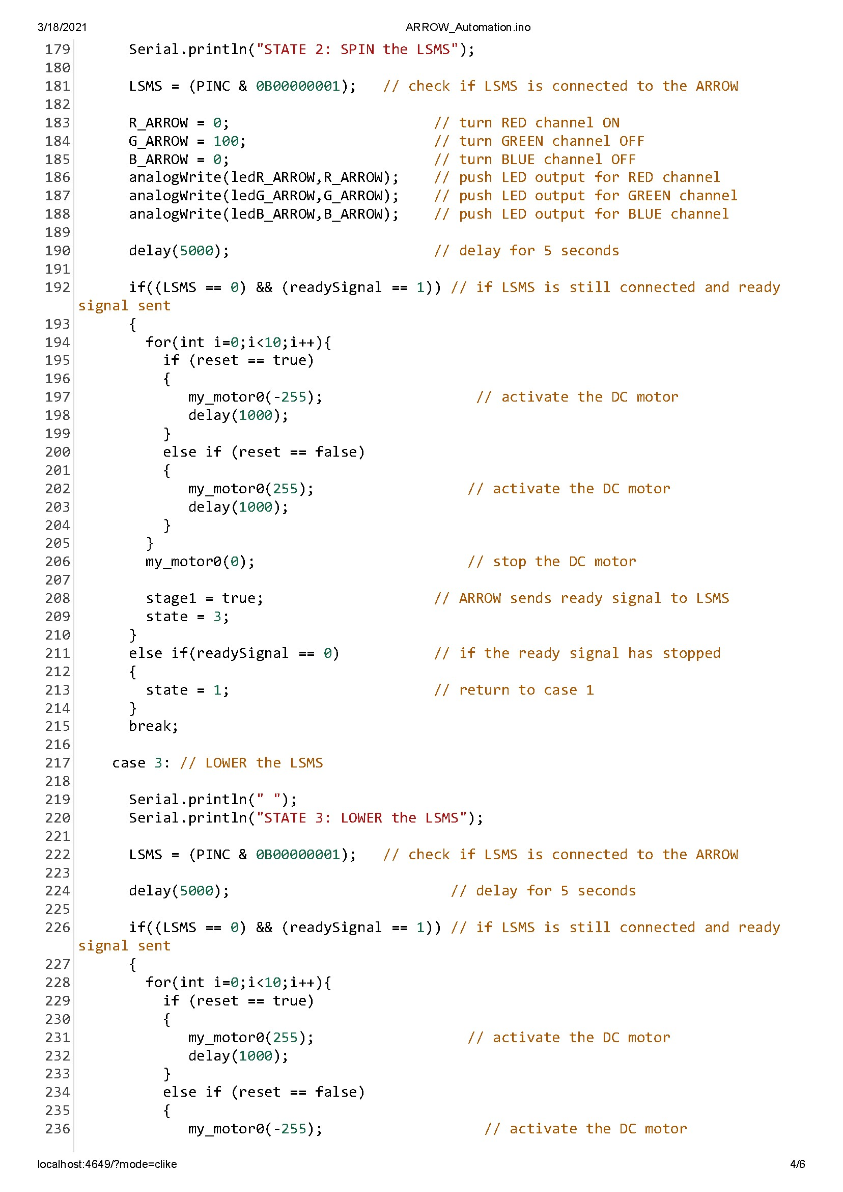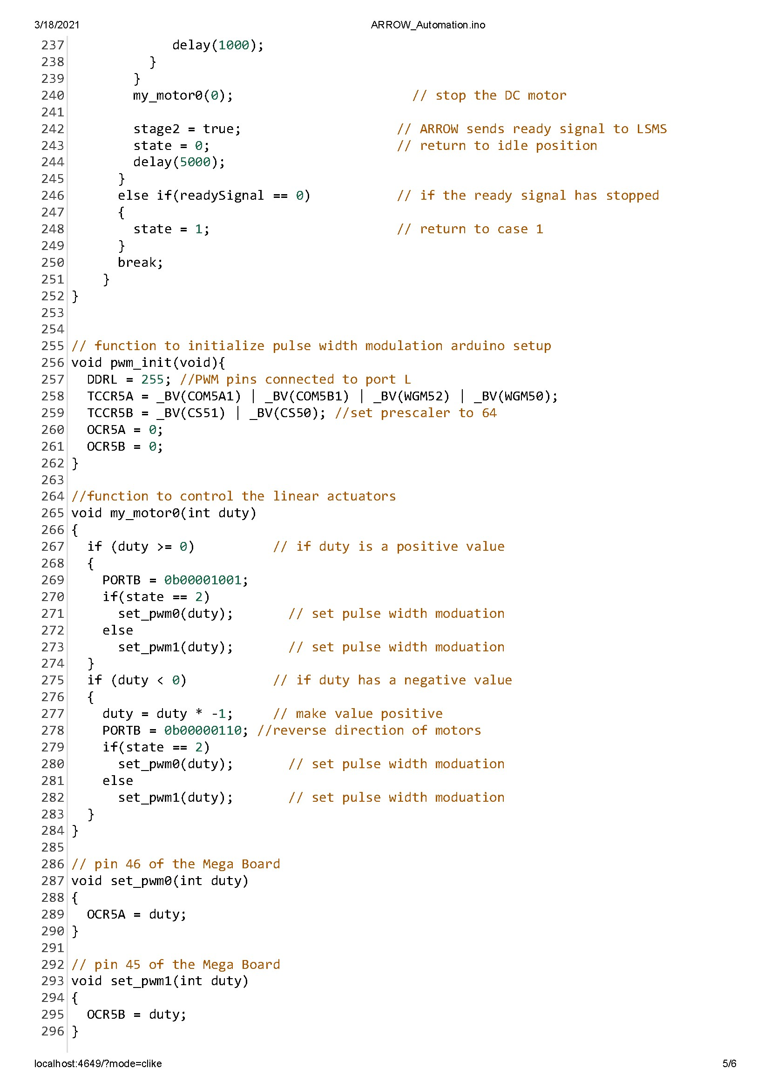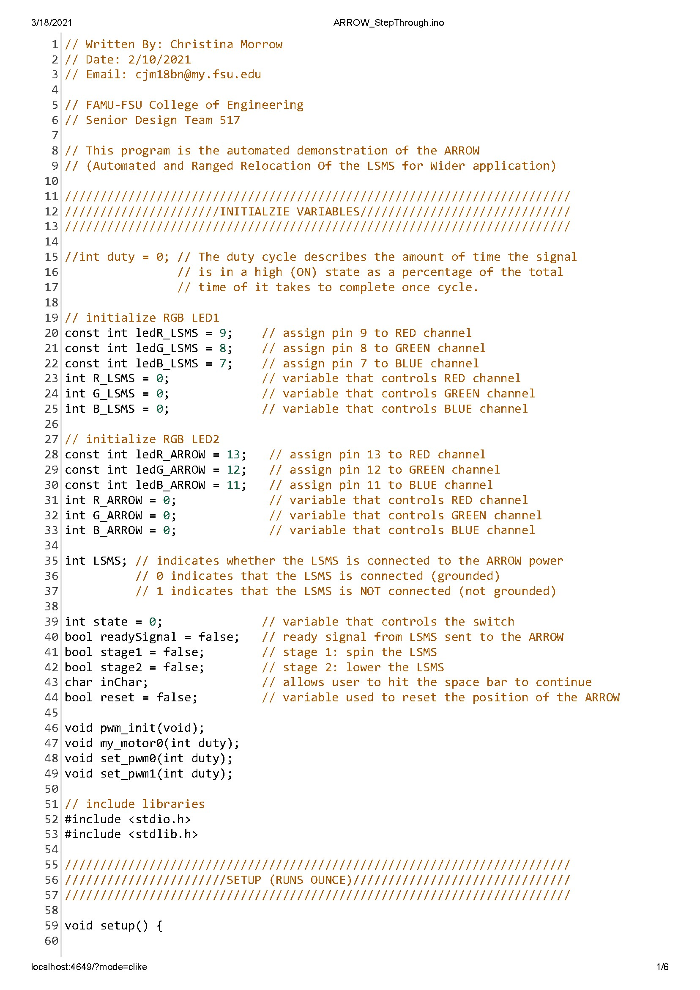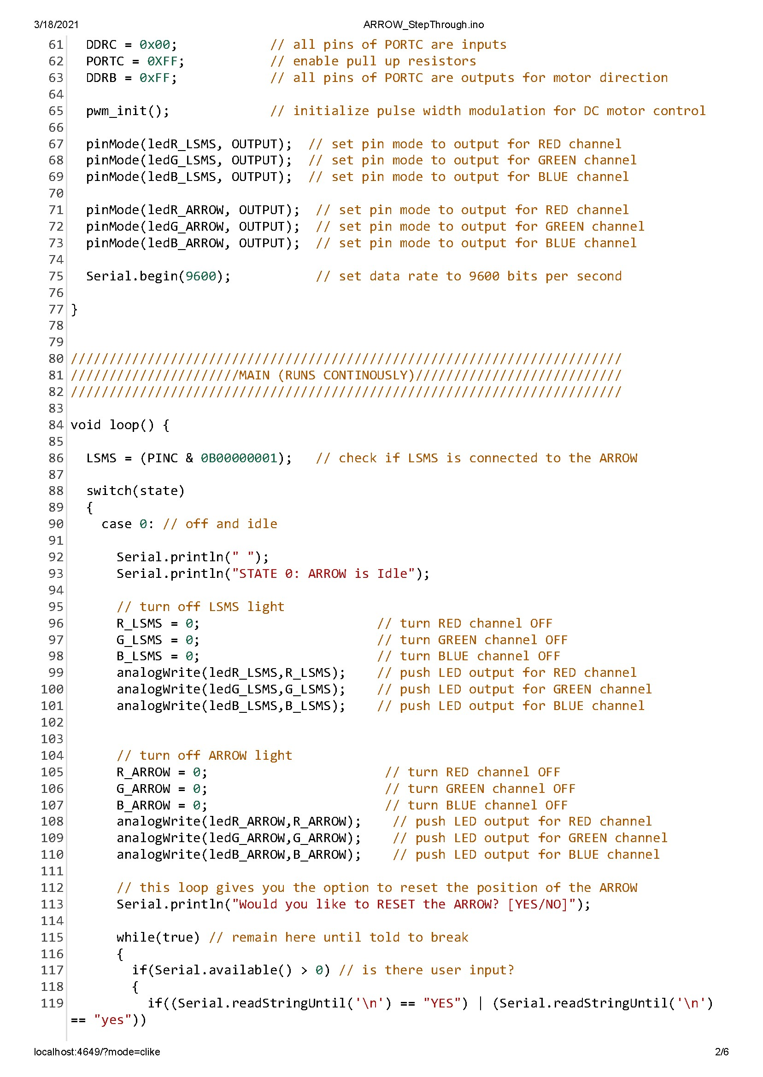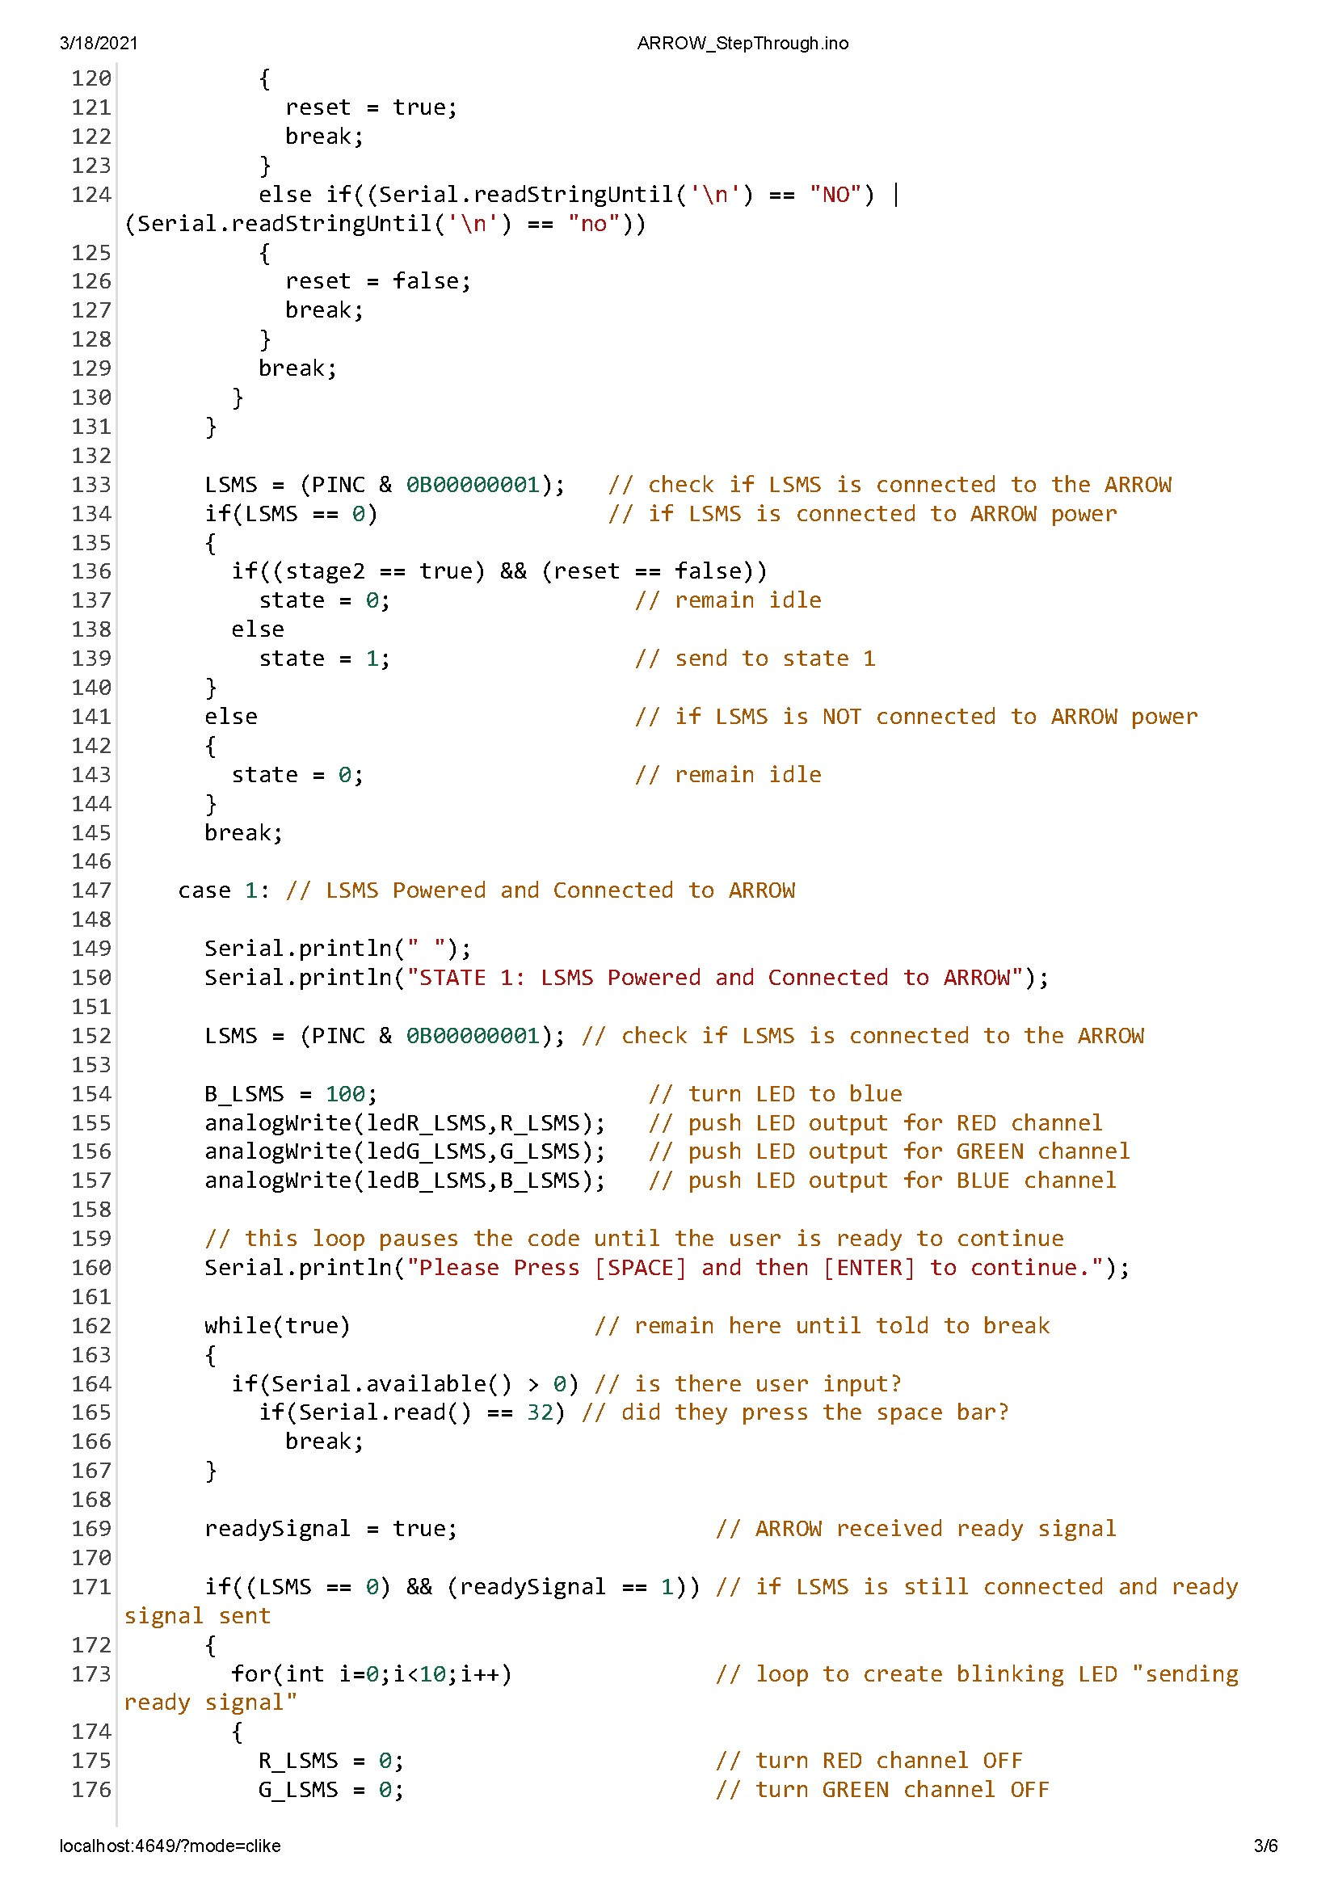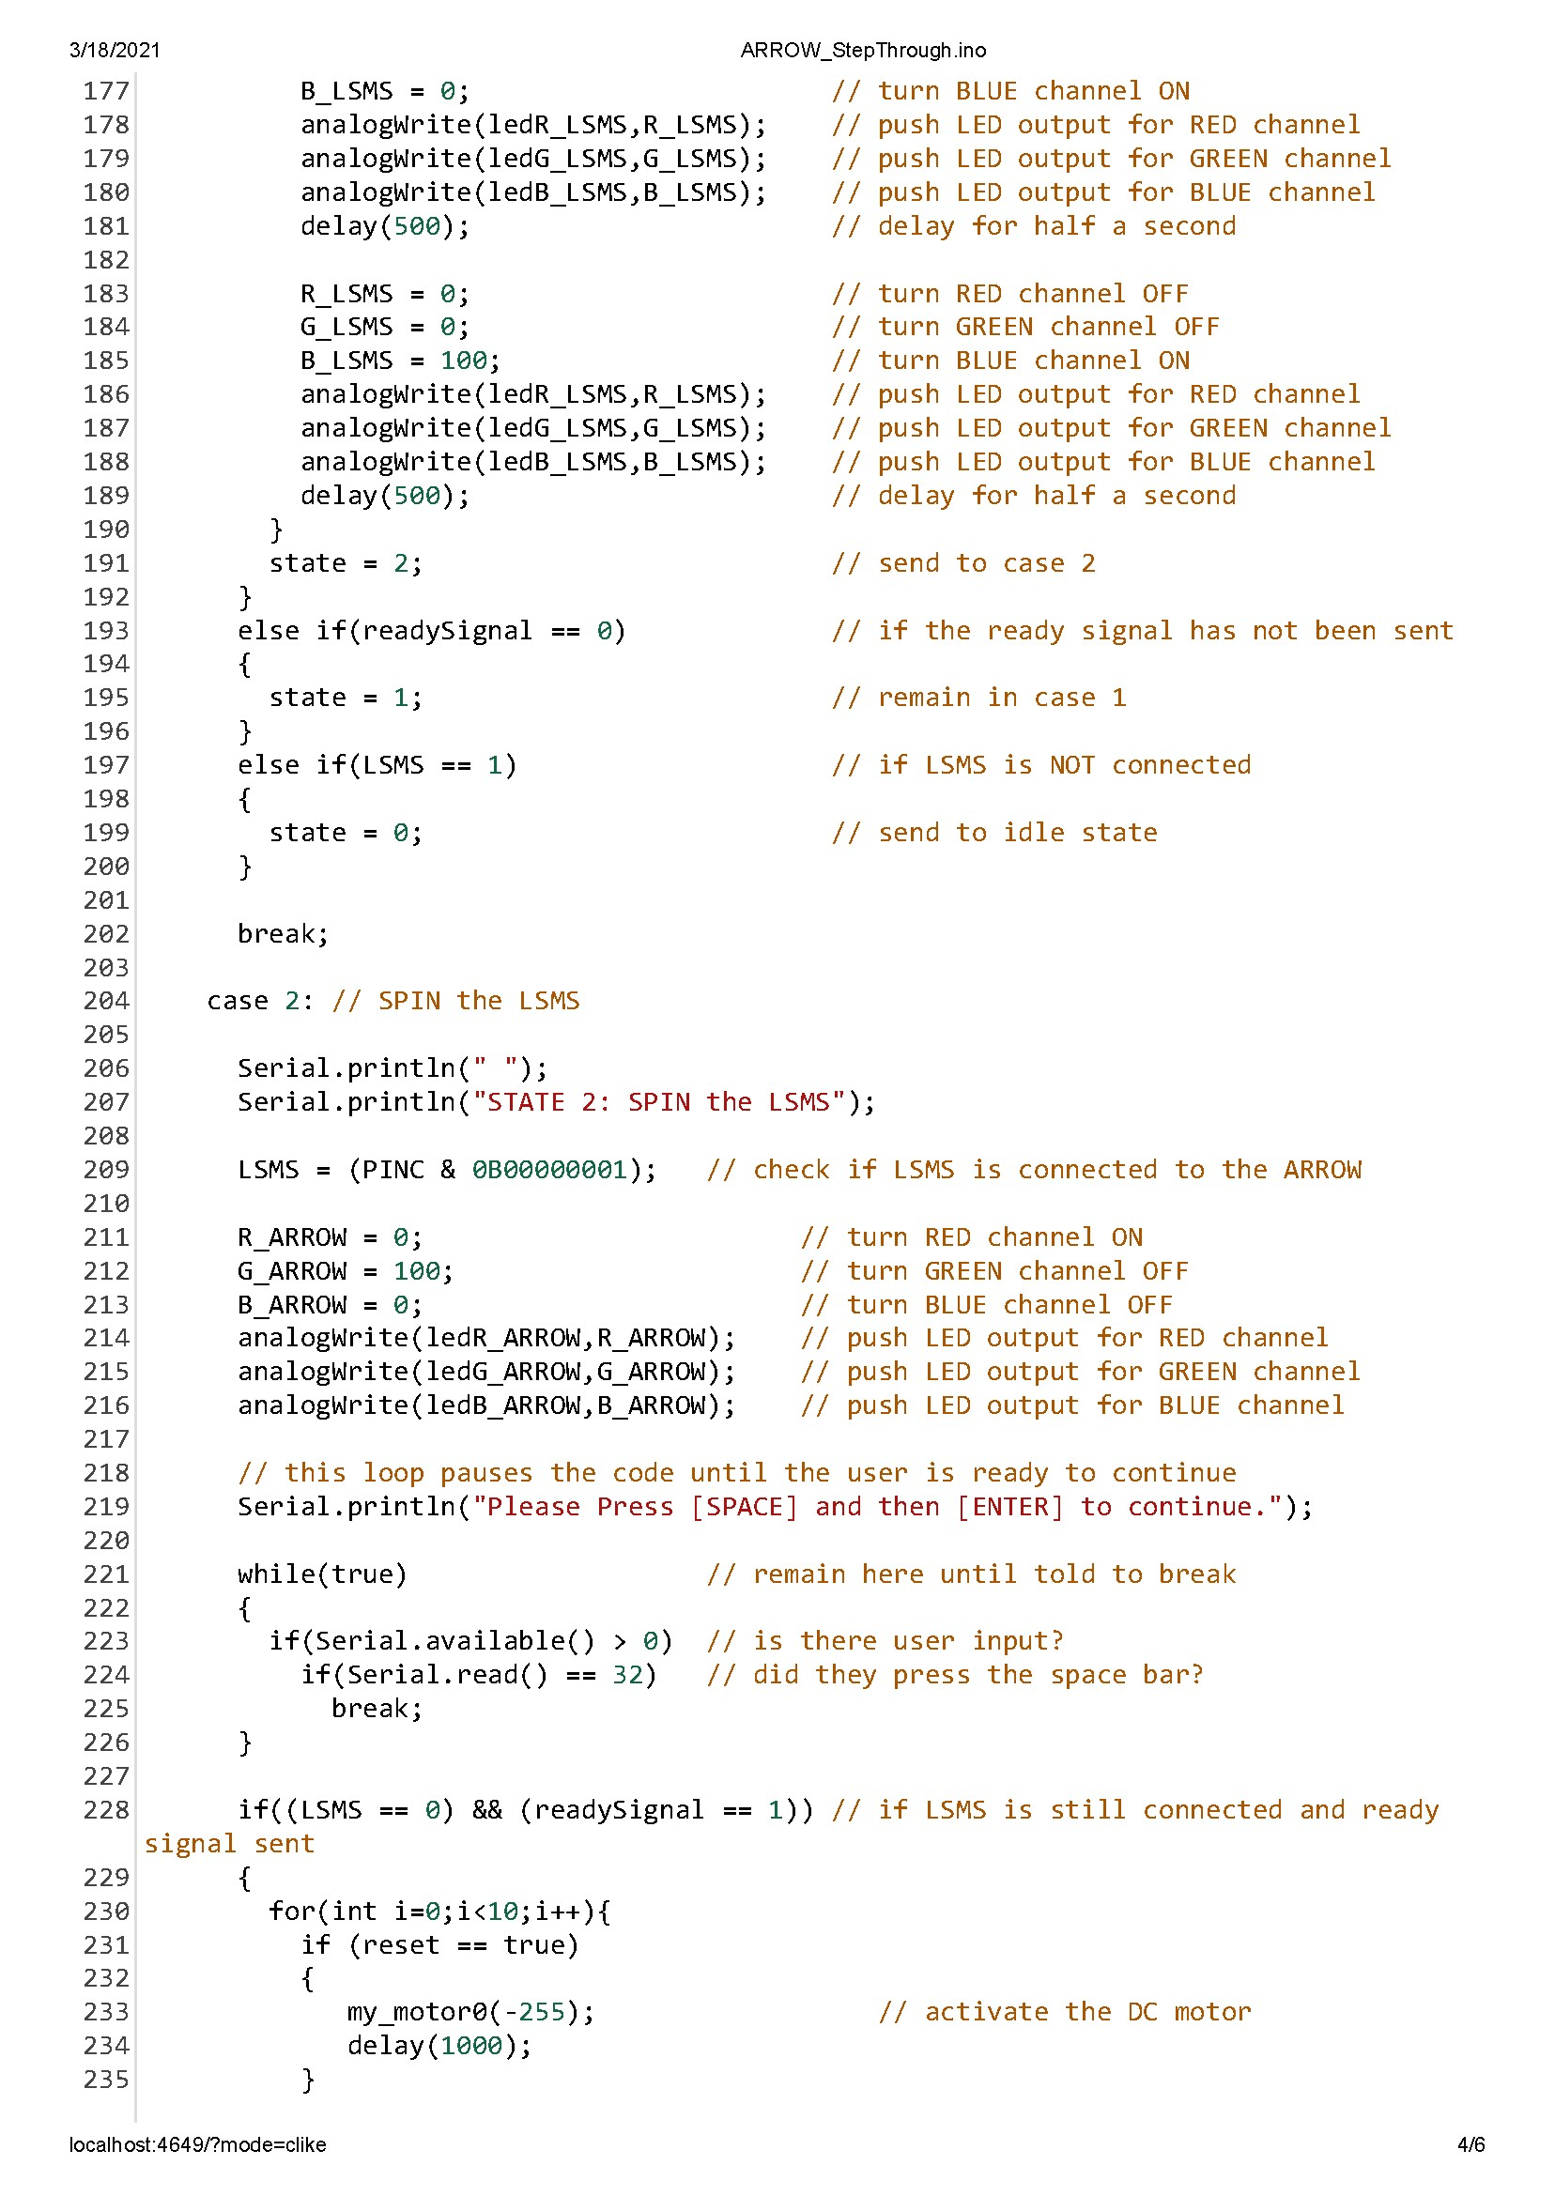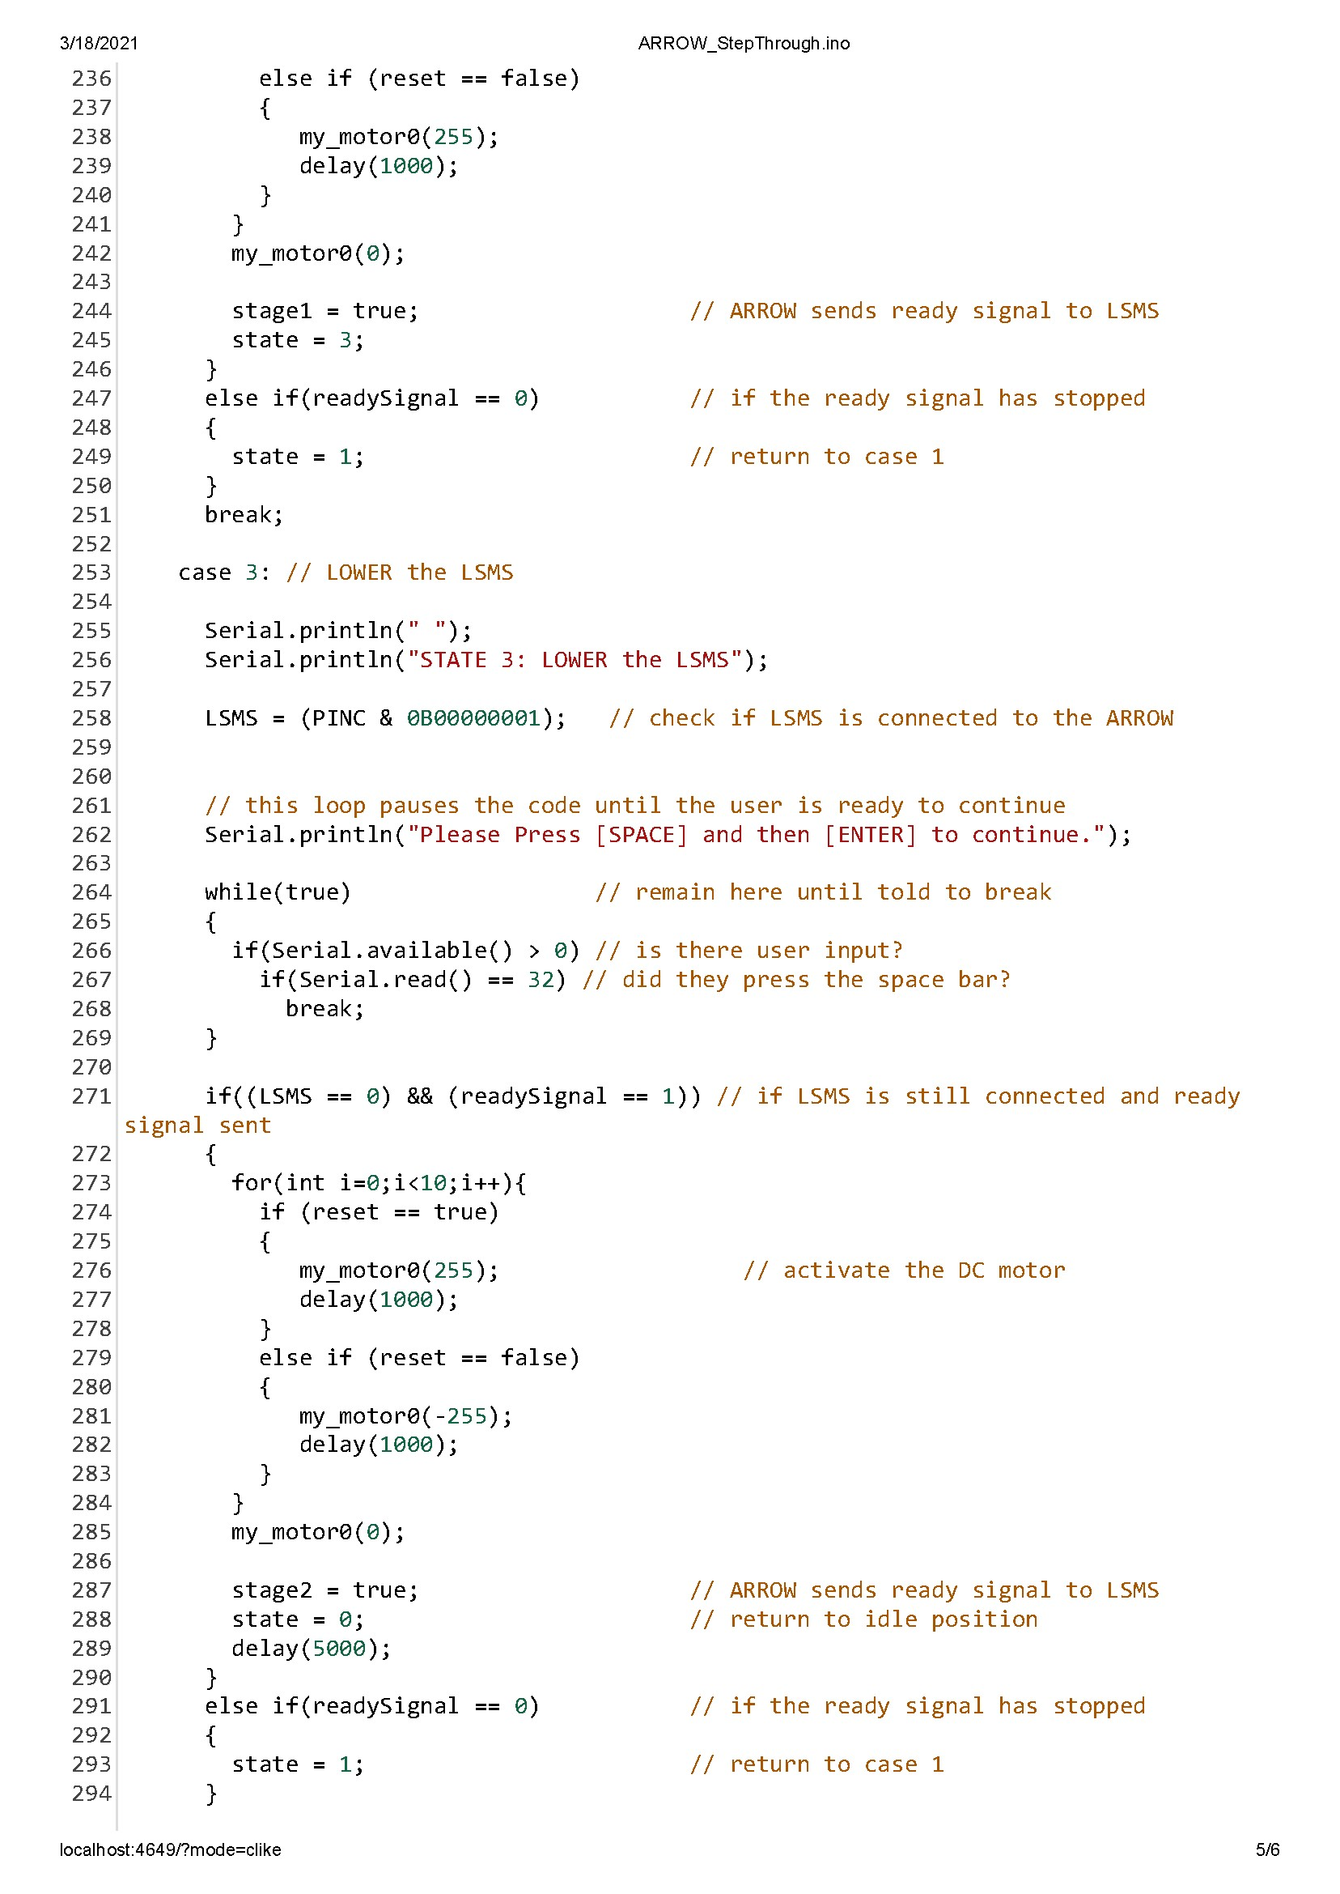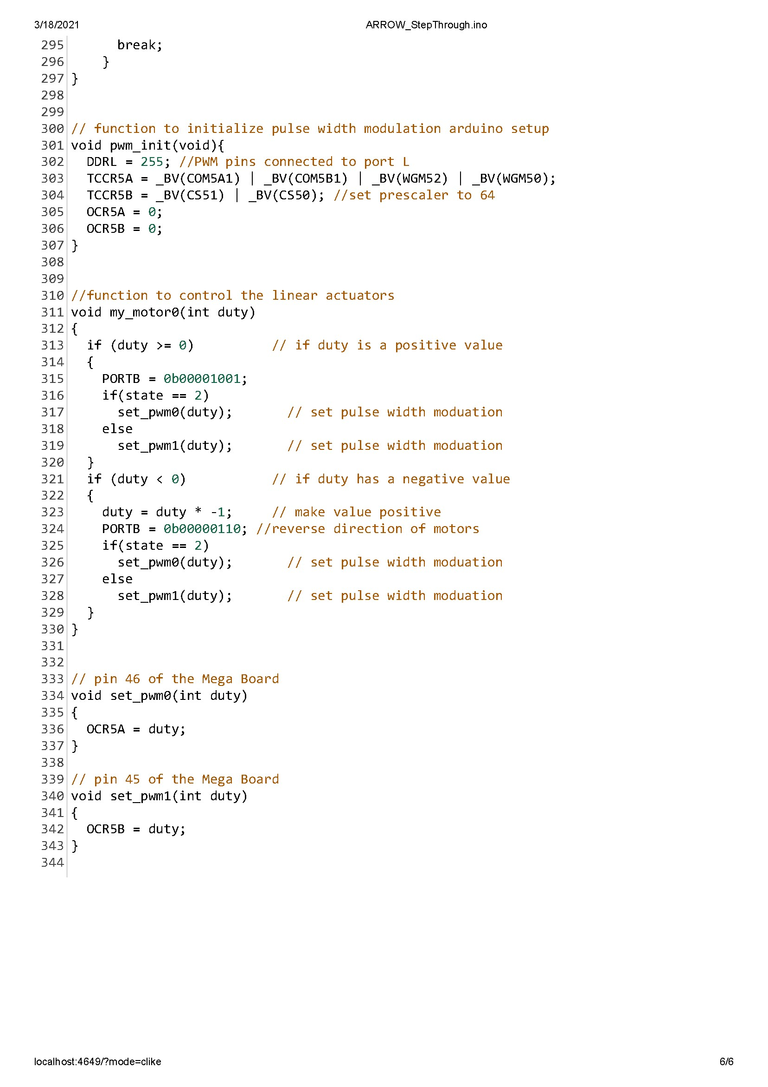

References

Dorsey, J., Jones, T., Doggett, W., King, B., Mercer, C., Brady, J., . . . Ganoe, G. (2011). Recent Developments in the Design, Capabilities and Autonomous Operations of a Lightweight Surface Manipulation System and Test-bed. AIAA SPACE 2011 Conference & Exposition. doi:10.2514/6.2011-7266

Doggett, W. (., King, B., Jones, T., Dorsey, J., & Mikulas, M. (2008). Design and Field Test of a Mass Efficient Crane for Lunar Payload Handling and Inspection: The Lunar Surface Manipulation System. AIAA SPACE 2008 Conference & Exposition. doi:10.2514/6.2008-7635

Dorsey, J., Jones, T., Doggett, W., King, B., Mikulas, M., & Roithmayr, C. (2009). Developments to Increase the Performance, Operational Versatility and Automation of a Lunar Surface Manipulation System. AIAA SPACE 2009 Conference & Exposition. doi:10.2514/6.2009-6795

Dorsey, J., Mikulas, M., & Doggett, W. (2008). Preliminary Structural Design Considerations and Mass Efficiencies for Lunar Surface Manipulator Concepts. AIAA SPACE 2008 Conference & Exposition. doi:10.2514/6.2008-7916

Jefferies, S., Doggett, W., Chrone, J., Angster, S., Dorsey, J., Jones, T., . . . Caldwell, D. (2010). Lunar Lander Offloading Operations Using a Heavy-Lift Lunar Surface Manipulator System. AIAA SPACE 2010 Conference & Exposition. doi:10.2514/6.2010-8804

Mullinix, R. (2021). T517 Lunar Landing Payload Crane. Retrieved April 11, 2021, from https://web1.eng.famu.fsu.edu/me/senior_design/2021/team517

PEREGRINE LUNAR LANDER: PAYLOAD USER’S GUIDE [PDF]. (2020, June). Astrobotic Technology.

